1. (No Calc 2017)

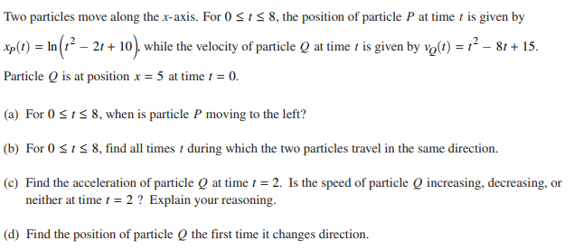

1. (Calc 2017)

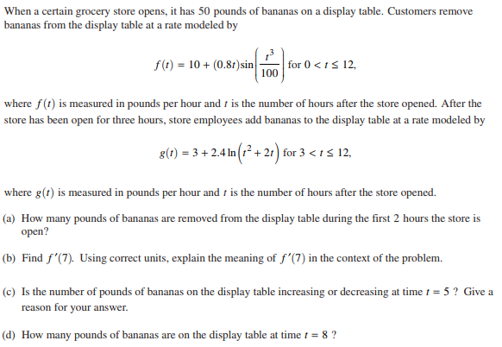

1. (Calc 2016)

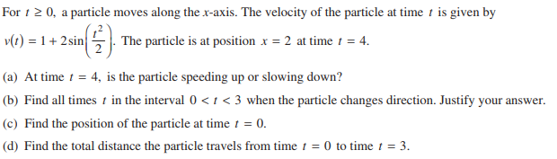

1. (Calc 2003)

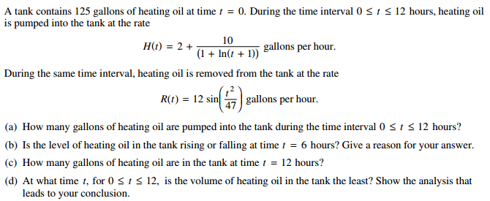

1. (No Calc 2003) 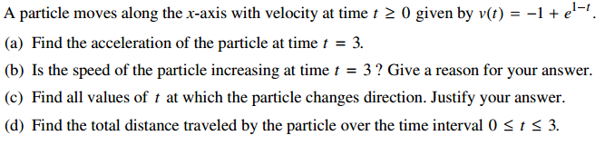
2. (Calc 2015) 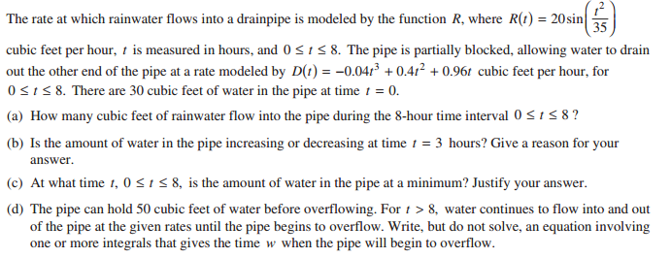
3. (No Calc 2015) 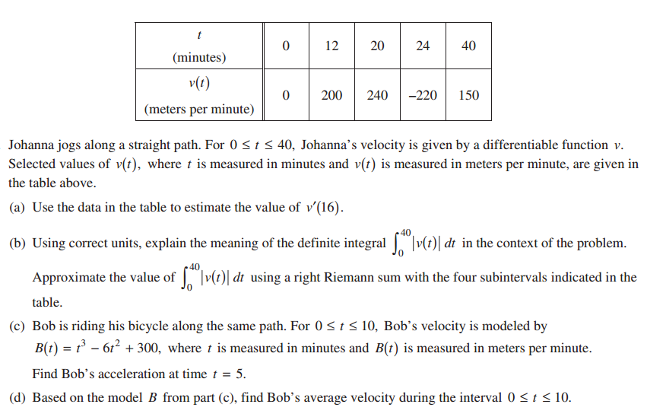
4. (Calc 2013) 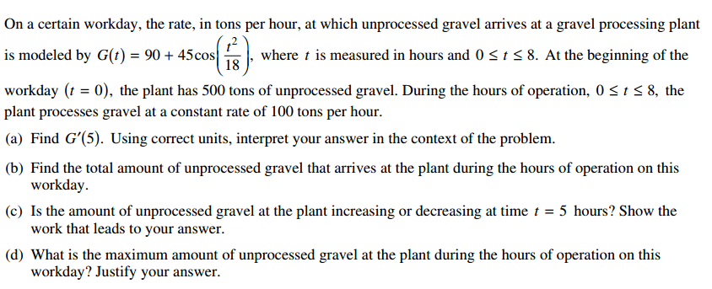
5. (Calc 2013)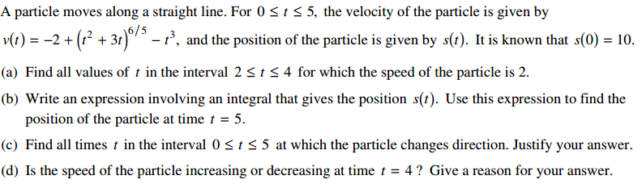
6. (No Calc 2012) 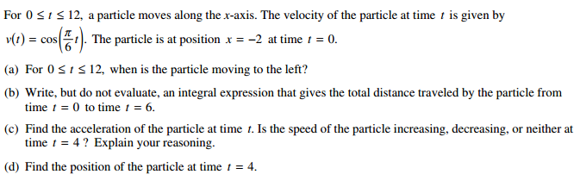
7. ( No Calc 2000) 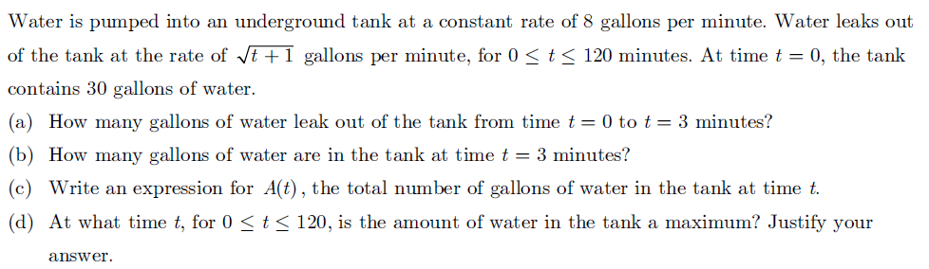
8. ( Calc 2000) 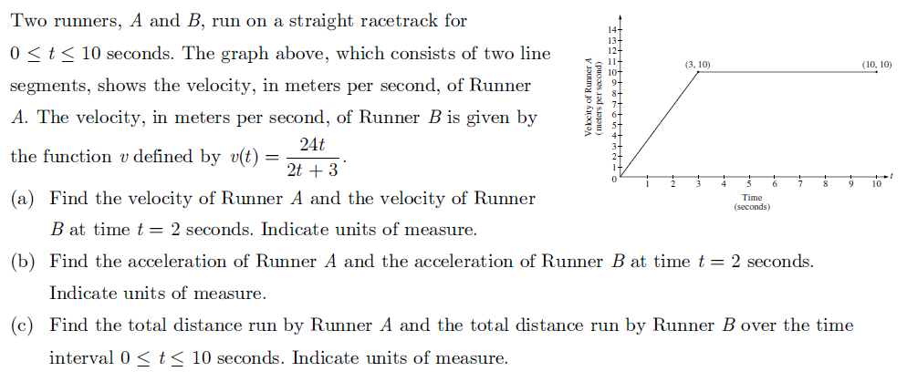
9. ( Calc 2009) 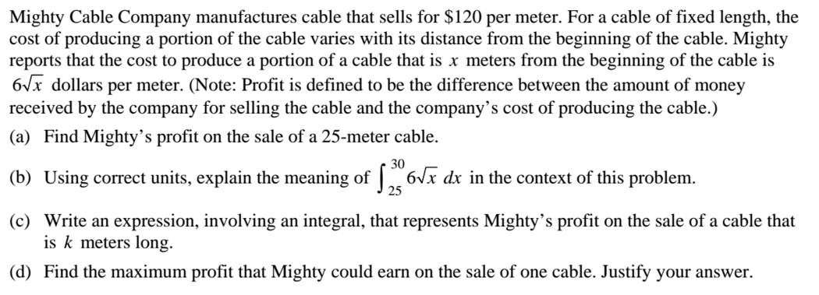
10. ( Calc 2009) 