2.1 – Worksheet – Day 1

All work must be shown and justified in this course for full credit. Insupported answers may receive NO credit.

- The only way to guarantee the existence of a limit is to algebraically prove it. Describe the different ways you can investigate the existence of a limit.
- Using words, explain what is meant by the expression $\lim_{q→c}{f\left(q\right)=T}$.
- Assume $\lim_{x→b}{f\left(x\right)=7}$ and $\lim_{x→b}{g\left(x\right)=-3}$. Determine:
a) $\lim_{x→b}\left(f\left(x\right)+g(x)\right)$ b) $\lim_{x→b}\left(f\left(x\right).g(x)\right)$
c) $\lim_{x→b}\left(4g(x)\right)$ d) $\lim_{x→b}\left(\frac{f\left(x\right)}{g(x)}\right)$
- When asked to evaluate the limit of a function, what should be done first?
- Evaluate the following limits by using direct substitution.
a) $\lim_{x→7}sec\left(\frac{πx}{6}\right)$ b) $\lim_{x→4}{\sqrt[3]{x+4}}$
c) $\lim_{x→1/2}{3x^{2}(2x-1)}$ d) $\lim_{y→2}{\frac{y^{2}+5y+6}{y+2}}$
e) $\lim_{x→-2}{{\left(x-6\right)}^{2/3}}$ f) $\lim_{x→2}{\sqrt{x+3}}$
- Explain why you cannot use direct substitution to determine each of the following limits.
a) $\lim_{x→-2}{\sqrt{x-2}}$ b) $\lim_{x→0}{\frac{1}{x^{2}}}$ c) $\lim_{x→0}{\frac{{(4+x)}^{2}-16}{x}}$
- If a limit does not exist, there are 3 possible reasons why. List them all three.
- Find each limit or explain why the limit does not exist.
a) $\lim_{x→2}{f(x)}$, if $f\left(x\right)=\left\{\begin{aligned}lnx for 0<x≤2 \\ x^{2}lnx for 2<x≤4\end{aligned}\right.$ b) $\lim_{x→2^{+}}{f(x)}$, if $f\left(x\right)=\left\{\begin{aligned}3x+1 , x<2 \\ \frac{5}{x+1}, x≥2\end{aligned}\right.$
c) $\lim_{x→1}{\frac{x^{2}-4}{x-1}}$ d) $\lim_{x→2}{\frac{x+1}{{(x-2)}^{2}}}$
- Determine whether each statement about the graph below is True or False.
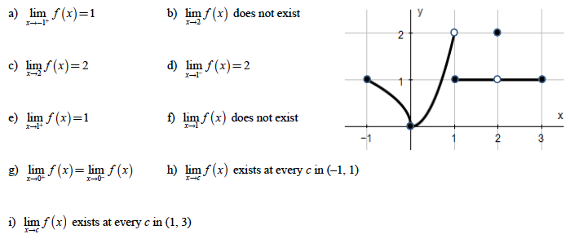
- Use the graph of f(x) to estimate the limits and value of the function, or explain why the limit does not exist.
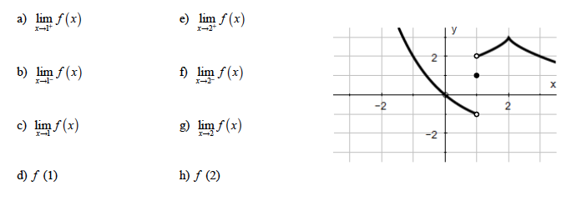
- For each of the following functions, (i) draw the graph, (ii) determine $\lim_{x→c^{+}}{f(x)}$ and $\lim_{x→c^{-}}{f(x)}$, and (iii) explain what the value of $\lim_{x→c}{f(x)}$ is or explain why it doesn’t exist.

 