**2.2 – day 2 – Extra Practice**

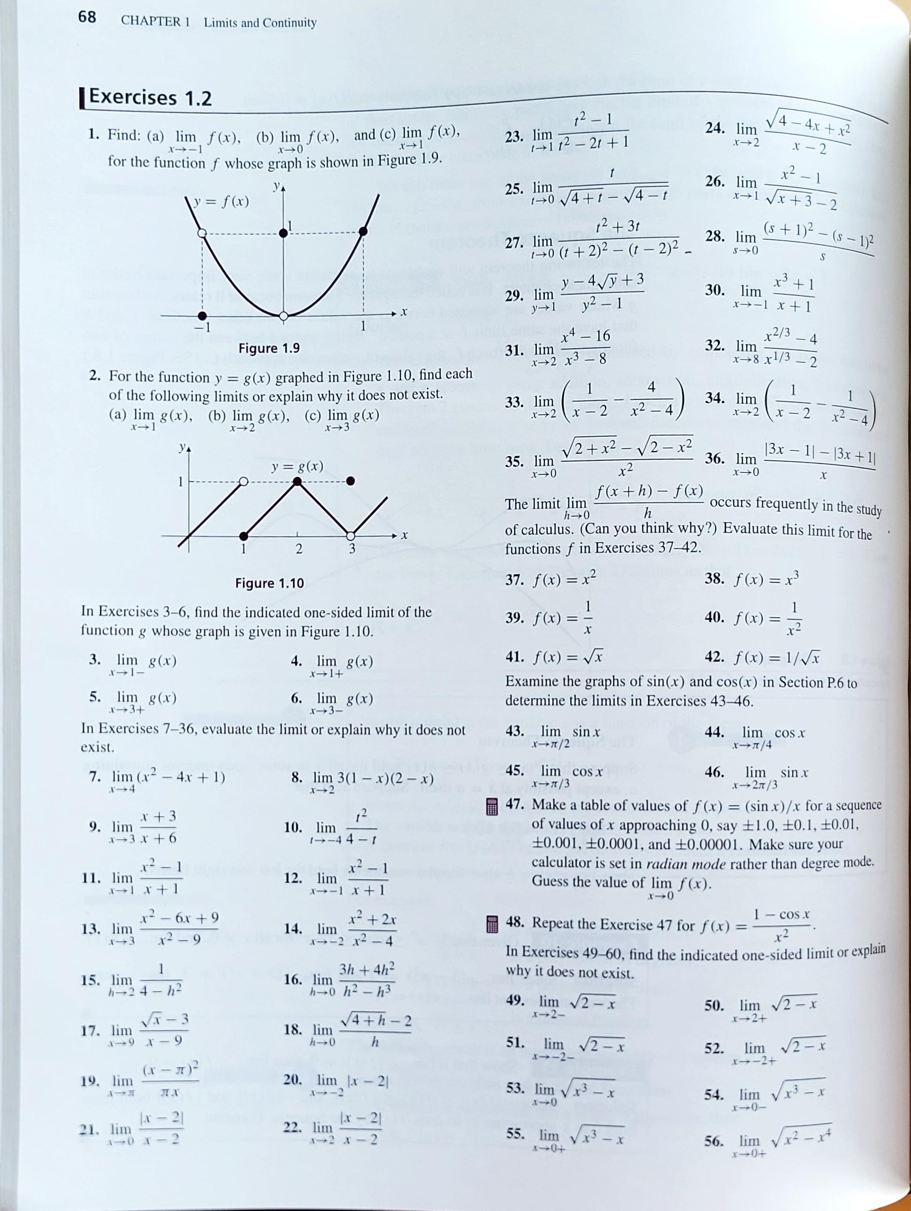

SOLUTIONS

