7.3 - solids

CROSS SECTIONS :
If you cut a cylinder , what shape of a slice do you get?

It depends in what direction!!
If you cut it perpendicular to its length, you get a circle.
If you cut it perpendicular to its base, you get a rectangle.

The shape of the slice is called a cross section of a shape.

What is the cross section of a square based pyramid :
- Perpendicular to its base ?
- Parallel to its base ?

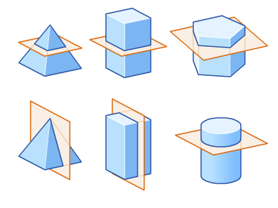
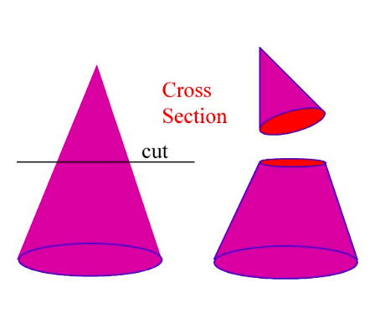

We are going to determine the volumes of objects for which the cross sections are always the same :
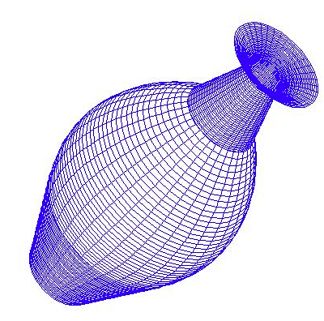
And describe their base using functions…

For example : If we want the base of our solid to be a circle, here are the different solids depending on the shape of the cross sections :
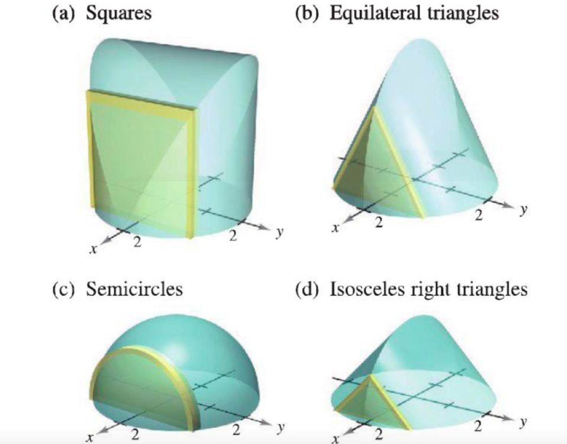

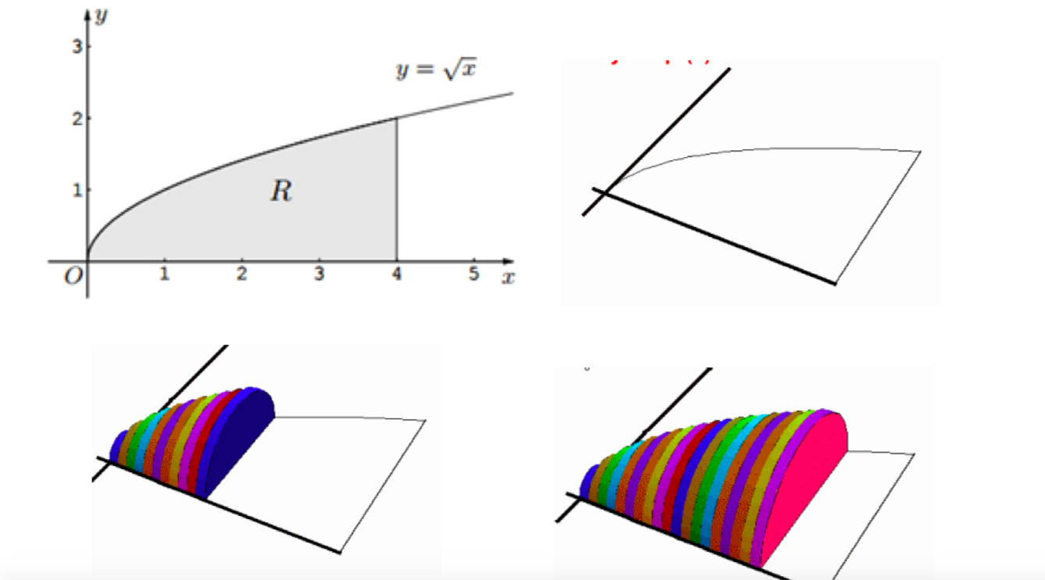

Animation Geogebra :
https://www.geogebra.org/m/YpqytNph#material/XArpgR3A
Lesson University of Houston :
https://online.math.uh.edu/HoustonACT/videocalculus/H.264/27-volumes1-H264.mov

SOLIDS OF REVOLUTION :

Animation geogebra :
https://www.geogebra.org/m/hhRJQyz9

Lesson Univerity of Houston :
https://online.math.uh.edu/HoustonACT/videocalculus/H.264/28-volumes2-H264.mov

