Additional Prerequisites for Calculus

- Even and Odd functions:
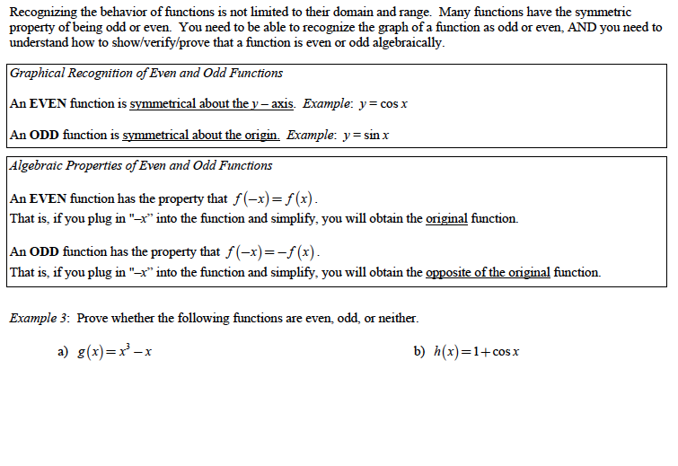
c) $f\left(x\right)=5x^{2}-3$ d) $k\left(x\right)=\left(x+1\right)\left(3x-3\right)$
- Piecewise functions:
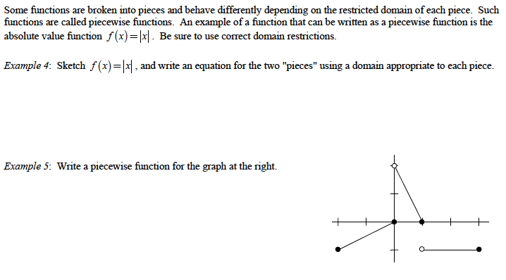
Hwk: worksheet + p 19 # 21 - 34

- One to one functions:
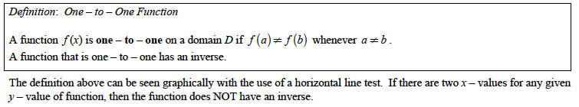
Note: A function that is always increasing* is one to one.
A function that is always decreasing* is one to one.

Hwk: worksheet + p 44 # 1 – 6,13 – 24,52,53
extend: p 45 # 59,60,62.

- Trigonometric inverse functions:
$y=sinx$ $y=\sin^{-1}x$
$y=cosx$ $y=\cos^{-1}x$
$y=tanx$ $y=\tan^{-1}x$
$y=cscx$ $y=secx$ $y=cotx$
- The Greatest Integer Function:
The Greatest Integer Function is denoted by y = [x] or $y=Int(x)$.
For all real numbers, x, the greatest integer function returns the largest integer
less than or equal to x. In essence, it rounds down a real number to the nearest integer.
For example: [1] = 1 [1.5] = 1 [3.7] = 3 [4.3] = 4
Beware! [-2] = -2 [-1.6] = -2 [-2.1] = -3 [-5.5] = -6
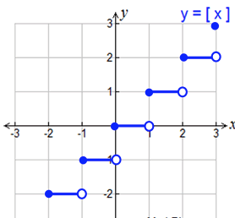

- Usual shapes areas and volumes:
