2.1 - Limits

Let’s have a look at the graph of: $f\left(x\right)=\frac{x^{2}-4}{x^{2}+x-6}=\frac{(x+2)(x-2)}{(x+3)(x-2)}$:

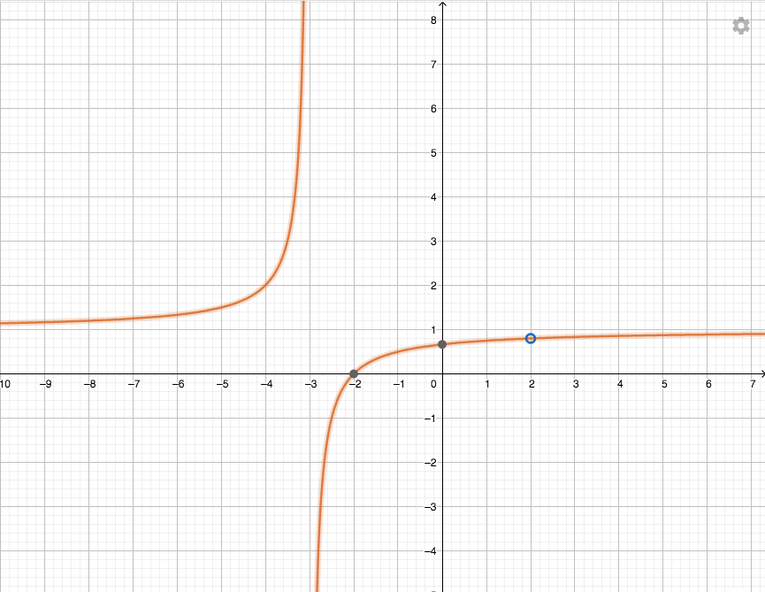

$\lim_{x→2}{{f(x)}^{}}=$ $\lim_{x→-2}{{f(x)}^{}}=$
$\lim_{x→-3}{{f(x)}^{}}=$
$\lim_{x→∞}{{f(x)}^{}}=$ $\lim_{x→-∞}{{f(x)}^{}}=$

Informal definition of a limit:
The limit of a function is the y-value that the function approaches when the x-value gets closer and closer to a certain value (from both sides when relevant).

Note: $∞$ is not a real number. Therefore, when the limit equals $∞$ we consider that the limit doesn’t exist, however, the information describes well the behaviour of the function.

Formal definition of a limit at a finite point:
Let $f(x)$ be a function defined on an open interval that contains a value a, except possibly at a.
Then, we say that $\lim_{x→a}{{f(x)}^{}}=L$
if for every number $ε>0$, there is some number $δ>0$ such that:
$$\left|x-a\right|<δ ⇒ \left|f\left(x\right)-L\right|<ε$$

Graphically, it means:
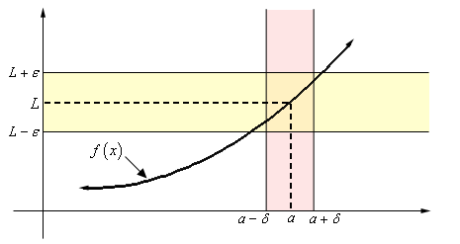
We can determine limits by looking at a graph or by working on the equation…

Examples:
1)
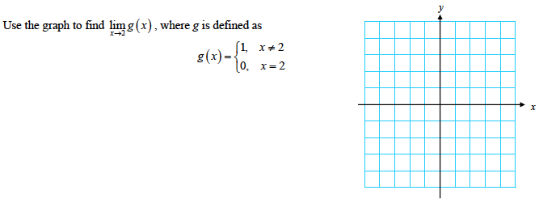

2)
Let $f\left(x\right)=3x-5$, determine $\lim_{x→-3}{{f(x)}^{}}$

One sided limits:
Sometimes, the function doesn’t approach the same value from the right side and from the left side…
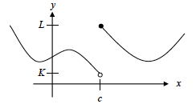
In that case, we consider that the limit as x approaches c doesn’t exist.
However, we can still describe this behavior by writing:
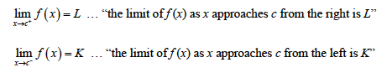
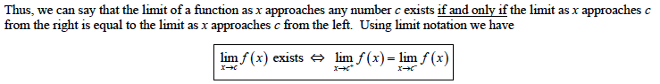

Example: Let $f\left(x\right)=\left\{\begin{aligned}5-2x if x>2 \\ 3x+1 if x≤2\end{aligned}\right.$
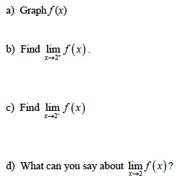

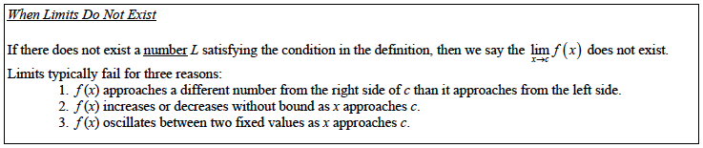

Examples: Investigate the existence of the following limits:
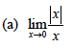
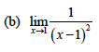
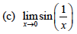
Graph it on your calculator…

Determining limits from equations:
Usually, to determine limits, we start by trying to substitute the value directly and see what we get by using the intuitive rules:
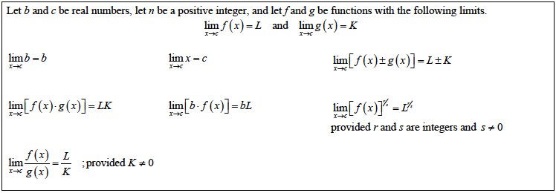

Examples:
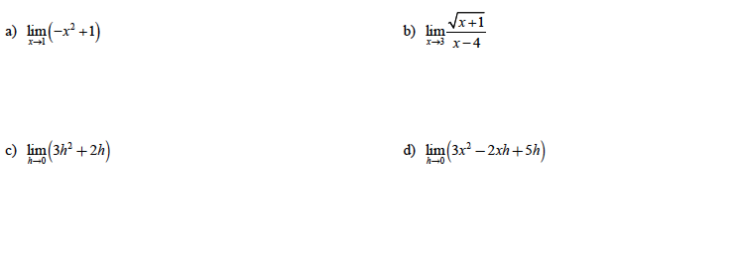
However, when we are dealing with limits that equal 0 or $∞$,we sometimes get what we call: indeterminate forms like: $\frac{\text{0}}{\text{0}} o r \frac{∞}{∞} or 0×∞ or ∞-∞$

Examples:
1) $\lim_{x→-1}{\frac{2x^{2}-x-3}{x+1}}$ 2) $\lim_{x→0}{\frac{ \frac{1}{x} }{\frac{1}{x^{2}}}}$ 3) $\lim_{x→2}{(x-2)×\frac{1}{x^{2}-4x+4}}$ 4) $\lim_{x→-1}({\frac{1}{x+1}}-\frac{1}{3x+3})$

In those cases, we can’t conclude with a direct substitution. You need to find a way to transform the expression to know “who wins” …
The answer can be a number, 0, $∞$ or DNE (does not exist)

1)

2)

3)

4)

Note: - It is important to always write the word lim in front of your expression as long as there still are some variables left. If you want to work on transforming the expression, you can start a different line and not write lim anywhere… until you take the limit.
- When an expression approaches 0, depending if it’s coming from the right or the left, the “not
quite 0” has a different sign. Therefore, in a “ $\frac{1}{0}$ ” type of limit, you need to determine if it’s a “positive” zero or a “negative” zero to conclude about a + or a - $∞$.

More examples:
5) $\lim_{x→0}{\frac{\frac{1}{x+4} - \frac{1}{4}}{x}}$

6) $\lim_{x→3}{\frac{\sqrt{x+1}-2}{x-3}}$

7) $\lim_{x→-1}{\frac{1}{x+1}-\frac{2}{(x+1)(x+3)}}$

Famous limit to remember: $\lim_{x→∞}{\frac{e^{x}}{x}=∞}$ It is also true for any power of x.

An exponential functions grows much faster than any polynomial function…

Another “famous limit that you need to remember is:
$\lim_{x→0}{\frac{sinx}{x}}$
It is actually more general than that and you can remember that:
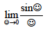
Examples:
1) $\lim_{x→0}{\frac{sin⁡(3x)}{3x}}$

2) $\lim_{x→0}{\frac{sin⁡(5x)}{3x}}$

3) $\lim_{x→0}{\frac{tanx}{x}}$

Sometimes, we canʼt work directly on the function. Another option would be to use the squeezing theorem (or sandwich theorem):
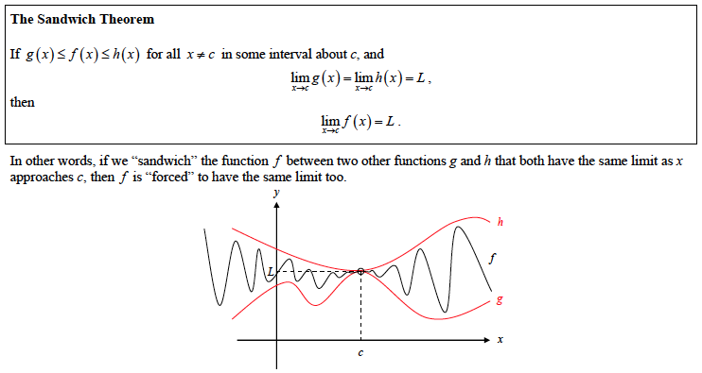

Examples:
- proof of $\lim_{x→0}{\frac{sinx}{x}}$ (ask for worksheet)
- Prove that $\lim_{x→0}{x^{2}\sin\left(\frac{1}{x}\right)=0}$

Hwk: worksheet
+ textbook p 65 # 1 – 10; p 66 # 5 – 44; 51 – 62; 65 – 74

2.2 – Limits involving infinity

In this section, we continue to investigate limits when x approaches infinity (it can be done from one side only) and also when the function approaches infinity as x approaches a certain value.
These situations are linked with the concepts of asymptotes:
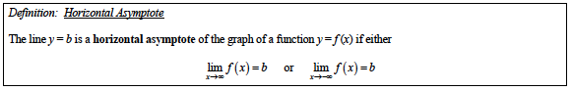
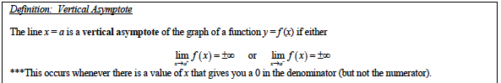

We already have mentioned the indeterminate forms like:
$\frac{\text{0}}{\text{0}} o r \frac{∞}{∞} or 0×∞ or ∞-∞$

And we remember that in a “ $\frac{1}{0}$ ” type of limit, you need to determine if it’s a “positive” zero or a “negative” zero to conclude about a + or a - $∞$.

Limits as x approaches infinity:

We have learned in chapter 9 that when the function is a rational function, its end behavior as x approaches infinity is the same than the end behavior of its leading term…

Applications:
- $\lim_{x→∞}{\frac{2x+5}{3x^{2}-6x+1}}$
- $\lim_{x→∞}{\frac{2x^{2}-3x+5}{x^{2}+1}}$
- $\lim_{x→∞}{\frac{x^{4}+x^{3}+9}{3x-3}}$

Note: This is only true as x approaches infinity!!
When determining limits towards infinity involving non-rational functions, you can try to use “direct substitution”, and if it’s indeterminate the squeezing theorem or try to factor the strongest term…
Examples:
- $\lim_{x→∞}{\frac{sin⁡(x)}{x}}$
- $\lim_{x→∞}{\frac{5+2^{x}}{3-2^{x}}}$
- $\lim_{x→-∞}{\frac{5+2^{x}}{3-2^{x}}}$

Infinite limits as x approaches a:
Examples:
Determine the vertical asymptotes of each function and describe the function’s behavior around it.
- $f\left(x\right)=\frac{x^{2}-1}{2x+4}$
- $g\left(x\right)=\frac{1-x}{2x^{2}-5x-3}$
- $h\left(x\right)=\frac{x-2}{3x^{2}-5x-2}$

Hwk: worksheet + p 76 # 1 – 54;
2.3 – Continuity

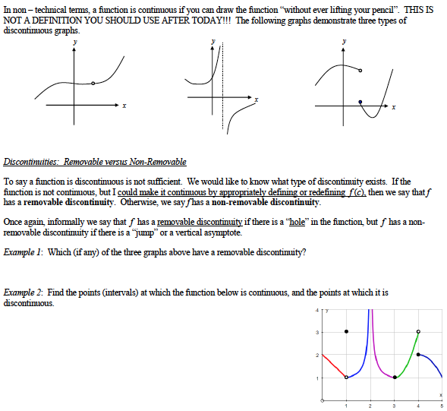
Continuity at a point c:
A function f is continuous at a point c iff:
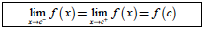

Example: Determine if h is continuous at 1.
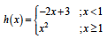

Note: This definition assumes that c is not an end value of a closed domain…we can easily see what it would be for the end values… (one sided limit available only…)

Continuity of a function:
A function is called continuous if it is continuous at every point in its domain.

Examples: Determine if the following functions are continuous or not.
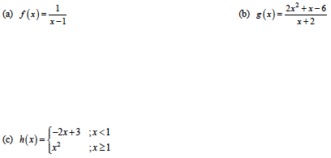
Examples: Determine the value of the constant a or k so that the following functions are continuous on their domain.
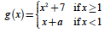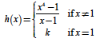

Properties of Continuous functions:
- If f and g are continuous at x = c, then the following combinations are continuous at x = c:
a) sums: $f+g$
b) Difference: $f-g$
c) Products: $f.g$
d) Constant multiples: $k.f$ for any number k
e) Quotients : $\frac{f}{g}$ provided that $g(c)≠0$
- If f is continuous at c and g is continuous at f(c), then the composite $g∘f$ is continuous at c.

Example: Show that $y=\left|\frac{x.sinx}{x^{2}+2}\right|$ is continuous

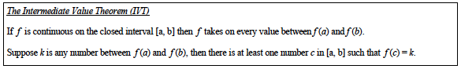

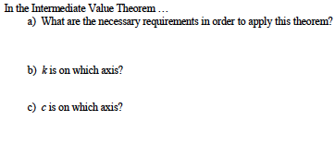

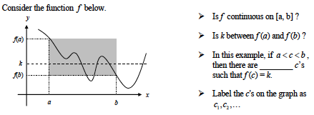

Example: Let $f\left(x\right)=\frac{x^{2}}{x-1}$. Verify that the Intermediate Value Theorem applies to the interval $\left[\frac{5}{2},4\right]$
and explain why the IVT guarantees an x-value of c where $f\left(c\right)=5$.

Hwk: worksheet + textbook p 84 # 1 – 36; 47 – 50;
2.4 – Rates of Change and Tangent Lines

Calculus will be used a lot for optimization. When given a curve, it is going to be important to see “how fast” the curve is increasing or decreasing. For a straight line, this information is given by the slope, but for a curve, it’s not as clear…

The idea is to consider that the curve is best approximated at a point by its tangent line at this point.
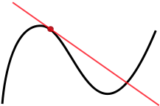

There is no good geometric definition of a tangent line to a curve at a certain point. We usually say that it’s the best linear approximation of the curve at this point, and that it touches the curve only once around the point of tangency, but it’s not rigorously true…

In order to determine the equation of a tangent line at a certain point P on a curve, we need to determine its slope.

The slope of a tangent line of a curve is the limit of the slopes of the secant lines close to that point…
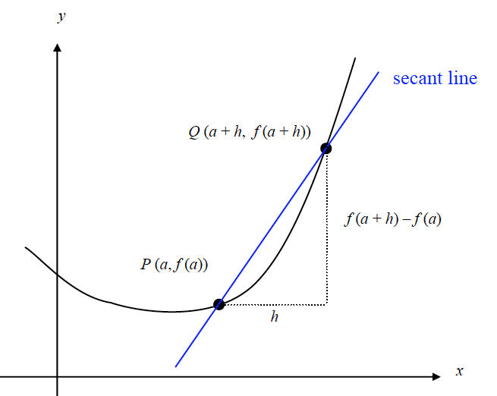

The slope of the tangent line of a curve $y=f(x)$ at a point $P(a, f\left(a\right))$ is the number:

$\lim_{h→0}{\frac{f\left(a+h\right)-f(a)}{h}}$

Provided the limit exists…

Your goal is to simplify this quotient until you have cancelled algebraically the h on the denominator in order to determine the limit…

Examples:
- $f\left(x\right)=2x^{2}-5$ slope of the tangent line at point $P(1;-3)$.
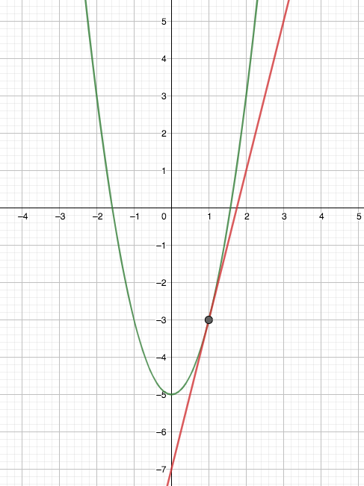
- $g\left(x\right)=x^{3}-1$ slope of the tangent line at point $P(1;0)$.
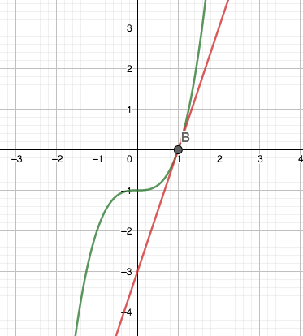
If the limit doesn’t exist, it can be because the curve has a vertical tangent line or because the function isn’t continuous at that point or if there is a corner.
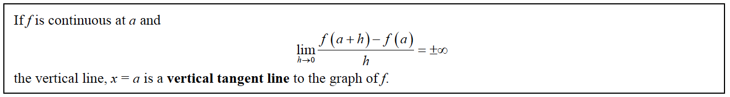

Types of graphs that have a vertical tangent line: Graphs with a corner (no tangent line at that pt)
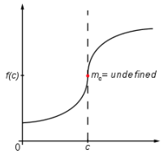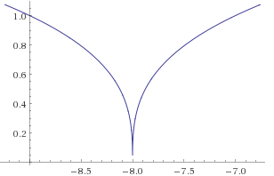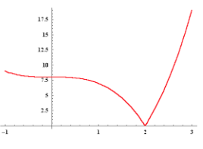
Important connection: Average and Instantaneous velocity:
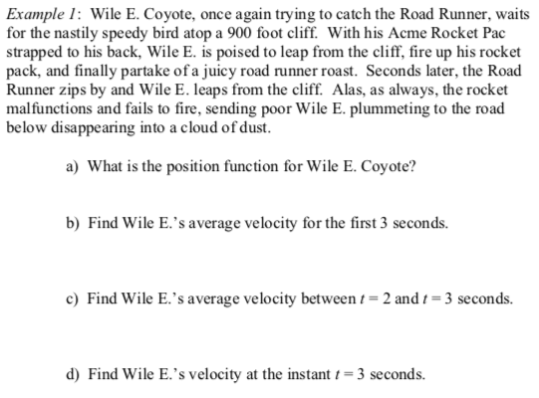

Hwk: worksheet 2.1 # 3, 4, 5, 16 - 2.4 # 11

Normal line to a curve:

Reminder: Two lines are perpendicular if their slopes are opposite reciprocals…

Example: Let $f\left(x\right)=\frac{1}{x+1}$
