Chapter 2 TEST
Graphing Calculators not allowed

- Consider the following graph of a function f :
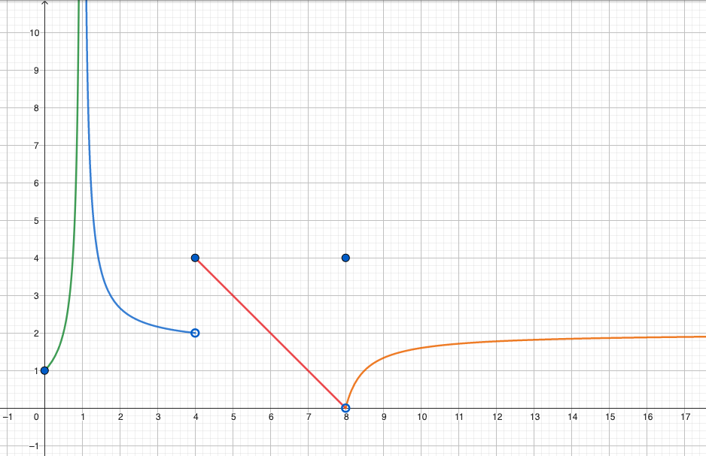
a) Determine the equations of all of its asymptotes. [1]
b) What is the domain of f? [1]
c) Where is the function discontinuous on its domain? [1]
d) Determine the following limits and values if they exist: [4]
i) $\lim_{x→1}{f(x) }$ v) $f(4)$
ii) $\lim_{x→8}{f(x) }$ vi) $f(8)$
iii)$\lim_{x→4^{+}}{f(x) }$ vii) $\lim_{x→4}{f(x) }$
iv) $\lim_{x→4^{-}}{f(x) }$ viii) $\lim_{x→∞}{f(x) }$
- A particle is moving along the x-axis so that at a time t (in seconds), it is at a position [3]
$x=3t^{2}-12t+1$(in metres).
a) Find its average velocity in the first 3 seconds.
b) Find its instantaneous velocity at time $t=1$.
c) In which direction is it moving at time $t=1$?
d) On which side of the origin is it at time $t=1$?
- Let $f\left(x\right)=\sqrt{x}$. [4]
a) Determine its slope at $x=a$.
b) Determine its slope at $x=4$.
c) Determine the equation of the tangent line at $x=4$.
d) Determine the equation of the normal line at $x=4$.
- Use the IVT to prove that the equation $x^{3}-4x=1-x^{2}$ is solvable. [2]
- Determine the following limits [16]
a) $\lim_{t→-4}{\frac{t^{2}}{4-t}}$
b) $\lim_{x→∞}{(\ln{x }-x)}$
c) $\lim_{x→-2}{\frac{x^{2}+2x}{x^{2}-4}}$
d) $\lim_{h→2}{\frac{1}{4-h^{2}}}$
e) $\lim_{x→2}{\frac{\left|x-2\right|}{x-2}}$
f) $\lim_{t→0}{\frac{t}{\sqrt{4+t}-\sqrt{4-t}}}$
g) $\lim_{s→0}{\frac{{\left(s+1\right)}^{2}-{\left(s-1\right)}^{2}}{s}}$
h) $\lim_{x→0}{\frac{sin⁡(2πx)}{sin⁡(3πx)}}$
i) $\lim_{x→1^{-}}{\frac{sin\sqrt{1-x}}{\sqrt{1-x^{2}}}}$
j) $\lim_{x→∞}{\frac{x^{3}-5x^{2}+7}{8+2x-5x^{3}}}$
k) $\lim_{x→∞}{\frac{e^{x}-x^{2}}{e^{x}+x^{5}}}$
l) $\lim_{x→-∞}{\frac{x^{2}+3}{x^{3}+2}}$
m) $\lim_{x→3}{\frac{1}{3-x}}$
n) Let $\left\lfloor x\right\rfloor$ be the greatest integer function.
$\lim_{x→3^{+}}\left\lfloor x\right\rfloor$ $\lim_{x→3^{-}}\left\lfloor x\right\rfloor$ $\lim_{x→3}\left\lfloor x\right\rfloor$
p) $\lim_{x→∞}{\frac{4\sin{x}}{x}}$
q) $\lim_{x→-∞}{[x+\sqrt{x^{2}-4x+1}]}$
- For each function, determine k such that it is continuous on its domain. [3]
a) $f\left(x\right)=\left\{\begin{aligned} \frac{e^{x}\tan{x}}{2x} , if -\frac{π}{2}<x<0 \\ k , if x≥0\end{aligned}\right.$
b) $g\left(x\right)=\left\{\begin{aligned}x-k , if x<3 \\ 1-kx , if x≥3\end{aligned}\right.$
- TRUE or FALSE? [3]
If TRUE, no explanation is needed.
If FALSE, give a counterexample (expression or graph)
a) If $\lim_{x→a}{f(x) }$exists, but $\lim_{x→a}{g(x) }$does not exist, then $\lim_{x→a}\left(f\left(x\right)+g(x)\right)$does not exist.
b) If neither $\lim_{x→a}{f(x) }$nor $\lim_{x→a}{g(x) }$exists, then $\lim_{x→a}\left(f\left(x\right)+g(x)\right)$does not exist.
c) If f is continuous at a, then so is $\left|f\right|$
d) If $\left|f\right|$ is continuous at a, then so is f.

