3.1 – Derivative of a function

In the last chapter, we used a limit to determine the slope of a tangent line. The slope of a tangent line is a precious information to have about a curve. It tells us if the curve is increasing or decreasing (sign of the slope) and it helps us find out maximum or minimum points.

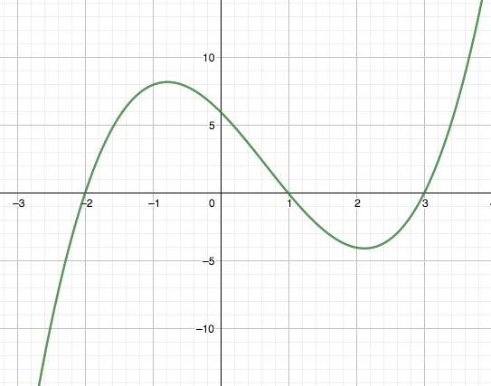

The derivative of a function is another function that gives us for each value of x in the domain the slope of the tangent line at that point. It is noted $f'$.

Definition of the derivative of a function f:
$f^{'}\left(x\right)=\lim_{h→0}{\frac{f\left(x+h\right)-f(x)}{h}}$, provided the limit exists.

Anywhere that the derivative exists, we say that the function is differentiable.

Examples: Use the definition of the derivative to determine the derivative of the following functions:
- $f\left(x\right)=3x-2$
- $g\left(x\right)=3x^{2}-5x+1$

Note: Other notation for the derivative: y’, $\frac{dy}{dx}$, $\frac{d}{dx}f(x)$, $\frac{df}{dx}$

Alternate definition of the derivative:
$f^{'}\left(x\right)=\lim_{c→x}{\frac{f\left(x\right)-f(c)}{x-c}}$ , provided the limit exists.
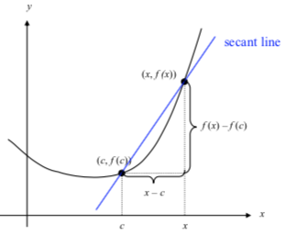

Example: Use the alternate definition of the derivative to determine the derivative of $f\left(x\right)=\sqrt{x}$

The graphs of f and f ‘ are related but don’t look similar at all…

Examples: Given the graphs of these two functions, graph their derivatives on the same axis:
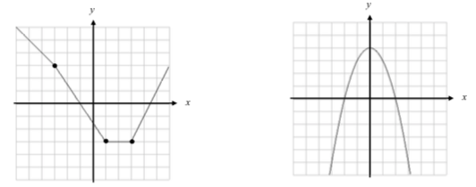

From the graph of the function it is possible to graph its derivative, but from the graph of a derivative, there are several possible functions…

Example:
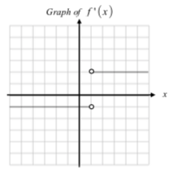
Possible graph of f Another possible graph of f

Another example: Suppose the graph below is the graph of the derivative of h.

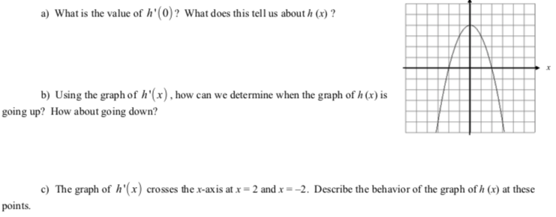

We can already remember that:

When the slope of the tangent line (the derivative) is positive, the function is increasing.
When the slope of the tangent line (the derivative) is negative, the function is decreasing.

Equation of a tangent line at a point a: $y=f^{'}\left(a\right)\left(x-a\right)+f(a)$

It comes from the point slope form: $y-y_{P}=m\left(x-x_{P}\right)$

Hwk: worksheet
textbook
3.2 - Differentiability

Reminder:
Definition of the derivative of a function f:
$f^{'}\left(x\right)=\lim_{h→0}{\frac{f\left(x+h\right)-f(x)}{h}}$, provided the limit exists.

Anywhere that the derivative exists, we say that the function is differentiable.

There are 3 types of situations when a function won’t be differentiable at a point:

If a function isn’t continuous at a certain point, it isn’t differentiable at that point.
If the tangent line of a function is vertical at a certain point, the function isn’t differentiable at that point.
If the tangent line on the right side of a point is different than the tangent line on the left side of that point, then the function isn’t differentiable at that point… (corner)
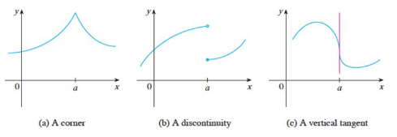
Note: * If a function is differentiable, then it is continuous. (true statement)
* If a function is not continuous, then it is not differentiable (equivalent contrapositive statement)
* But if a function is continuous, it doesn’t mean that it is differentiable! (which means that the converse statement is false. The converse statement is when you exchange the hypothesis and the conclusion. Here it woud be: “if the function is continuous, Then it is differentiable”. But, it is NOT true!)

If a statement is true, its contrapositive is also true, but its converse is not necessarily true…
Ex: Statement: if a figure is a square, then it has 4 sides
Contrapositive:
Converse:

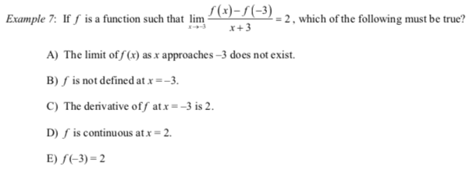
On your Graphing Calculator:
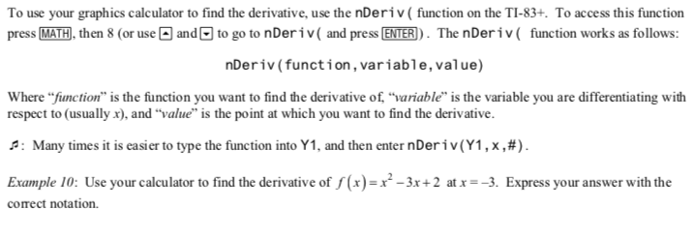
Note: Your calculator use another alternate definition of the derivative that doesn’t work if the point considered is an end point of the domain…

Hwk: Worksheet +

3.3 Rules for Differentiation

Determining the derivative of a function is a lot of work if we always go back to the definition of the derivative…
Instead, we’re going to memorize the derivative of most usual functions as well as some rules regarding operations of functions $\left(±, ×, ÷,∘\right)$.
Remember that additions and subtractions are intuitive, but products and quotients are not…

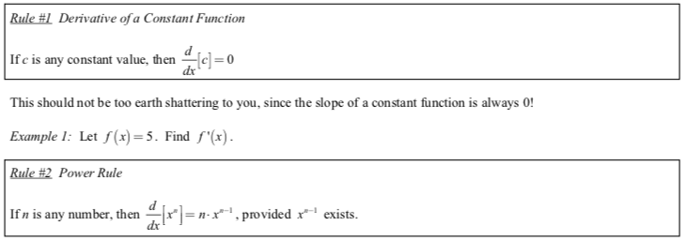

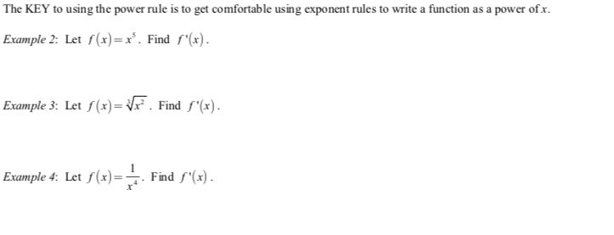
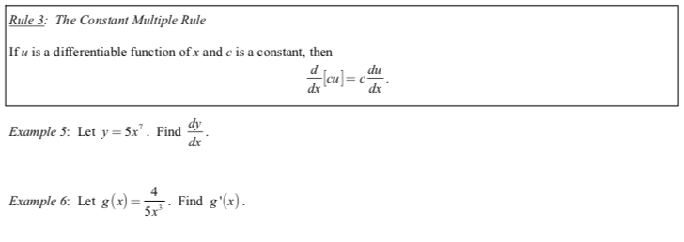

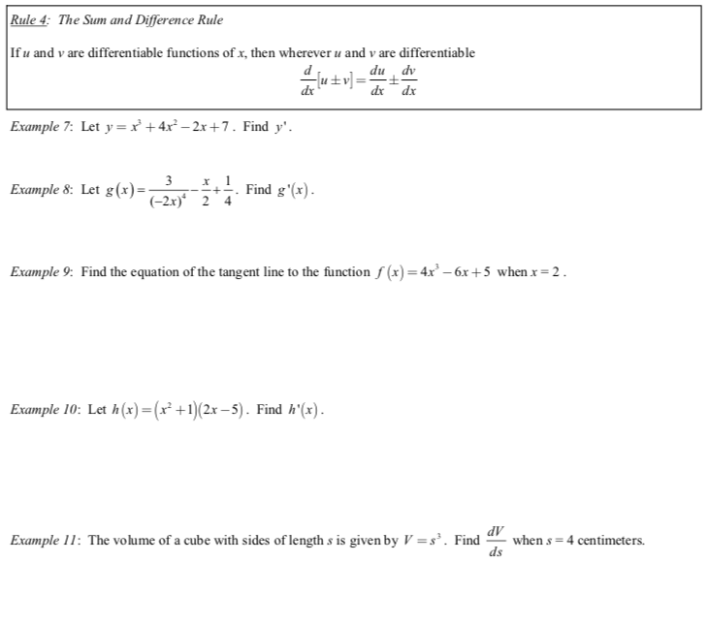
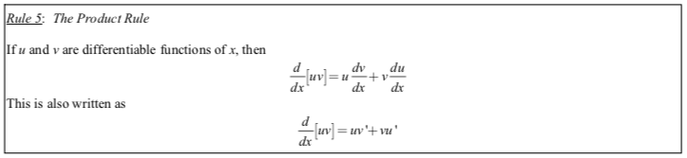

Examples: Find the derivative without using the product rule, and then with the product rule:
a) $f\left(x\right)=(2x+3)(4x^{2}-5)$
b) $y=(3+2\sqrt{x}$)$(5x^{3}-7)$
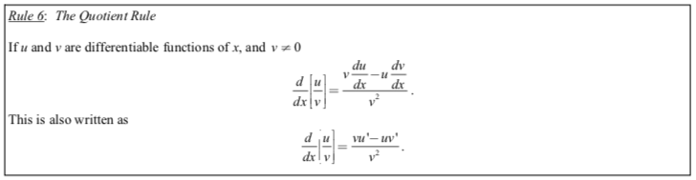

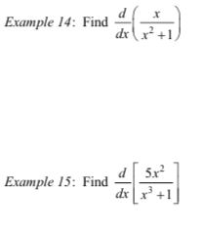

Higher Derivatives:

We can also talk about the derivative of the derivative (we call it second derivative) and so on…

Here are all the notations:
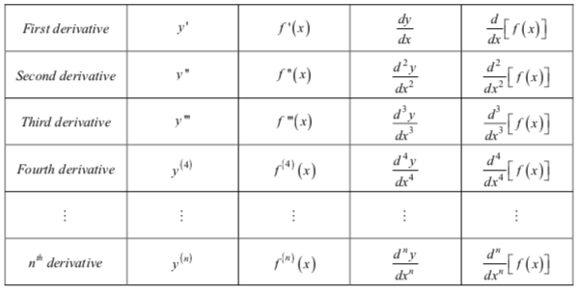
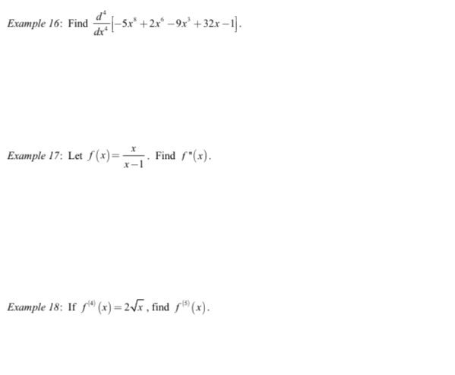

Hwk: worksheet +

3.4 – Velocity and Other Rates of Change

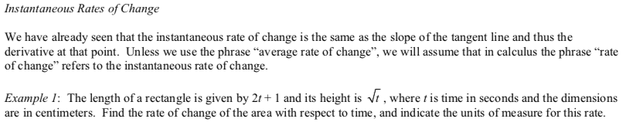

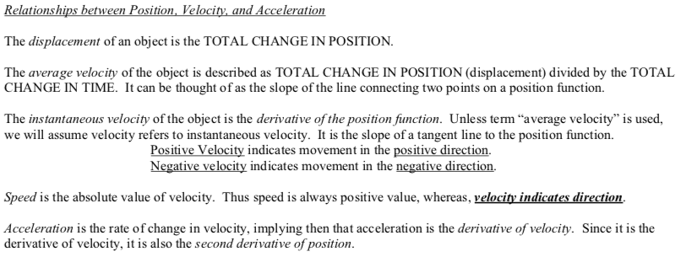

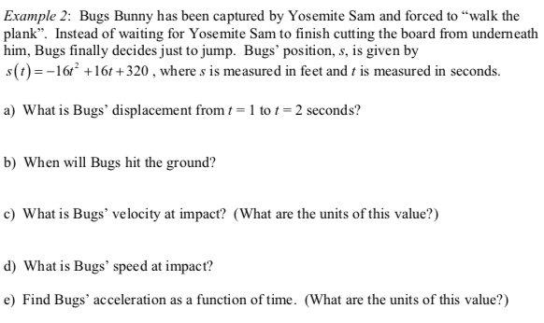

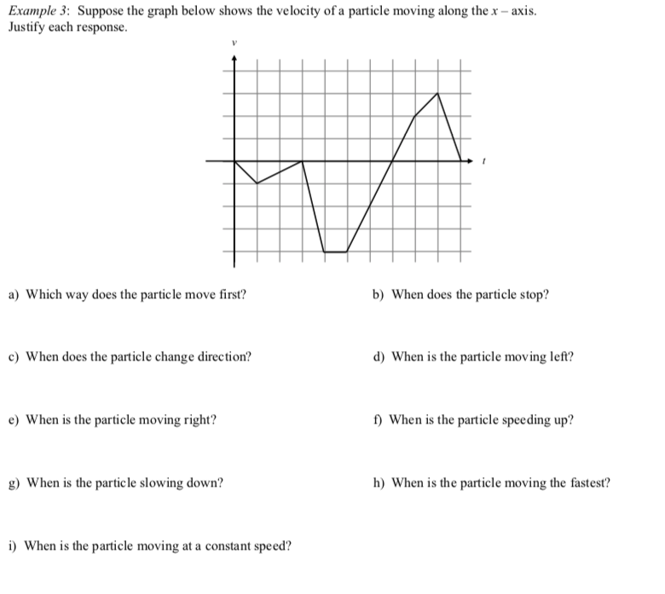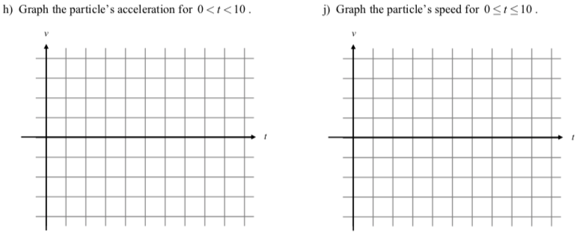Important notes:
- The unit for f ’(x) is the unit for f divided by the unit for x.
Example: If f gives you a distance in km, and x is time in hours, then the unit for f ‘(x) is km/h.
If f gives you a speed in km/h, and x is time in hours, then the unit for f ‘(x) is km/h².
- The derivative of the position function, is the speed.
The derivative of the velocity function is the acceleration. $p^{'}=v$ $v^{'}=a$
- A particle is speeding up if the velocity and the acceleration have the same sign.

Derivatives in Economics:

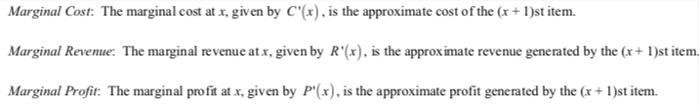

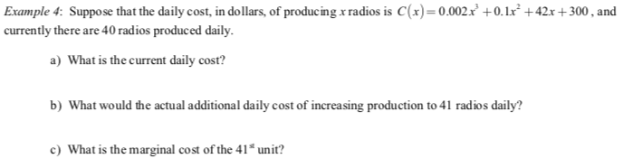

3.5 – Derivatives of Trigonometric Functions

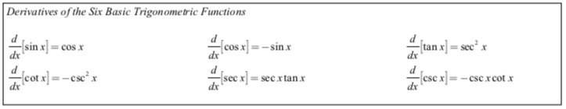

Demos: (sin and cos using conjugate expressions and sinh/h + tan)

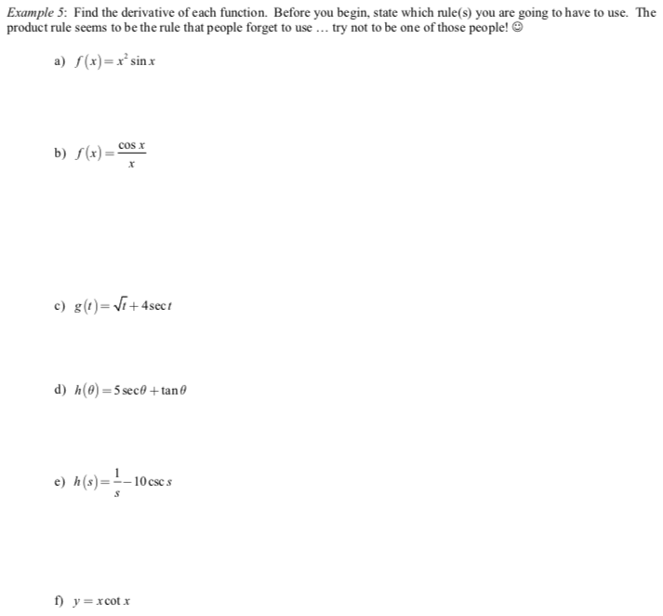

Example with the TI 83 or 84:

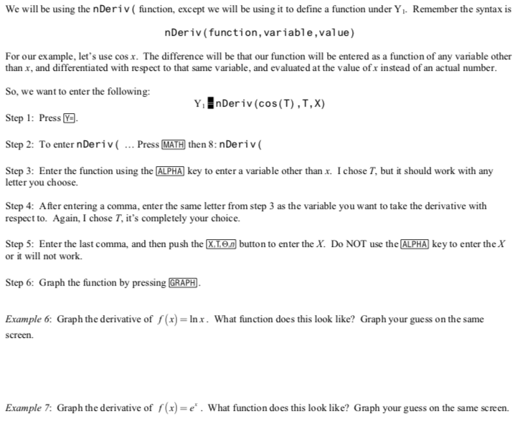

3.6 – The Chain Rule

We can now differentiate many usual functions without having to go back to the definition. And we can also differentiate their products, quotients, …
We are now going to learn how to differentiate composite functions (when an usual function is “inside” an other usual function). For example: $f\left(x\right)=\sqrt{2x-3}$. We will call the method used “The Chain Rule”.

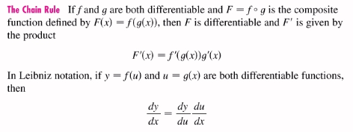

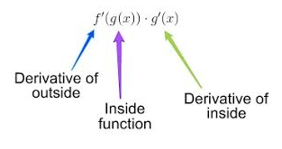

Examples:
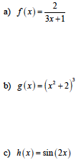
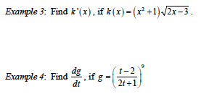

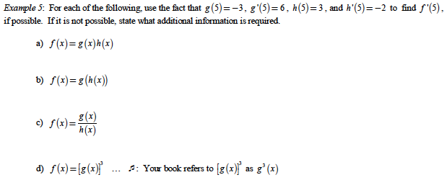

3.7 – Implicit Differentiation

Equations that are solved for y are called explicit functions (ex: $y=3x-5$).
Equations that are not solved for y are called implicit functions (ex: $2x-3y+5=0$).

So far, we have only differentiated functions that were explicit.
We can also differentiate functions that are implicit by differentiating both sides of the equation and solving what we get for y’ (or $\frac{dy}{dx}$).
BE CAREFUL, when differentiating, don’t forget that y is a function of x…

Examples: Differentiate:
- $2x-3y+5=0$.
- $x^{2}+y^{3}=2x$
- $3xy=\sqrt{y}$
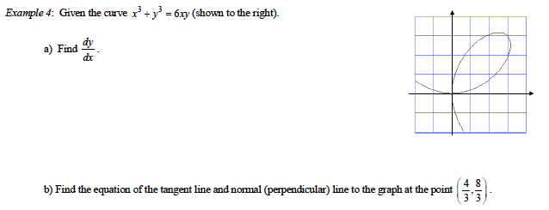

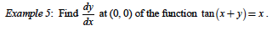

3.8 – Derivatives of Inverse Trigonometric Functions

Implicit differentiation allows us to determine the derivatives of Inverse trigonometric functions.

Example: Suppose $y=\sin^{-1}x$. Determine $\frac{dy}{dx}$. (Be careful, domain must be restricted for y to be a function…)

Note: $\sin^{-1}x$ is the same thing as $arcsin⁡(x)$.

We won’t reprove each formula, but we will commit them to memory:

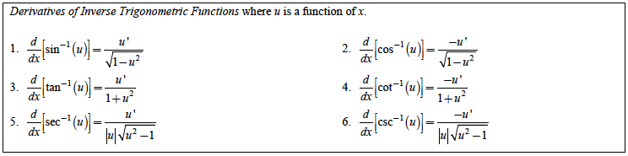

Examples: Find the derivatives of:
- $f\left(t\right)=\sin^{-1}(t^{2})$ b) $y=\tan^{-1}\left(\sqrt{x-1}\right)$

Derivative of an Inverse function: $\frac{df^{-1}}{dx}\left(x\right)=\frac{1}{f'(f^{-1}\left(x\right))}$

Notation: If you evaluate a derivative at a certain point x = a, you can write $f'(a)$ or ${\left.\frac{df}{dx}\right|}_{a}$. You will see both notations in the textbook.

With that new notation, the previous formula becomes: 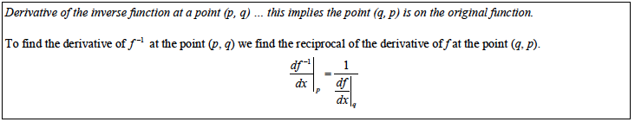

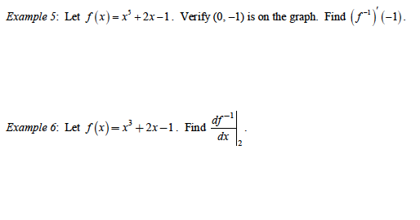
3.9 – Derivatives of Exponential and Logarithmic Functions

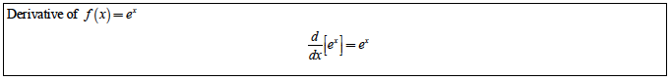

Examples: Determine the derivatives of:
- $f\left(x\right)=3e^{x}+5x+3$ b) $g\left(x\right)=e^{x}\sqrt{x^{2}-1}$

c) $h\left(x\right)=e^{2x-1}$ d) $k(x)$ = $3e^{\frac{-1}{x}}$

Note: Derivative of other exponential functions: $y=a^{x}$
You can always rewrite an exponential function in base e by noticing that $a=e^{lna}$

Examples: Determine the derivatives of:
a) $f\left(x\right)=3^{x}$ b) $g\left(x\right)=5^{2x+1}$

- $h\left(x\right)=a^{x}$

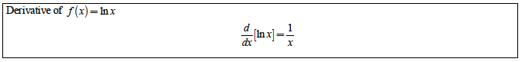

Examples: Determine the derivatives of:
- $f\left(x\right)=ln⁡(3x-5)$ b) $g\left(x\right)=\frac{(2x+1)}{ln⁡(5x)}$

c) $h\left(x\right)=ln⁡(tanx)$

Note: Derivatives of other logarithmic functions: $y=\log_{a}x$
You can always rewrite a log expression in ln using: $\log_{a}x=\frac{lnx}{lna}$

Examples: Determine the derivatives of:
- $f(x)=\log_{4}x$ b) $y=5\log_{3}(2x+1)$

c) $y=\log_{a}x$

Logarithmic Differentiation:

When expressions are very complicated with many products and exponent rules, it is sometimes easier to compose the function by ln in order to benefit from the log laws…

Example: Determine the derivatives of: $y=\frac{\sqrt[3]{5x} ∙ e^{2x^{2}}}{{5x}^{3}}$

