4.1 – Extreme Values of Functions

When describing a graph, we need to distinguish absolute and relative extrema (min and max).

Example:
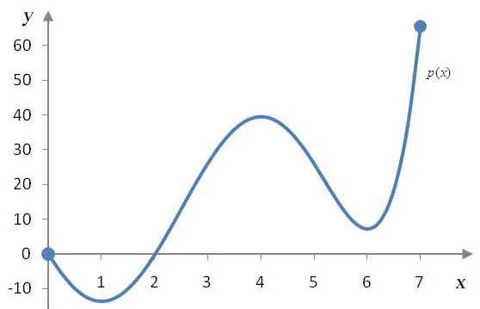

An absolute maximum is a value that is max on the whole domain.
A relative or local maximum is a value that is maximum on an open interval around it.

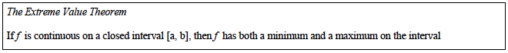

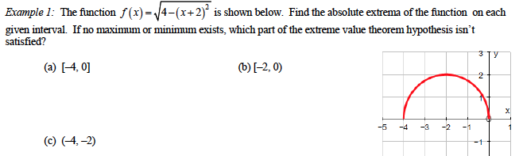

Critical Points: We call critical point a point where something happens on the graph (a change in direction for example).

Let f be a function defined at a point c.
c is a critical point if $f^{'}\left(c\right)=0$ or if $f'$ is undefined at c.

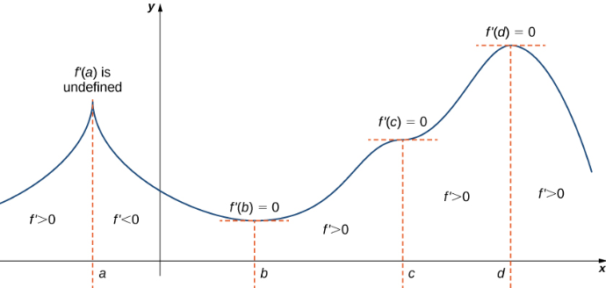

To find absolute/local extrema, you can:
- Determine the critical points.
- Compare the values of the function at all the critical points as well of the end points of the domain (or limits if relevant)

Examples: Find the extrema for the following functions:
- $f\left(x\right)=3x^{4}-4x^{3}$
- $g\left(x\right)={\left(x+2\right)}^{\frac{2}{3}}$
- A rectangle is bounded by the x – axis and the semicircle $y=\sqrt{25-x^{2}}$. What length and width should the rectangle have so that its area is a maximum?

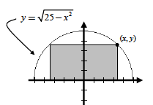

4.2 – Mean Value Theorem

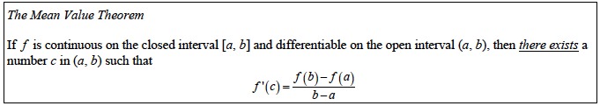

Basically, the Mean Value Theorem says that the average rate of change over the entire interval is equal to the instantaneous rate of change at some point in the interval. It’s an existence theorem. It doesn’t say when, it just says that at some point, it happens.
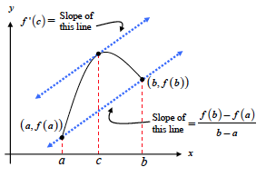
Examples:
1) Apply the MVT to the function $f\left(x\right)=x(x^{2}-x-2)$ on the interval [-1; 1]
2) A plane begins its takeoff at 2:00pm on a 2500-mile flight. The plane arrives at its destination at 7:30pm (ignore time zone changes). Explain why there were at least two times during the flight when the speed of the plane was 400 miles per hour.

Test for Increasing and Decreasing Functions:

Let f be a function continuous on an interval $[a;b]$ and differentiable on $(a;b)$

- f is increasing on $[a;b]$if $f^{'}\left(x\right)>0$ for all x in $(a;b)$ except potentially on a finite number of points (where it could be 0).
f is decreasing on $[a;b]$if $f^{'}\left(x\right)<0$ for all x in $(a;b)$ except potentially on a finite number of points(where it could be 0).
f is constant on $[a;b]$if $f^{'}\left(x\right)=0$ for all x in $(a;b)$.

The critical points are the points where your graph might change direction. Therefore, to determine the variations of your function, you should:
- determine its domain.
- find the critical points.
- Determine the sign of the derivative in between each critical point and end points.
- Determine the extrema values as well as the limits.

All this information should be summarized in a variation table. BUT the table is not an acceptable answer on the exam and on tests. You MUST write a sentence to give your answer and justify it.

Examples: Determine the variations of
1) $f\left(x\right)=4x^{3}-15x^{2}-18x+7$.

2) $g(x)={\left(x^{2}-9\right)}^{\frac{2}{3}}$

Antiderivatives:
If you are given the derivative of a function, the action to determine the original function is called antidifferentiation or finding the antiderivative.

Example: Suppose that $f^{'}\left(x\right)=2x+3$, what could f be?

IMPORTANT: A function never has only 1 antiderivative. They all differ by a constant.
You need to be given one more info about the function in order to determine that constant.

Example: Suppose that $f^{'}\left(x\right)=2x+3$, and that $f\left(0\right)=2$ what could f be?

4.3 – Connecting f ’ and f’’ with the graph of f

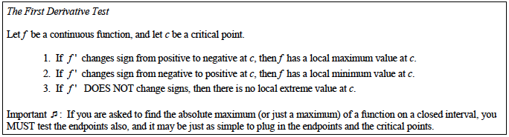

Concavity:

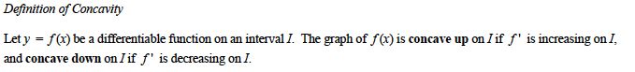

In other words:

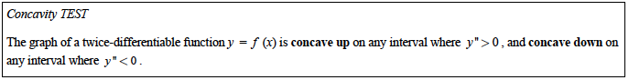

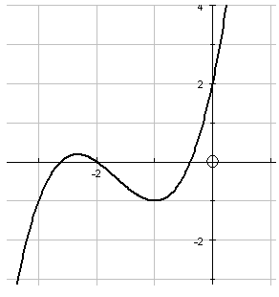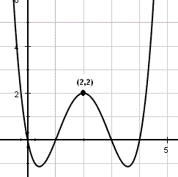
Example: Determine the variations and the concavity of $f\left(x\right)=x^{4}-4x^{3}$.

Points of Inflection:

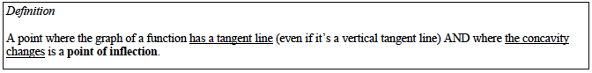

In other words, a point of inflection is when changes signs.

Example: Determine the points of inflection of $f\left(x\right)=3x^{5}+10x^{4}+15x+7$.

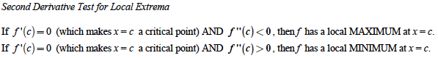

Example: Use the second derivative test to identify any local extrema of $f\left(x\right)=-x^{4}+4x^{3}-4x^{2}+1$.

4.4 – Modeling And Optimization

In order to optimize a quantity, make a drawing when you can, and you need to express this quantity as a function of only 1 variable in order to determine its extrema values…

Example 1:
An open top box is going to be made by cutting equal squares out of the four corners of a 20x25 cm piece of paper. What size square should be cut out of the paper to make a Maximum volume?

Example 2:
A rectangle is going to be inscribed under one arch of the sine curve. One side of the rectangle will be on the x-axis. What is the largest area the rectangle can have and what are the dimensions of that area?

Example 3:
Suppose that $r(x)=9x$ is the revenue function and $c\left(x\right)=x^{3}-6x^{2}+15x$, the cost function for a business, where x represents thousands of units produced and r and c are in thousands of dollars.
Is there a production level that maximizes profit? If so, what is it?

Example 4: It can get very complicated…
A cone is constructed from a flat, circular disk of radius 4cm, by removing a sector of arc length x and then connecting the new edges.
What arc length will produce the cone of maximum volume? And what is that volume?

4.5 – Linearization and Newton’s Method

Linearization:

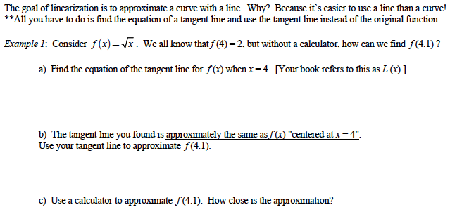

Example 2: Find the linearization of $f\left(x\right)=cosx$ at $x=\frac{π}{2}$, and use it to approximate $cos1.75$ without a calculator. Then use your calculator to determine the accuracy of the approximation.

4.6 – Related Rates

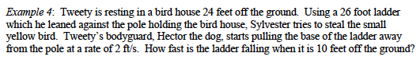

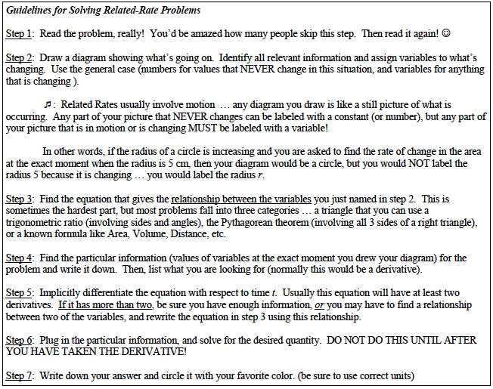

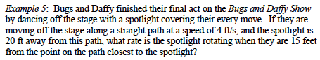

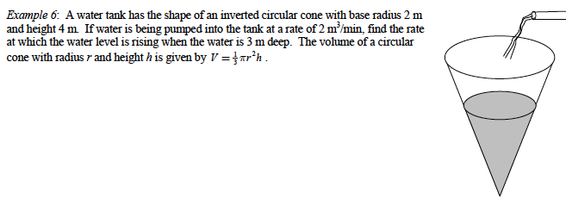

8.2 – L’Hôpital’s Rule

We can use derivatives to determine limits when it’s an indeterminate form like $"\frac{0}{0}"$.

L’Hôpital’s Rule:
Suppose that $f\left(a\right)=g\left(a\right)=0$ and $g'(a)$ exists, and that $g'(a)≠0$.

Then, $\lim_{x→a}{\frac{f(x)}{g(x)}=\frac{f'(a)}{g'(a)}}$.

Example: Determine $\lim_{x→0}{\frac{\sqrt{1+x}-1}{x}}$ using l’Hôpital’s Rule.
L’Hôpital’s Rule (stronger form):
Suppose that $f\left(a\right)=g\left(a\right)=0$, that f and g are differentiable on an open interval I containing a,
and that $g'(x)≠0$ on I if $x≠a$.

Then, $\lim_{x→a}{\frac{f(x)}{g(x)}=\lim_{x→a}{\frac{f'(x)}{g'(x)}}}$.

Example: Evaluate $\lim_{x→0}{\frac{\sqrt{1+x}-1-x/2}{x^{2}}}$
L’Hôpital’s Rule (for indeterminate forms like $\frac{∞}{∞}$):
Suppose that $\lim_{x→a}{f\left(x\right)=\lim_{x→a}{g(x)}=∞}$, that f and g are differentiable on an open interval I containing a,
and that $g'(x)≠0$ on I if $x≠a$.

Then, $\lim_{x→a}{\frac{f(x)}{g(x)}=\lim_{x→a}{\frac{f'(x)}{g'(x)}}}$.

Example: Determine
- $\lim_{x→\frac{π}{2}}{\frac{secx}{1+tanx}}$ 2) $\lim_{x→∞}{\frac{lnx}{2\sqrt{x}}}$

Hwk: p 450 #

