Chapter overview

In this chapter we will see that for some situations, we need to calculate the area between the x-axis and a curve.
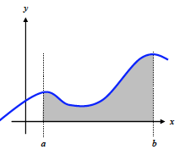
We will learn how to approach it geometrically (Riemann Sums) and realize that a limit will give us the exact area (The definite integral). 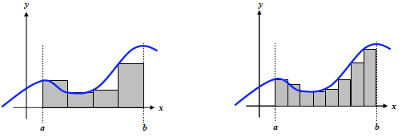 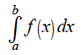
We will then realize that the definite integral is closely linked to antiderivatives.
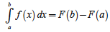
We will work more deeply on antiderivatives in chapter 6…

5.1 – Estimating with Finite Sums

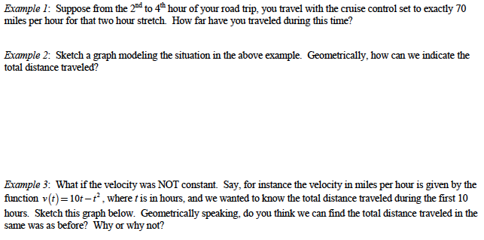

If we are given the graph of a rate of change (like velocity in miles per hour) we will be able to find the accumulated change over an interval (like total distance traveled in miles) by finding the area under the curve.

We will now see different ways to approximate the area under a curve (or more specifically the area between the x-axis and the curve between 2 values of x).

Note that it will be an algebraic area (which means that it can be positive or negative) as opposed to a geometric area that is always positive. It will be negative if the curve is below the x-axis, and positive if it is above.
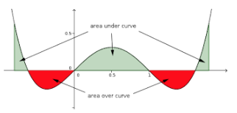

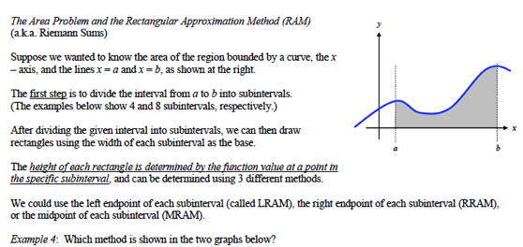

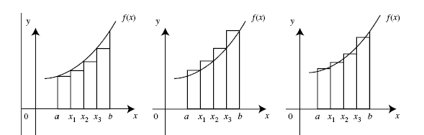

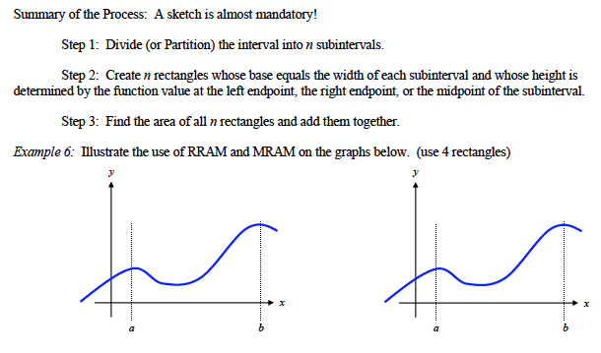
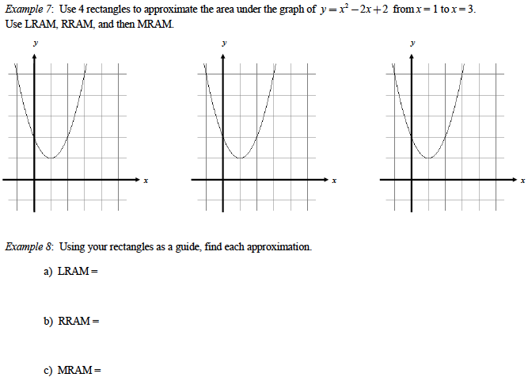
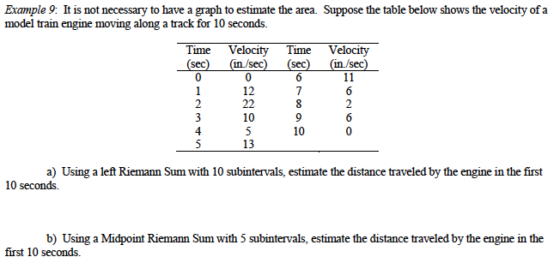

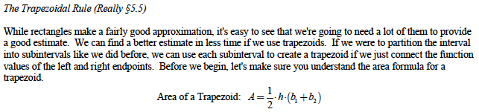
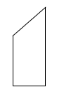

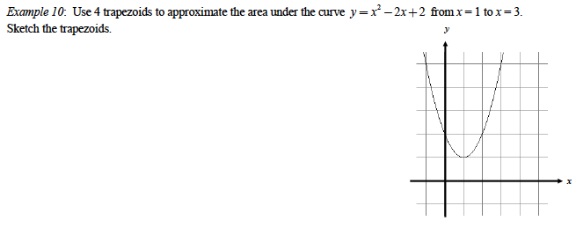
5.2 - Definite Integrals

The trapezoid approximation is a great one, but it’s still not giving us an exact value of the area… No matter which approximation we use, the more subintervals we use, the better the approximation.
The exact value would be if we could have an infinity of subintervals with an infinitesimally small width… The way to do it, would be to divide the interval into n subintervals and take the limit of the approximation as n approaches infinity.

Definition of the Definite Integral:
The definite integral of f(x) over [a,b] is the limit of Riemann Sums:
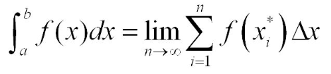
where n is the number of subintervals, $f\left(x_{i}\right)$ is any value of the function on the i^{th} subinterval, and $Δx$ is the length of the subintervals (assuming they are all the same).

If the subintervals are not all the same, we write:
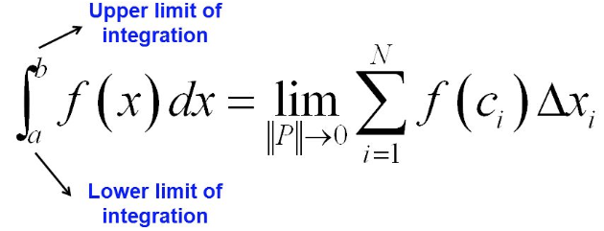
where $\left\|P\right\|$ is the maximum width of the subintervals, $f\left(c_{i}\right)$ is any value of the function on the i^{th} subinterval, and $Δx_{i}$ is the length of the i^{th} subinterval.

Where the limit exists, we say that f(x) is integrable over [a,b].

Note: The sigma notation $Σ$ that means “sum” is replaced by $∫$ which can also be interpreted as “sum” but for an infinity of infinitely thin “sticks” on the graph…

Examples from the AP exam:

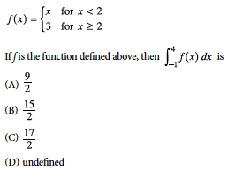
- 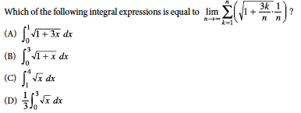
On the exam, you will be asked to calculate a Riemann sum with 4 or 5 subintervals to make sure you understand how it works, or you will be asked to recognize an integral as a limit of Riemann sums (like in the previous example), but that’s it. You won’t be asked to actually find that limit yourself. If you need to evaluate a definite integral, you will do it using usual/easy geometric shapes (like in the following examples).

Important: If the function is continuous over [a,b], then the function is integrable.
But even if the function is not continuous over [a,b], it can still be integrable, as long as the
discontinuity is a hole or a jump.
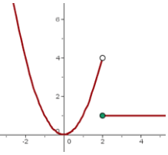

Important (again): The area is an algebraic area that will be positive if the curve is above the x-axis, and negative if the curve is below the x-axis.

Examples: Evaluate

d) $\int_{4}^{8}{(3-x)}dx$ e) $\int_{-5}^{5}{\left(2x-1\right)dx}$
f) $\int_{0}^{3}{f(x)}dx$ with $f\left(x\right)=\left\{\begin{aligned}x if x≥1 \\ -3 if x<1\end{aligned}\right.$

Examples: Given that $\int_{0}^{π}{sinx dx}=2$, use what you know about the sine function to evaluate the following integrals:
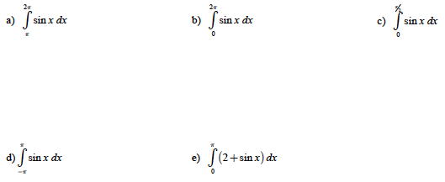

Example: Let $f\left(x\right)=\left\{\begin{aligned}2x+1 if-5≤x≤0 \\ 1 if 0<x≤3 \\ 4-x if 3<x≤5\end{aligned}\right.$.

Calculate with 2 different methods the area between the curve and the x-axis.

Example: Let $g\left(x\right)=\int_{-2}^{x}{w\left(t\right)dt}$, where the graph of w(t) is given by the graph below.

Determine: a) g(0)
b) g(2)
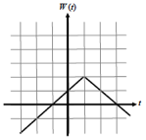

c) g(-3)

Note: In this last example, the definite integral was defining a new function… It happens when the lower limit and/or the upper limit depends on a variable (which has to be different than the variable used in the integrand)

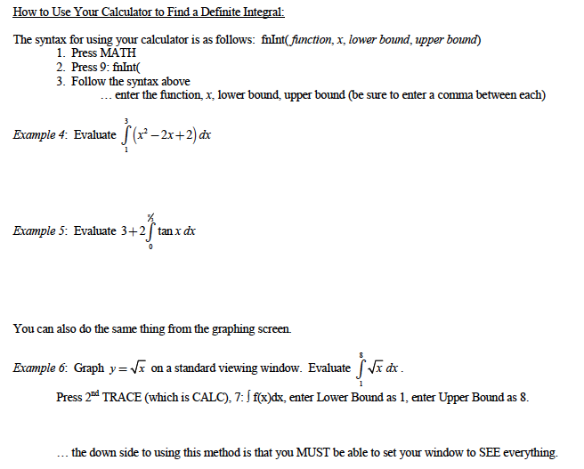

5.3 – Definite Integrals and Antiderivatives

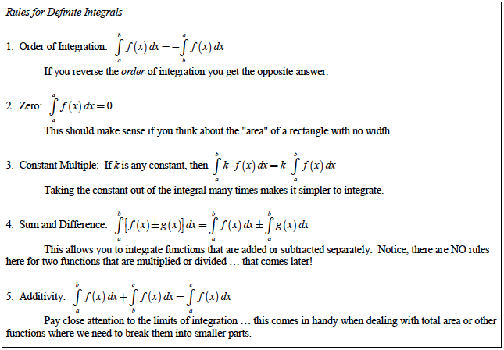

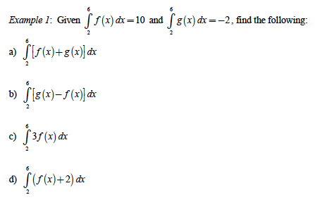
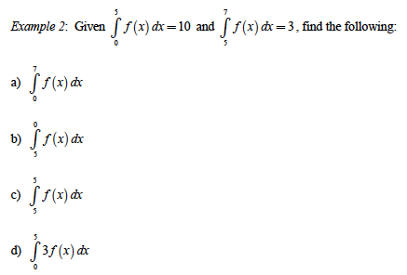

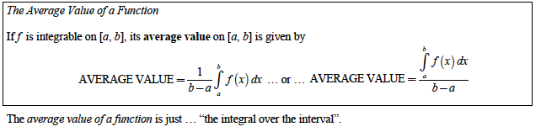

Example: Determine the average value of the function $f\left(x\right)=x^{2}$ between 1 and 5.

Here is another look at the Mean Value Theorem with integral notations…

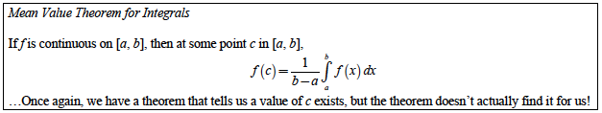

5.4 – Fundamental Theorem of Calculus

The relationship between the definite integral and the antiderivatives is called:

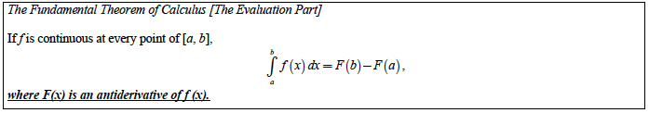

Reminder: F is an antiderivative of f if $F^{'}\left(x\right)=f(x)$.

The set of all antiderivatives of a function $f(x)$ is denoted $\int{f\left(x\right)dx}$ and is called the Integral of f.

A function doesn’t usually have a single antiderivative. All antiderivatives differ by a constant.

$\int{f\left(x\right)dx=F\left(x\right)+C}$, where C is called the constant of integration.
C determines which antiderivative you’re talking about…. You leave it random if you’re talking about all of the antiderivatives in general.

To determine an antiderivative, you need to imagine what function would have the appropriate derivative…

You need to memorize most usual functions’ antiderivatives:

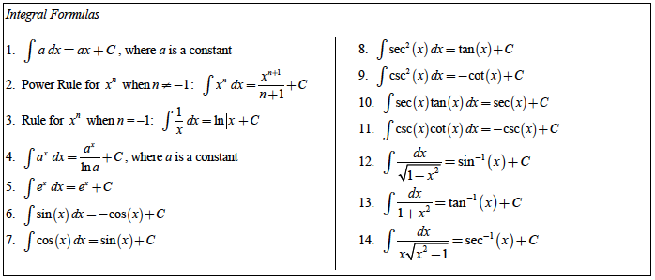

Using these formulas, you can now find the integral of sums and differences of functions, but NOT products, quotients or compositions of functions! We will learn some techniques for products and compositions in the next section…

Examples: Evaluate:
- $\int{\left(\frac{1}{x^{3}}+\frac{1}{x^{2}}+\frac{1}{x}+1+x+x^{2}\right)dx}$ 2) $\int{\left(-x^{-3}+\sqrt[3]{x}-1+e^{x}\right)dx}$

Examples: Use the evaluation part of the Fundamental Theorem of Calculus to evaluate each expression:

e) $\int_{a}^{x}{f^{'}\left(t\right)dt}$ where a is a constant. f) $\frac{d}{dx}\left[\int_{a}^{x}{f^{'}\left(t\right)dt}\right]$, where a is a constant.

