6.1 – Antiderivatives and Slope Fields

Differential equations:

A differential equation is an equation containing a derivative. To solve equations, we usually use an inverse operation to undo what is happening to x. To undo a derivative, we will take an antiderivative. But, we need to be cautious, because a function has many possible antiderivatives, so we will have a constant that can only be determined if we have some more info (like a specific value that the function needs to have…).

The order of a differential equation is the order of the highest derivative involved in the equation.

This year, we will only learn one method to solve differential equation: by separation of variables. It is not always possible…

Examples: solve:
- $\frac{dy}{dx}=sinx$ if $y\left(0\right)=2$ 2) $y^{'}+6x^{2}=e^{x}$

3) $y^{'}=2xy$ if $y\left(3\right)=1$

Slope Fields:

A slope field for the first order differential equation $y'=f(x,y)$ is a plot of short line segments with slope $f(x,y)$ for a lattice of points $(x,y)$ in the plane.
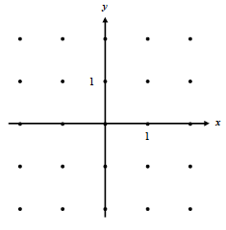

Example: for $\frac{dy}{dx}=2y$

Suppose now that (0;-1) is on the solution of the previous differential equation. By following the slopes, draw on the previous diagram what you think the particular solution looks like (the graph should follow the pattern of the slope field, but may go between the points rather than through them…)

Solve the previous differential equation by separating the variables, and compare with your graph.

Example: Determine the particular solution of the following differential equation, and graph it on the slope field provided.
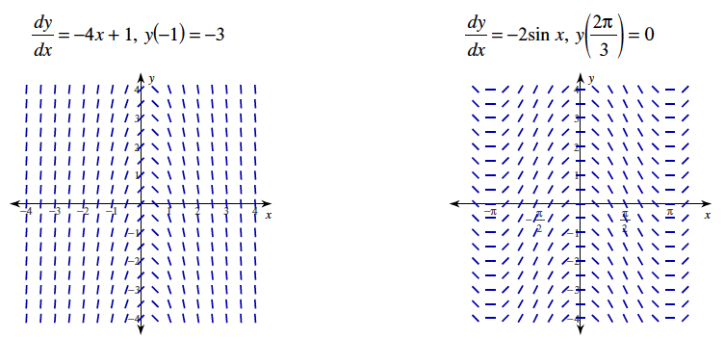
6.2 - Integration by Substitution

We’re trying to undo the chain rule…

Example: Let $f\left(x\right)={(3x^{2}+1)}^{5}$ then, $f^{'}\left(x\right)=5{(3x^{2}+1)}^{4}×6x$ or $f^{'}\left(x\right)=30x{(3x^{2}+1)}^{4}$

Then, by definition, we should have: $\int{30x{(3x^{2}+1)}^{4}dx}= {(3x^{2}+1)}^{5}+C$

How can we find the result on our own? Every time we see a composite function to integrate, it must be multiplied by the derivative of the “inside” function in order to be integrated.

Examples:

Be careful, when substituting by u, all the x must disappear for it to work…
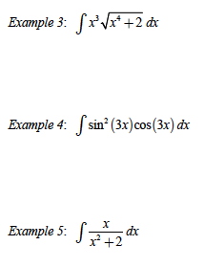

Hwk: worksheet day 1
Here are some examples where substitution works, but not directly…

$$\int{x^{2}\sqrt{x-1}dx}$$

$$\int{x\sqrt{4-x}dx}$$

$$\int{\frac{y}{\sqrt{2y+1}}}dy$$

$$\int{cos^{3}xdx}$$

When substitution doesn’t work, you need to transform your expression into something where it works…
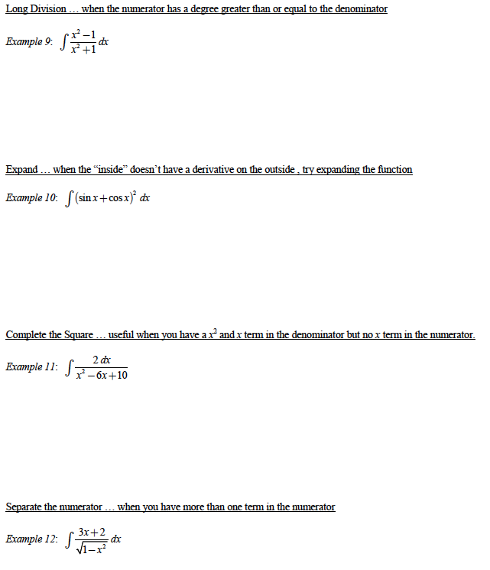
Hwk: worksheet day 2
Here are some examples with trigonometric functions:
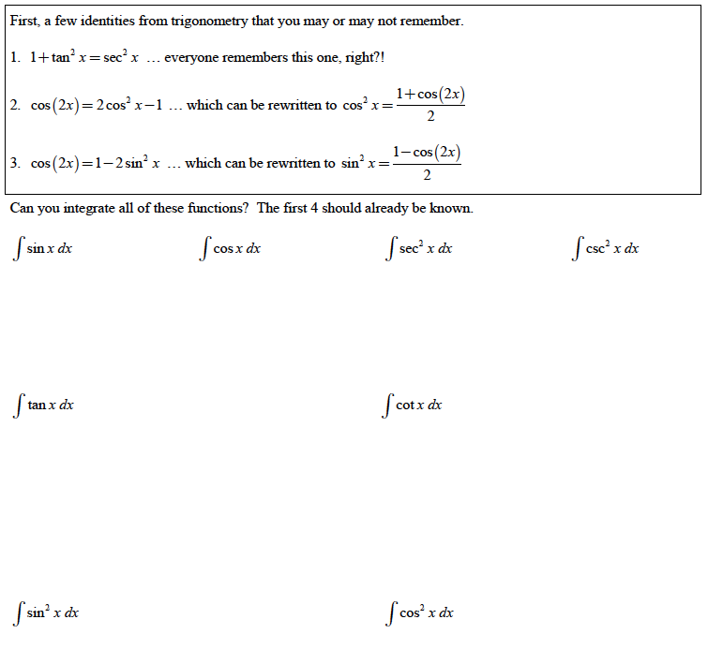

Hwk: worksheet day 3
Definite Integrals with substitution: You have 2 options:

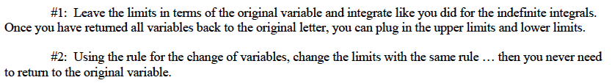

Examples:
- $\int_{0}^{1}{x\sqrt{1-x^{2}}dx}$
- $\int_{-π}^{π}{\frac{cosx}{\sqrt{4+3sinx}}dx}$
- $\int_{0}^{π/4}{\frac{\tan^{3}θ}{\cos^{2}θ}dθ}$

Hwk: worksheet day 4
6.4 – Exponential Growth and Decay

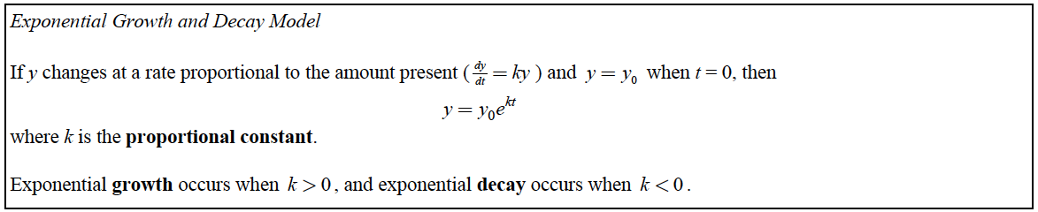

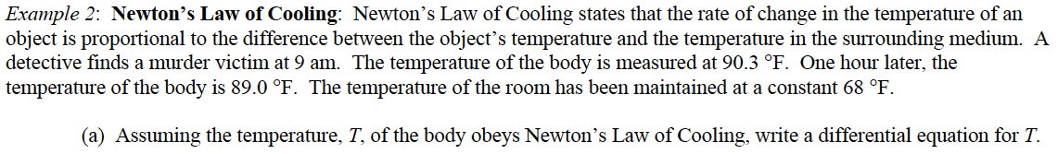

Be Careful with percentages!
- if you’re given a rate as a percentage and it is continuously compounded, then you know k and you can use: $y=y_{0}e^{kt}$ but you can’t use the formula from Precalc 12: $Q=A×r^{\frac{t}{n}}$.
- If you’re given 2 values and it is compounded continuously, you might have to find k (and k is slightly different than the overall percentage because of the compounding).

Example 4: During the exponential phase, a population of bacteria in a culture increases at a rate proportional to the current population. If the growth rate is 5% per hour, and the current population is 500, what will be the population in 6.4 hours?

Example 6: During the exponential phase, a population of bacteria in a culture increases at a rate proportional to the current population. If the population doubles in 20 days, and the current population is 1000, when will the population be 3000?

Example 7: A savings account balance is compounded continuously. If the interest rate is 2.8% per year and the current balance is $2400.00, in how many years will the balance reach $3000?

Example 8: A radioactive substance decays at a rate proportional to the amount present. If the decay rate is 5% per year, and the current mass is 100mg, what will be the mass in 10 years?

Hwk: worksheet + extra practice + textbook problems

