Chapter 6 TEST
NON-CALCULATOR SECTION
Multiple Choice
- $\int{\frac{x}{x^{2}+1}dx}$
A) $\ln{\sqrt{x^{2}+1}+C}$ B) $\frac{2x}{{(x^{2}+1)}^{2}}+C$ C) $\arctan{x}+C$ D) $\ln{(x^{2}+1)}+C$
Free Responses
- Determine whether the function $y=2\sin{2x}$ is a solution to the differential equation $y^{'''}-8y=0$
- Solve the differential equations :
a) $\frac{dy}{dx}=e^{2-x}$
b) $y^{'}-e^{y}\sin{x=0}$
c) $xy^{'}-(x+2)y=0$ with $y\left(1\right)=-1$
- a) Sketch the slope field for the differential equation $y^{'}=xy$+1
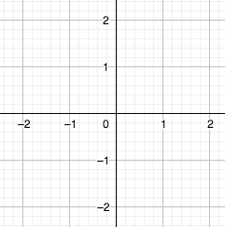
b) Use the slope field to sketch the solution that passes through $(-1,1)$.
- Match each equation to its slope field :
A : $\frac{dy}{dx}=2x-y$ B : $\frac{dy}{dx}=-\frac{4x}{y}$ C : $\frac{dy}{dx}=x\sin{\frac{πy}{4}}$ D : $\frac{dy}{dx}=3-2y$
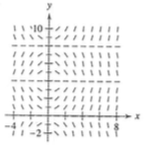 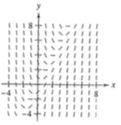
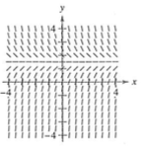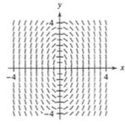
- Evaluate the following integrals :
a) $\int_{0}^{π}{\cos{\frac{x}{2}}dx}$
b) $\int_{0}^{1}{x^{2}{(x^{3}-2)}^{3}dx}$
c) $\int_{1}^{e}{\frac{1-lnx}{x}}dx$
d) $\int_{1}^{2}{x^{2}\sqrt{x-1}dx}$
7. Find the indefinite integral :
a) $\int{\sin^{3}{x}\cos{x}dx}$
b) $\int{\frac{\cos{θ}}{\sqrt{1-\sin{θ}}}dθ}$
c) $\int{\frac{e^{2x}}{e^{2x}+1}dx}$
d) $\int{{(5x-3)}^{4}dx}$
e) $\int{\cos^{3}{x}dx}$
Chapter 6 TEST
CALCULATOR SECTION
Multiple Choice

8. A pizza, heated to a temperature of 350 degrees Fahrenheit (ºF), is taken out of an oven and placed in a 75ºF room at time t = 0 minutes. The temperature of a pizza is changing at a rate of $-110e^{-0.4t}$ degrees Fahrenheit per minute. To the nearest degree, what is the temperature of the pizza at time
t = 5 minutes?
A) 112ºF B) 119ºF C) 147ºF D) 238ºF E) 335ºF
9. If Radium decomposes at a rate proportional to the amount present, then the amount R left after t years, if R_{o} is present initially and c is the negative constant of proportionality, is given by
A) $R=R_{o}ct$ B) $R=R_{o}e^{ct}$ C) $R=R_{o}+\frac{1}{2}ct^{2}$ D) $R=e^{R_{o}ct}$ E) $R=e^{R_{o}+ct}$
10. According to newton’s law of cooling, the temperature of an object decreases at a rate proportional to the difference between its temperature and that of the surrounding air. Suppose a corpse at a temperature of 32ºC arrives at a mortuary where the temperature is kept at 10ºC. Then the differential equation satisfied by the temperature T of the corpse t hours later is
A) $\frac{dT}{dt}=-k(T-10)$ B) $\frac{dT}{dt}=-k(T-32)$ C) $\frac{dT}{dt}=-kT(T-10)$ D) $\frac{dT}{dt}=32e^{-kt}$

Free Responses

11. A population grows continuously at a rate of 1.85%. How long will it take the population to double?

12. Find the balance in an account when $1000 is deposited for 8 years at an interest rate of 4% compounded continuously.

