Chapter 6 TEST
Part I – No calculator

- Which of the following is the slope field for the differential equation: $y^{'}=\frac{x}{y}$? [1]
A B
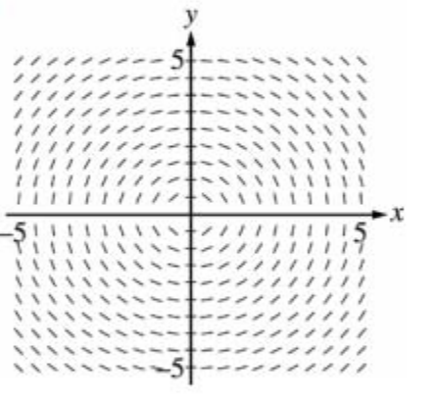 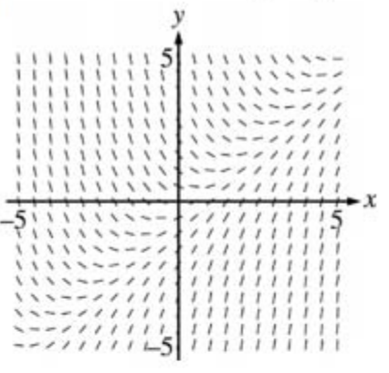
C D
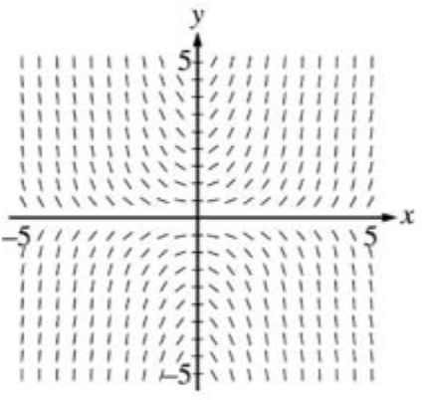 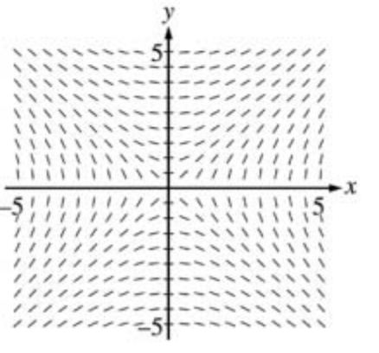
- Show that $y=2+e^{-x^{3}}$ is a solution of the differential equation $y^{'}+3x^{2}y=6x^{2}$. [1]

- Solve the differential equation (that satisfies the initial condition when given): [4.5]
a) $\frac{dy}{dx}=\frac{x+\sin{x}}{3y^{2}}$
b) $y^{'}=y^{2}+1$ , $y\left(1\right)=0$
c) $xe^{-t}\frac{dx}{dt}=1$ , $x\left(0\right)=-2$
- Evaluate the following integrals: [20.5]
a) $\int{\frac{x^{2}}{\sqrt{2+x^{3}}}dx}$
b) $\int{e^{4x}dx}$
c) $\int{sec3θ tan3θ dθ}$
d) $\int{\frac{{\left(lnx\right)}^{2}}{x}dx}$
e) $\int{t^{2}\cos\left(1-t^{3}\right)dt}$
f) $\int{\frac{e^{x}}{e^{x}+1}dx}$
g) $\int{\frac{e^{x}+1}{e^{x}}dx}$
h) $\int{\cos^{3}{x}dx}$
i) $\int{x\sqrt{x+2}dx}$
j) $\int{\frac{2}{x^{2}-6x+10}dx}$
k) $\int{\sin^{2}{x}dx}$
l) $\int{\tan{x}dx}$
- Evaluate the following definite integrals: [6]
a) $\int_{0}^{1}{{(2x-1)}^{100}dx}$
b) $\int_{0}^{1/2}{\frac{1}{1+4x^{2}}dx}$
c) $\int_{0}^{3}{\frac{dx}{2x+3}}$
Chapter 6 TEST
Part II – Calculator Allowed
- Newton’s Law of Cooling states that the rate of cooling of an object is proportional to the temperature difference between the object and its surroundings. Suppose that a roast turkey is taken from an oven when its temperature has reached 185ºF and is placed on a table in a room where the temperature is 75ºF.
a) If the temperature of the turkey is 150ºF after half an hour, what is the temperature after 45min? [2]
b) When will the turkey have cooled to 100ºF? [1]
- How long will it take an investment to double in value if the interest rate is 6% compounded continuously?
[1]
- A tank contains 20kg of salt dissolved in 5000 L of water. Brine that contains 0.03 kg of salt per liter of water enters the tank at a rate of 25 L/min. The solution is kept thoroughly mixed and drains from the tank at the same rate. How much salt remains in the tank after half an hour? [3]

