7.1 – Integrals as a Net Change

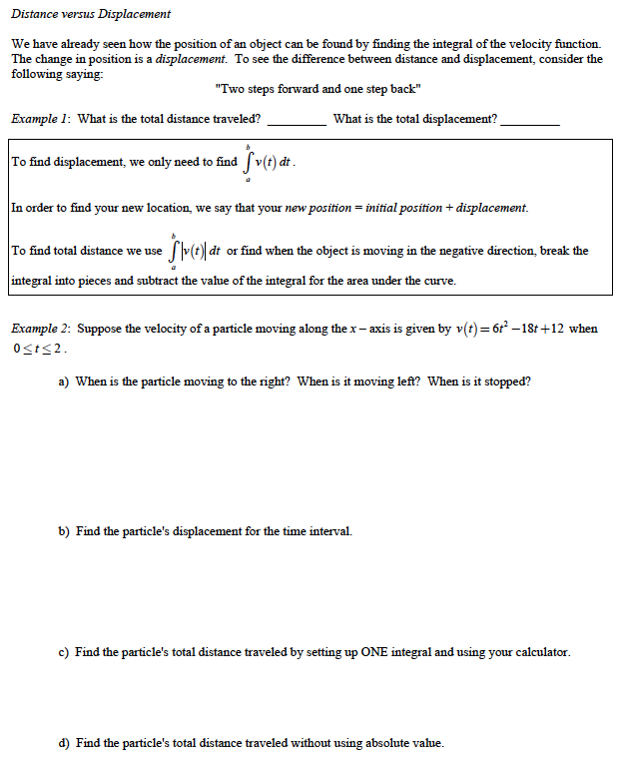
Consumption over Time:

Velocity is not the only rate in which you can integrate to get a total. In fact if you were given a function that gave the number of tickets per hour that the police wrote each day, and you wanted to find the total number of tickets in a 24-hour period, you could integrate.

Example 3: The tide removes sand from Sandy Point Beach at a rate modeled by the function R given by
$R\left(t\right)=2+5sin\left(\frac{4πt}{25}\right)$.
A pumping station adds to the beach at a rate modeled by the function S given by
$S\left(t\right)=\frac{15t}{1+3t}$.
Both $R(t)$ and $S(t)$ have units of cubic yards per hour and t is measured in hours for $0≤t≤6$.
At time $t=0$, the beach contains 2500 cubic yards of sand.

- How much sand will the tide remove from the beach during the 6-hour period? Indicate units of measure.
- Write an expression for $Y(t)$, the total number of cubic yards of sand on the beach at time t.
- Find the rate at which the total amount of sand on the beach is changing at time $t=4$.

7.2 – Areas in the Plane

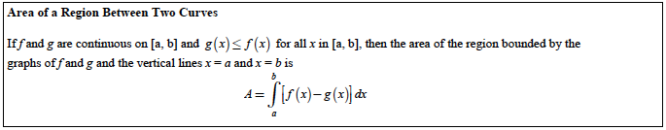

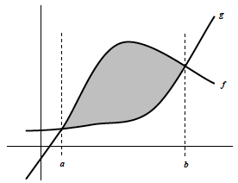

Example: Find the area of the region bounded by the graphs of $y=x^{2}+2$, $y=-x+2$, $x=0$ and $x=1$.

Note: It is very important to start with a rough graph in order to know which one is “above”…

Example: Find the area of the region bounded by the graphs of $x=3-y^{2}$ and $x=y+1$.

Example: Find the area of the region bounded by the graphs of $y=x(x-2)(x-3)$, $y=4x-8$, $x=-1$ and $x=4$.

7.3 - Volumes

We already know that the integral can be seen as a sum of thin strips with values f(x) and width dx.

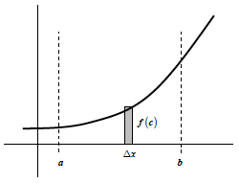

$$Area= \int_{a}^{b}{f\left(x\right)dx}$$

The same way, it can calculate volumes if we add thin slices with a base area A(x) and width dx.
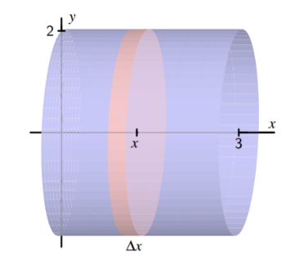

$$Volume=\int_{a}^{b}{A\left(x\right)dx}$$

We will need to determine the area of a cross section (as a function of x most of the time, but sometimes y) and just integrate it…

In the previous example, $A\left(x\right)=4π$, and you get: $V=\int_{0}^{3}{4πdx}$

Example:
The base of a solid is the region in the first quadrant enclosed by the parabola $y=4x^{2}$, the line $x=1$, and the x-axis. Each plane section of the solid perpendicular to the x-axis is a square. Determine the volume of the solid.

Example:
The base of a solid is the region enclosed by the parabola $y=4x^{2}$, the line $y=1$, and the y-axis.
Each plane section of the solid perpendicular to the x-axis is a square. Determine the volume of the solid.

Example:
The base of a solid is a region in the first quadrant bounded by the x-axis and the line $x+2y=8$.
If the cross-section of the solid perpendicular to the x-axis are semicircles. What is the volume of the solid to the nearest hundredth?

Example: The base of a solid is the region in the first quadrant enclosed by the graph of $y=2-x^{2}$ and the coordinate axes. If every cross section of the solid perpendicular to the y-axis is a square, what integral gives you the volume of the solid?

Solids of Revolution:
Example: What is the volume of the cylinder formed by revolving the graph of $y=3$ around the x-axis on the interval [0;4]?

Note: when we rotate a curve around an axis, the cross-section is always a circle. Therefore, $A\left(x\right)=π{\left(f(x)\right)}^{2}$.
f(x) is then the radius of the cross-section, and we usually note it R(x).

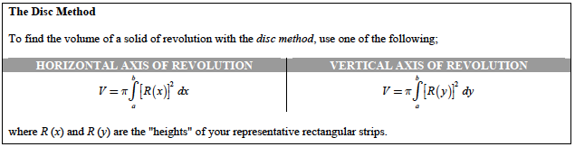

Example: a) Determine the volume of the solid formed by revolving the following region about the x-axis.
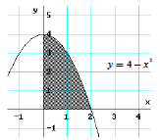
b) Same question about the y-axis.
Your turn: Same questions for the following region:
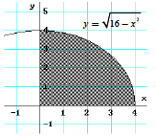

Example: Find the volume of the solid generated by revolving the region bounded by the graphs of the equations $xy=6$, $y=2$, $y=6$ and $x=6$ about the indicated lines.
- The line $x=6$

- The line $y=6$

The Washer method:
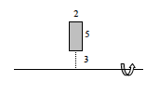

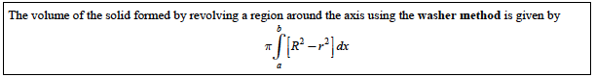

Examples: Determine the integral that represents the volume of the solid generated by revolving the region bounded by the graphs of the equations about the indicated lines:
