Prerequisites Worksheet

Even and Odd Functions
- Complete each graph, assuming that a) is even and b) is odd:
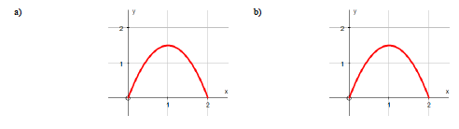
- Prove whether the following functions are even, odd or neither:

Piecewise Functions
- Graph each of the following functions:
- Determine a piecewise function for each of the following graphs:
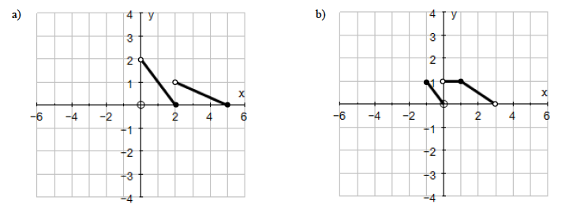
- An earthquake that occurred at 9:17AM cracked a water tower in a small town. Water began leaking out of the tower at rate 12 cm³/min for the first 25 minutes, then the rate increased to 24 cm³/min for the next 30 minutes. It took 45 minutes before the leak was fixed, and in that final 45 minutes, the water was leaking at a rate of 20 cm³/min. Write a piecewise function for the amount of water leaking out of the tower as a function of time.

One to one Functions
- Explain in your own words what a one-to-one function is.
Composite Functions and Inverse Functions
- What are the 3 domain issues you must remember for this course?
- What are the domains of the following functions?
- Suppose $f\left(x\right)=x+5$ and $g\left(x\right)=x^{2}-3$. Find each of the following
a) $f\left(g(x)\right)$ b) $g\left(f(x)\right)$
c) $f\left(g(0)\right)$ d) $g\left(f(0)\right)$
e) $g\left(g(-2)\right)$ f) $f\left(f(x)\right)$
- Complete the following table:
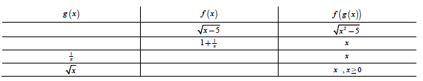
- Find $f\left(g(x)\right)$ and determine their domain.
a) $f\left(x\right)=x^{2}+7$ and $g\left(x\right)=\sqrt{x+4}$
b) $f\left(x\right)=\frac{4x+1}{x-3}$ and $g\left(x\right)=\frac{3x+1}{x-4}$
- Explain how to find an inverse of a given function algebraically.
- Explain how to verify/prove that two functions are inverses of each other.
- Find the inverse of each following functions and determine their domain and ranges so that they are both functions:
a$) f(x)=2x+3$ b) $g\left(x\right)=\sqrt[4]{2x+7}-5$
c) $h\left(x\right)=\frac{2x+1}{x+3}$ d) $k\left(x\right)=2\sin\left(x\right)+1$
e) $j\left(x\right)=5\cos^{-1}x+2$ f) $l\left(x\right)=5\ln{(2x-1)}+3$
- Verify that the function $k\left(x\right)=\sqrt{1-x^{2}}$ for $0<x<1$ is its own inverse.
- Without using a calculator, evaluate the following expressions:
a) $sin\left(\cos^{-1}\left(\frac{7}{11}\right)\right)$ b) $tan\left(\sin^{-1}\left(\frac{9}{13}\right)\right)$

Greatest Integer Function
- Determine the following values for $f\left(x\right)=Int (x)$
$f\left(1.3\right)=$ $f\left(0.9\right)=$ $f\left(-1.6\right)=$
$f\left(5.8\right)=$ $f\left(-4.2\right)=$ $f\left(3\right)=$
- Make sure you know how to draw the Greatest Integer function precisely.

