QUIZ 2.1 – 2.2
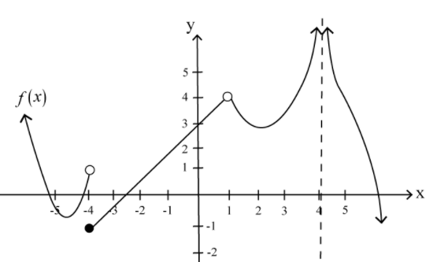
- For the function f shown, evaluate the following: [4]
a) $\lim_{x→-4^{-}}{f(x)}$ =
b) $\lim_{x→-4^{+}}{f(x)}$ =
c) $\lim_{x→1^{-}}{f(x)}$ =
d) $\lim_{x→1^{+}}{f(x)}$ =
e) $\lim_{x→4^{-}}{f(x)}$ =
f) $\lim_{x→4^{+}}{f(x)}$ =
j) $f(-4)$ =
k) $f(1)$ =
l) $f(4)$ =

g) $\lim_{x→-4}{f(x)}$ =
h) $\lim_{x→1}{f(x)}$ =
i) $\lim_{x→4}{f(x)}$ =
- Determine the left and right sided limits of the following function at -3. $f\left(x\right)=\left\{\begin{aligned}\frac{x^{2}+6x+9}{2x+6}, x<-3 \\ -2x+5, x≥-3\end{aligned}\right.$ [2]
- Let $f$ be a function such that: $\frac{x^{2}-4}{x-2}≤f(x)≤\frac{8\sin{(x-2)}}{2x-4}$ for $1<x<3$. [2]
Determine $\lim_{x→2}{f(x)}.$
- Evaluate each of the following limits. Show your work for all questions. [12]
a. $\lim_{x→2}{\frac{x^{2}+5x+6}{x-3}}$ b. $\lim_{x→+∞}{\frac{3x^{2}-4}{x^{2}-1}}$

c. $\lim_{x→{-5}^{-}}{\frac{\left|5+x\right|}{x^{2}-25}}$ d. $\lim_{x→-1^{+}}{\frac{3x^{2}-4}{x^{2}-1}}$

e) $\lim_{h→0}{\frac{\frac{1}{3+h}-\frac{1}{3}}{h}}$ f. $\lim_{x→0}{\frac{\sqrt{3-x}-\sqrt{3}}{x}}$

g) $\lim_{x→∞}{\frac{x^{2}-x+1}{x^{3}+2}}$ h) $\lim_{x→-∞}{\frac{x^{3}-x+1}{x^{2}+2}}$

- $\lim_{x→∞}{\frac{3x-sin3x}{x}}$ j) $\lim_{x→0}{\frac{\sin{3x}}{\sin{x}}}$

