**QUIZ 3.1 – 3.3**

1. Find the derivative of each of the following. Be sure to simplify when possible. [6]  
     
   a) 

b) $y = (2x^{3} – 7x + 1)(3x – 8)$

c) 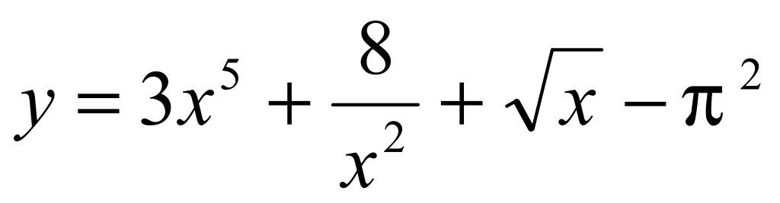

1. Prove that the the function *f* has a zero on the interval [1; 10] without determining it. [2] $$f\left(x\right)=\sqrt{10x}-15logx$$

1. Let $f(x)=\left\{\begin{aligned}x^{2} , x≤1 \\ 2x , x>1\end{aligned}\right.$ [2]  
   a) Determine $f'(x)$ for $x<1$.  
     
     
     
   b) Determine $f'(x)$ for $x>1$.  
     
     
     
   c) Is *f* differentiable at 1? Explain. *Be careful, there is a trap…*

1. Use the definition of the derivative to determine the derivative of $f\left(x\right)=\sqrt{x}$. [2]
2. Use the alternate definition of the derivative to determine the derivative of $g\left(x\right)=3x^{2}$. [2]
3. Graph the derivative of the following function on the second grid: [1]  
     
    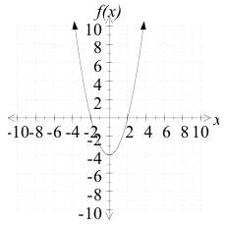 
4. Find the equation of the tangent line to $y=5\sqrt{x}-\frac{27}{x}$ at $x=9$. [2]