**QUIZ 3.1 – 3.6**

1. Find the derivative of each of the following. Be sure to simplify when possible. [12]  
   a)   
     
     
     
     
     
     
     
   b) 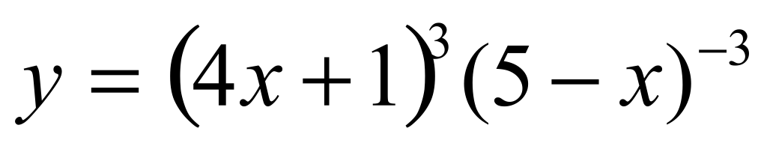  
     
     
     
     
     
     
     
   c) $y=\left(\csc{x}+1\right)\tan{x}$  
     
     
     
     
     
     
     
   d) $y = 4x^{6}{(x^{2} + 3x + 5)}^{5}$  
   e)  
     
     
     
     
     
     
     
   f) 
2. Find the equation of the tangent line to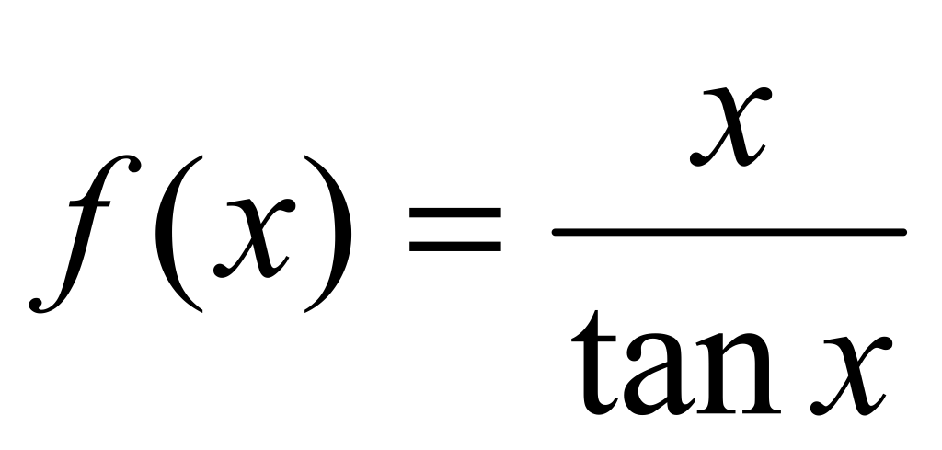 at the point where *x* =. [3]
3. A particle’s position along a number line is given by *s*(*t*) = 4*t*2 – 16*t*, for *t* ≥ 0 [5]
4. Find the particle’s velocity and acceleration functions.
5. When does the particle change direction?
6. Find the total distance travelled by the particle in the first 3 seconds.