**QUIZ 4.1 – 4.4**

1. For what value(s) of *c* will $y=x^{3}+\frac{c}{x}$ have no critical point?

2. Determine the coordinates of the inflection points of *y* = *x*4 + *x*5

3. If *y* is a function of *x* such that < 0 for all *x* and < 0 for all *x*, propose a possible sketch of the function.

4. If *f*(*x*) = *x*3*e–2*x Determine the variations of the function.

5. If the derivative of the function *f* is *f* ′(*x*) = -3(*x* + 2)(*x* + 1)2(*x* + 3)3 then where does the graph of *f* have local minimums?

6. Find each value of *c* in the interval [0, 3] that satisfies the conditions of the Mean Value Theorem for the function *f*(*x*) = *x*2 + 2*x* – 1. **[2]**

7. Determine the variations and the concavity of: $f\left(x\right)=x\sqrt{5-x}$. Sketch a rough shape of the graph of *f*. **[4]**

8.

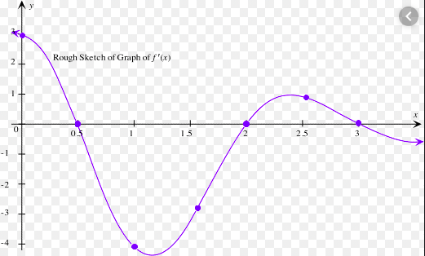

**Note: This is the graph of the derivative of *f*, not the graph of *f*.**

The figure above shows the graph of , the derivative of the function *f*. The domain of *f* is the set of all real numbers *x* such that 0 ≤ *x* ≤ 3.5.

a) For what value(s) of *x*, 0 < *x* < 3.5, does *f* have a relative maximum? Justify your answer. **[1]**

b) On what intervals, for 0< *x* < 3.5, is the graph of *f* increasing? Justify your answer. **[2]**

c) On what intervals, for 0 < *x* < 3.5, is the graph of *f* concave up? Justify your answer. **[2]**

d) For what value(s) of *x*, 0 < *x* < 3.5, does *f* have a point of inflection? Justify your answer. **[2]**

8. We are going to fence in a rectangular field. If we look at the field from above the cost of the vertical sides are $10/ft, the cost of the bottom is $2/ft and the cost of the top is $7/ft. If we have $700 determine the dimensions of the field that will maximize the enclosed area. **[4]**