QUIZ 5.1 – 5.3

Multiple Choices [4]

- Find the MRAM approximation for the area of the shaded region (under the curve between 0 and 4), using 8 subintervals of equal width.
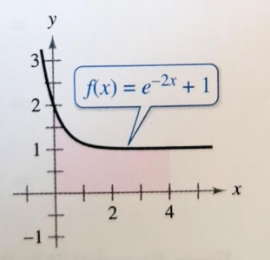
A) 4.425 B) 4.480 C) 6.719 D) 8.959
- The expression $\frac{1}{10}\left[{\left(\frac{1}{10}\right)}^{2}+{\left(\frac{2}{10}\right)}^{2}+{\left(\frac{3}{10}\right)}^{2}+…+{\left(\frac{10}{10}\right)}^{2}\right]$ is a Riemann sum approximation for
A) $\int_{0}^{1}{x^{2}dx}$ B) $\frac{1}{10}\int_{0}^{1}{x^{2}dx}$ C) $\int_{1}^{10}{x^{2}dx}$ D) $\int_{0}^{10}{x^{2}dx}$
- The table shows selected values for a continuous function f over the interval $\left[2,8\right]$.
$$x$$ | 2 | 3 | 5 | 8
$$f(x)$$ | 8 | 22 | 72 | 142
Using the subintervals $\left[2,3\right]$, $\left[3,5\right]$ and $\left[5,8\right]$, what is the trapezoidal approximation of $\int_{2}^{8}{f(x)dx}$?
A) 268 B) 338 C) 430 D) 592
- The graph of a piecewise linear function f is shown below.
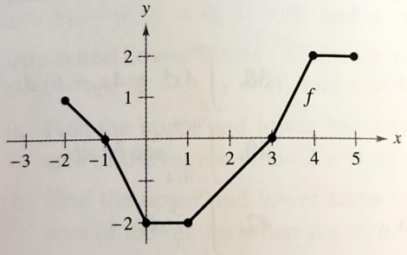
If g is the function defined by $g(x)=\int_{4}^{x}{f(t)dt}$, determine $g(-1)$.
A) -6 B) -4 C) 4 D) 6

Free Response Questions:

- The graph of f below consists of line segments and a semi-circle. [4]
Evaluate each definite integral.
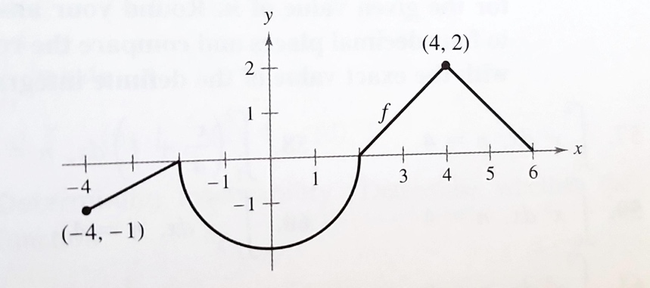
a) $\int_{0}^{4}{f(x)dx}$
b) $\int_{0}^{6}{\left|f(x)\right|dx}$
c) $\int_{4}^{-2}{f(x)dx}$
d) $\int_{0}^{2}{\left(f(x)+2\right)dx}$
- a) Write the following integral as the limit of a Riemann sum: $\int_{0}^{2}{e^{x}dx}$ [1.5]
b) Write the following limit as an integral: [1.5]
$$\lim_{n→∞}{\sum_{i=1}^{n}{\left(\frac{1}{n}\right)\left[8\left(\frac{i}{n}\right)+3\right]}}$$
- Consider the following graph: [3]
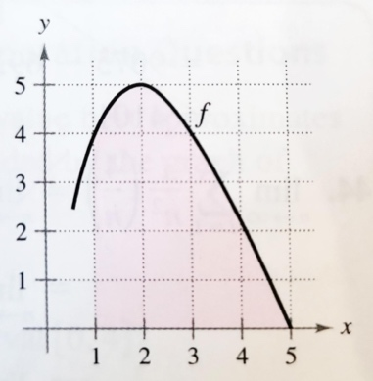
Using 4 rectangles, determine an approximation of the shaded region (under the curve between 1 and 5) with the given method:
a) LRAM
b) RRAM
- Use your calculator to determine $\int_{1}^{3}{lnx dx}$ to the nearest thousandth. [1]
- Given $\int_{0}^{5}{f(x)dx}=10$ and $\int_{5}^{7}{f(x)dx}=3$, evaluate: [4]
a) $\int_{0}^{7}{f(x)dx}$
b) $\int_{5}^{5}{f(x)dx}$
c) $\int_{5}^{0}{f(x)dx}$
d) $\int_{0}^{5}{3f(x)dx}$
- Given $\int_{2}^{6}{f(x)dx}=10$ and $\int_{2}^{6}{g(x)dx}=-2$, evaluate: [3]
a) $\int_{2}^{6}{\left[f(x)+g(x)\right]dx}$
b) $\int_{2}^{6}{\left[g(x)-f(x)\right]dx}$
c) $\int_{2}^{6}{\left[f(x)+3\right]dx}$
- Determine the exact value of the average value of the following function on the interval $\left[1,4\right]$:
$$f(x)=3-x$$ [2]

