QUIZ 6.1 – 6.2 – NO CALCULATOR

Multiple choice Questions [6]
- $\int{x\sqrt{16-3x^{2}}dx}=$
A) $\frac{2}{3}{\left(16-3x^{2}\right)}^{\frac{3}{2}}+C$ B) $-\frac{1}{4}{\left(16-3x^{2}\right)}^{\frac{3}{2}}+C$ C) $-\frac{1}{9}{\left(16-3x^{2}\right)}^{\frac{3}{2}}+C$ D) $\frac{1}{9}{\left(16-3x^{2}\right)}^{\frac{3}{2}}+C$
- What is the average value of $h\left(x\right)=\left(\sec^{2}{x}\right){\left(1+2\tan{x}\right)}^{3}$ on the interval $\left[0,\frac{π}{4}\right]$?
A) $\frac{40}{π}$ B) $10$ C) $\frac{81}{2π}$ D) $\frac{80}{π}$
- Which of the following is the solution of the differential equation $y^{'}=\frac{4}{\sqrt{16-x^{2}}}$?
A) $y=\arcsin{\frac{x}{4}}+C$ B) $y=4\arcsin{\frac{x}{4}}+C$ C) $y=\frac{1}{4}\arcsin{\frac{x}{16}}+C$ D) $y=16\arcsin{\frac{x}{4}}+C$
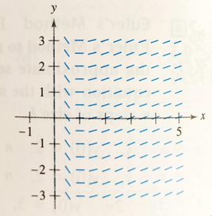
- Which differential equation corresponds to the following slope field?
A) $\frac{dy}{dx}=\frac{1}{x\ln{x}}$ B) $\frac{dy}{dx}=x^{2}-1$ C) $\frac{dy}{dx}=\ln{x}$ D) $\frac{dy}{dx}=\frac{\ln{x}}{x}$
- If $\frac{dy}{dx}=\frac{y^{2}+1}{x+2}$, then $y=$
A) $\tan\left[\ln\left|x+2\right|+C\right]$ B) $\tan\left[\ln\left|x+2\right|\right]+C$ C) $\ln\left|x+2\right|+C$ D) $\tan\left[\ln{x}+\frac{x}{2}+C\right]$
- If $\frac{dy}{dt}=y\sec^{2}{t}$ and $y=4$ when $t=0$, then $y=$
A) $e^{\tan{t}}+3$ B) ${4e}^{\tan{t}}$ C) $e^{\tan{t}}+4$ D) $\tan{t}+4$
Free Response Questions:
- Determine the following indefinite integrals: [8]
a) $\int{{\left(1+\frac{1}{t}\right)}^{3}\left(\frac{1}{t^{2}}\right)dt}$
b) $\int{\tan{(5θ)} dθ}$
c) $\int{\frac{\cos{t}}{1+\sin{t}} dt}$
d) $\int{x\sqrt{x+6} dx}$
- Determine the following definite integrals: [6]
a) $\int_{1}^{2}{2x^{2}\sqrt{x^{3}+1}} dx$
b) $\int_{1}^{3}{\frac{e^{3/x}}{x^{2}} dx}$
c) $\int_{0}^{\sqrt{3}/2}{\frac{1}{1+4x^{2}} dx}$
- Find the average value of the function $f\left(x\right)=\frac{x}{x^{2}-3}$ over the interval $[2,5]$. [2]
- Determine an equation for a function f such that $f^{'}\left(x\right)=2e^{-\frac{x}{4}}$ and $f\left(0\right)=1$. [2]
- Determine whether each of the following function is a solution of the differential equation: [3]
$xy^{'}-2y=x^{3}e^{x}$
a) $y=x^{2}$ b) $y=x^{2}e^{x}$
- Match the differential equation with its slope field. [2]
____ ____ ____ ____
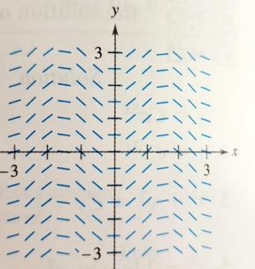 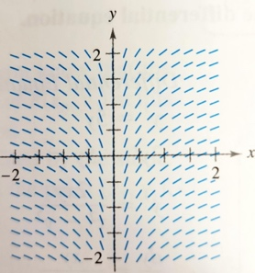 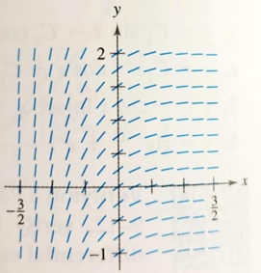 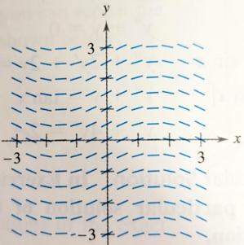
A) $y^{'}=\sin{2x}$ B) $y^{'}=\frac{1}{2}\cos{x}$ C) $y^{'}=e^{-2x}$ D) $y^{'}=x^{-1}$
- Solve the following differential equations [4]
a) $y^{'}=\frac{x}{4y}$ no condition
b) $\frac{y^{'}}{2x}=1+y^{2}$ Initial condition: $y\left(0\right)=1$

