QUIZ 7.1 – 7.2

NO Calculator Section

Multiple Choices:
- What is the area of the region bounded by the graphs of $x=y^{2}-2y$ and $y=-x+2$?
A) $\frac{3}{2}$ B) $\frac{10}{3}$ C) $\frac{9}{2}$ D) $\frac{31}{6}$
- The figure below shows the graphs of $y=2-4x-x^{2}$ and $y=-2x-1$.
What is the area of the shaded region?
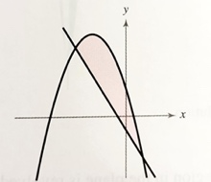
A) $\frac{5}{3}$ B) 10 C) $\frac{32}{3}$ D) $\frac{86}{3}$
- Which integral gives the area A of the region bounded by the graph of $f\left(x\right)=x^{3}-2x$ and the tangent line to the graph of f at $(-1,1)$?
A) $A=\int_{-1}^{2}{\left(x^{3}+3x+2\right)dx}$ B) $A=\int_{-1}^{2}{\left(x^{3}-3x-2\right)dx}$ C) $A=\int_{-1}^{4}{\left({-x}^{3}+3x+2\right)dx}$ D) $A=\int_{-1}^{2}{\left({-x}^{3}+3x+2\right)dx}$
Free Response Questions:
- Determine the area of the shaded region: [3]
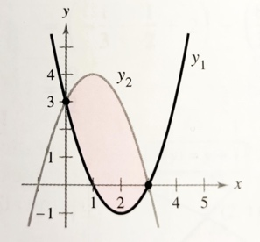
- Sketch the region bounded by the graphs of $f\left(x\right)=\cos{x}$ and $g\left(x\right)=2-\cos{x}$ for $0≤x≤2π$ and determine an integral that represents the area of the enclosed region (without evaluating it). [2]
Calculator section
- A tank contains 125 gallons of heating oil at time $t=0$.
During the time interval $0≤t≤12$ hours, heating oil is pumped into the tank at the rate: $H\left(t\right)=2+\frac{10}{1+\ln{(t+1)}}$ gallons per hour.
During the same time interval, heating oil is removed from the tank at the rate:
$R\left(t\right)=12\sin\left(\frac{t^{2}}{47}\right)$ gallons per hour.
a) How many gallons of heating oil are pumped into the tank during the time interval $0≤t≤12$ hours?
[2]
b) Is the level of heating oil in the tank rising or falling at time $t=6$ hours? Justify. [2]
c) How many gallons of heating oil are in the tank at time $t=12$ hours? [2]
d) At what time $t$, for $0≤t≤12$, is the volume of heating oil in the tank the least? Show the analysis that leads to your conclusion. [2]
- The graphs of $x=4-y^{2}$ and $x=y-2$ are given. Determine the area of the shaded region (show all your work. You can only simplify the final calculation with your calculator): [2]
