The EXISTENCE Theorems

These theorems guarantee the existence of a point satisfying a certain condition…

IVT
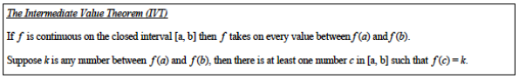

The IVT tells you that if a function is continuous on a closed interval, it will take all the y-values between the two end points.

EVT
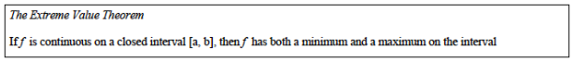

The EVT tells you that if a function is continuous on a closed interval, there will be a point in that interval that is the max and a point that is the min.

MVT
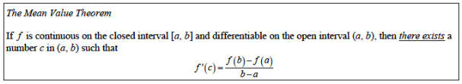

The MVT tells you that if a function is continuous on a closed interval and differentiable on the open one, there is a point where the instantaneous rate of change (derivative) equals the average rate of change of the function over the interval (the slope of a tangent line will be the same than the slope of the secant line joining the end points).

Applications:

The IVT is usually used to show that an equation has at least one solution.

The EVT is usually used to be able to give a name to a point that will be an extremum without really knowing where it is. It is useful to prove many theorems, but is extremely rare on an AP exam…

The MVT is usually used to show that a function has a local min or max in a certain interval.

Examples from the AP Exam…

Examples for IVT:

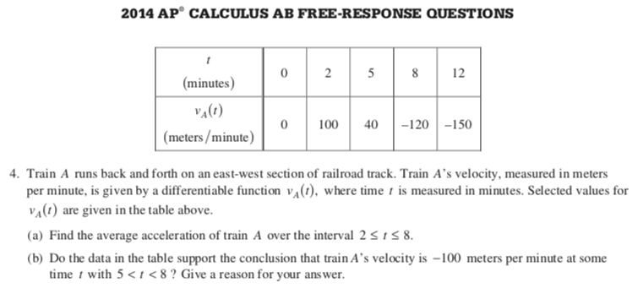

Example for MVT:

