1. (2016 No Cal)

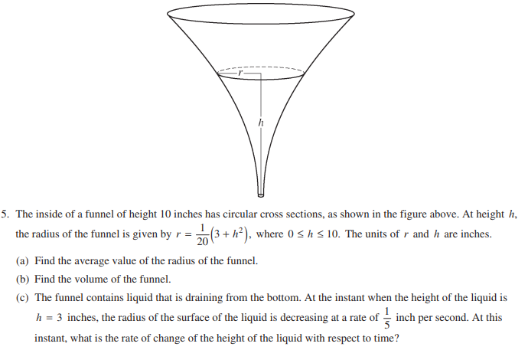

1. (2015 Calc)

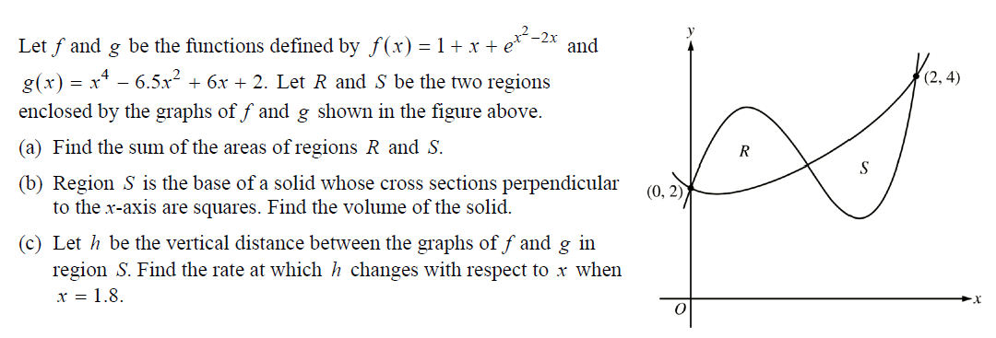

1. (2013 No Calc) 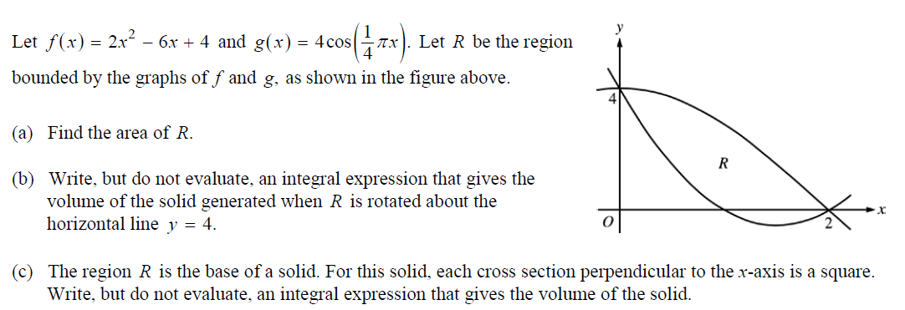
2. (2014 Calc) 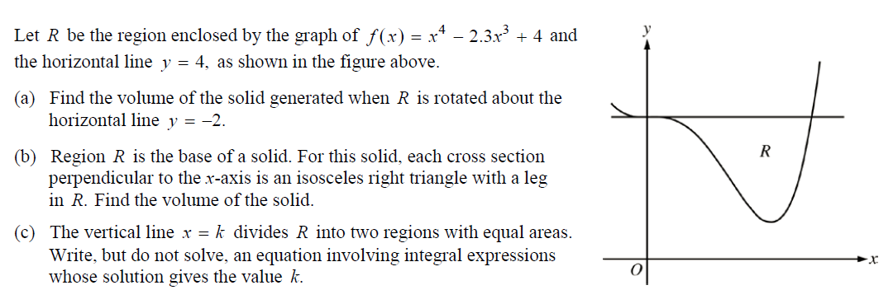
3. (2012 Calc) 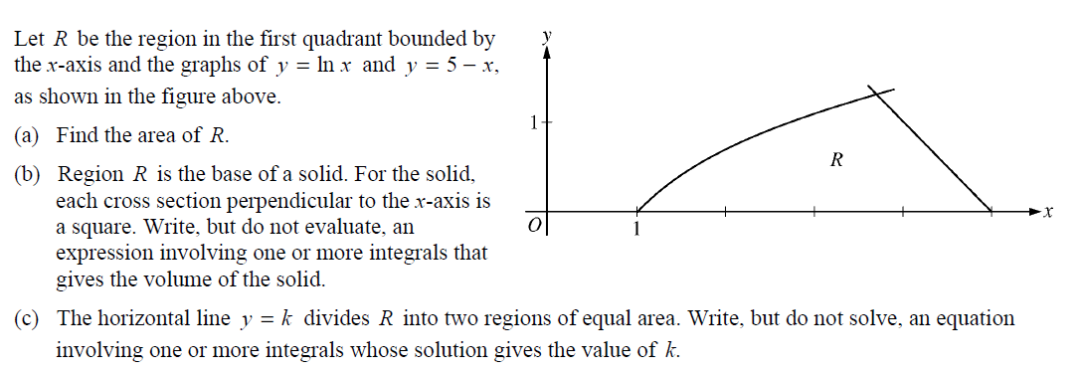
4. (2011 No Calc) 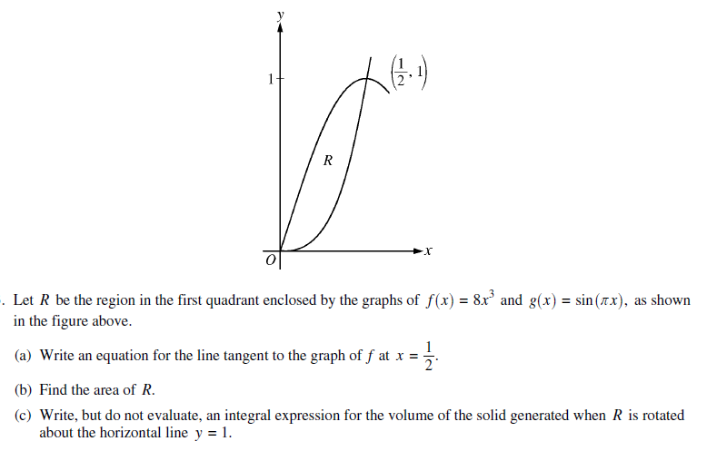
5. (2010 No Calc) 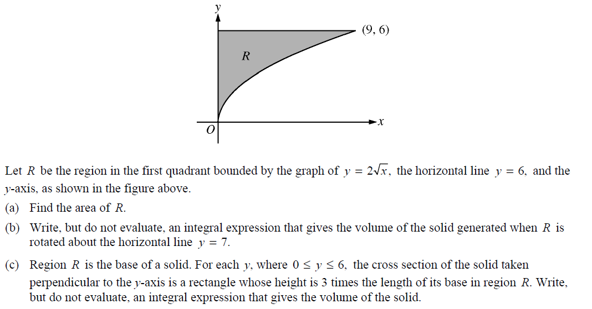
6. (2009 No Calc) 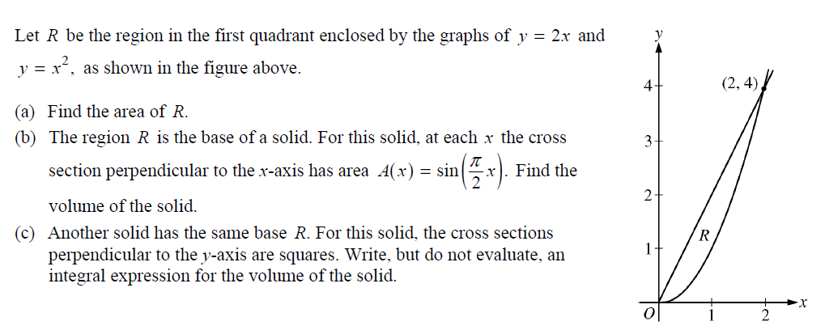
7. (2008 Calc) 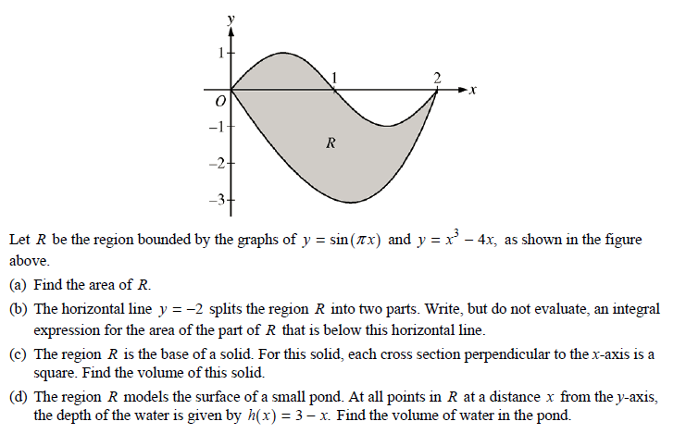
8. (2007 Calc) 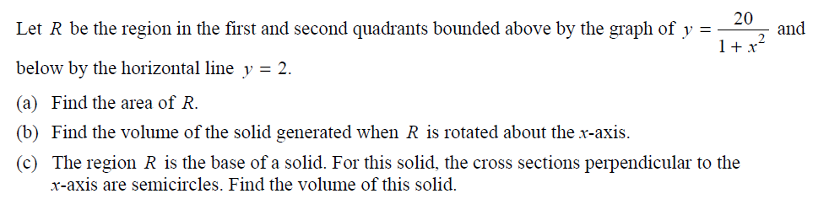
9. (2005 Calc) 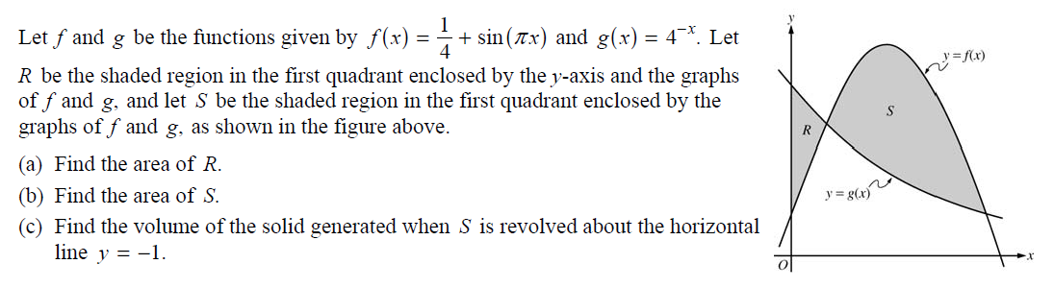
10. (2004 Calc) 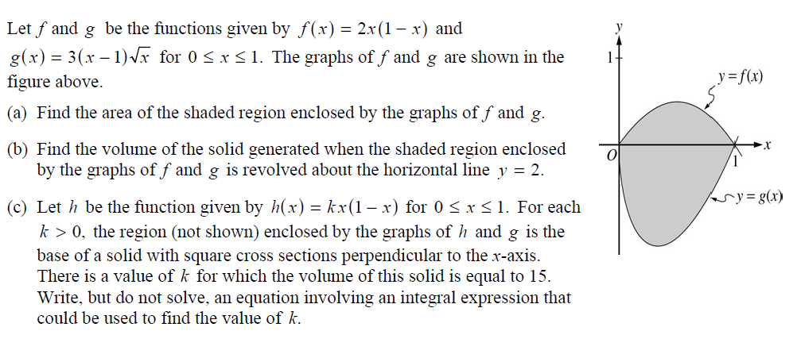
11. (2003 Calc) 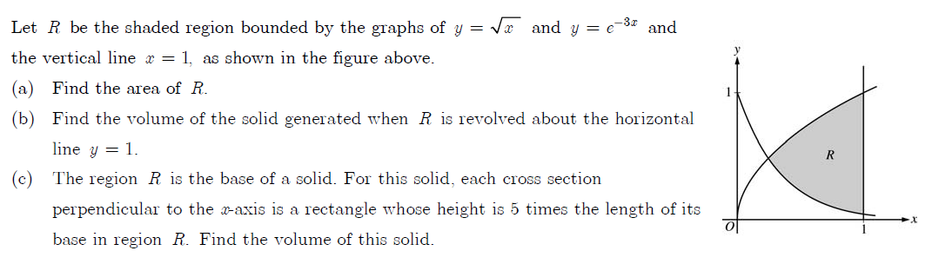
12. (2000 Calc) 