- (2017 No Calc)
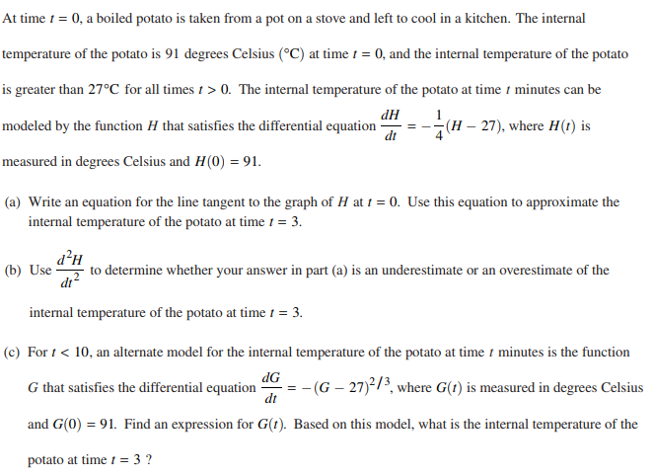
- (2016 No Calculator)
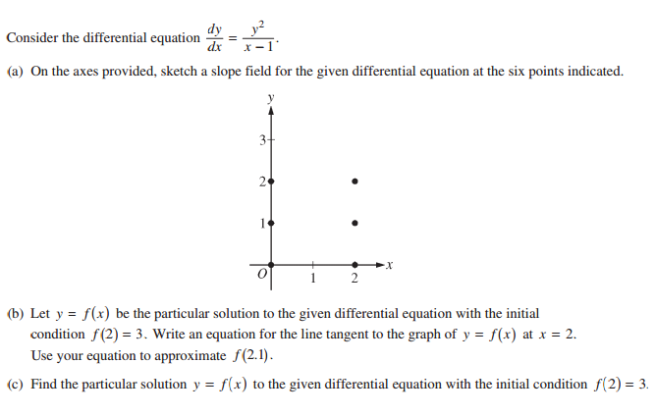
- (2015 No Calculator)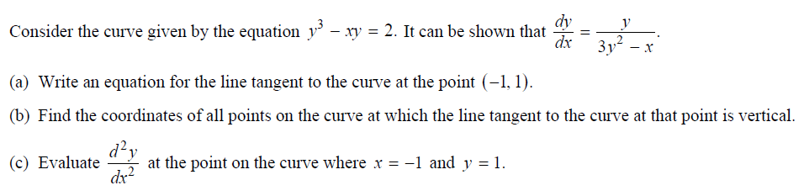
- (2013 No Calculator) 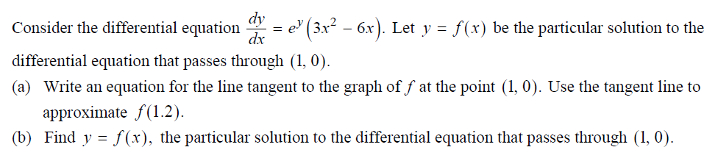
- (2012 No Calculator) 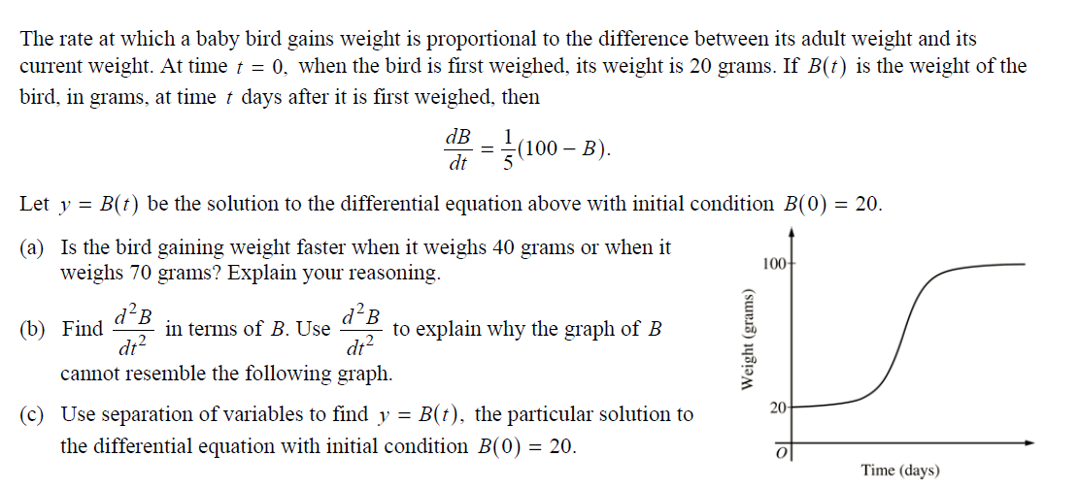
- (2000 No Calc)
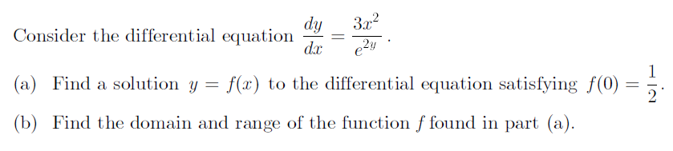
- (2011 No Calculator) 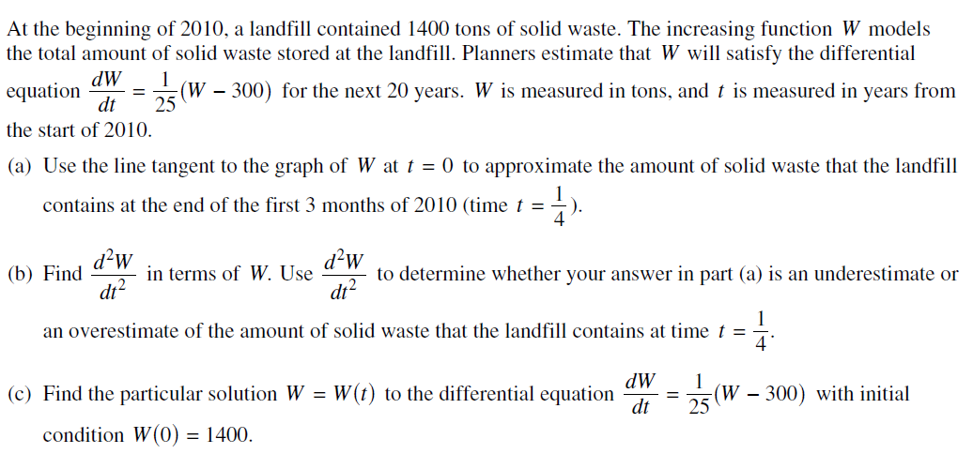
- (2010 No Calculator) 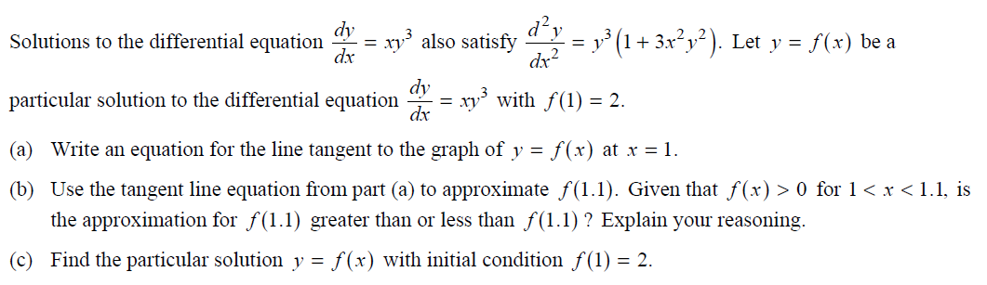
- (2008 No Calculator) 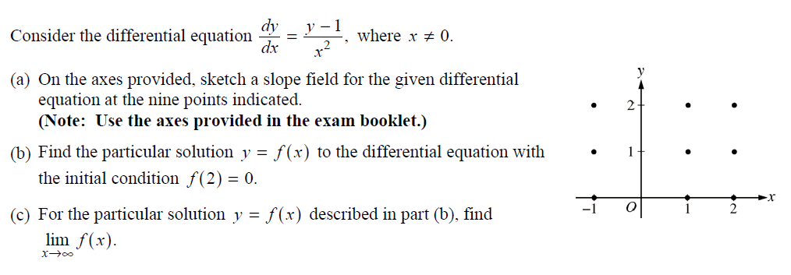
- (2006 No Calculator) 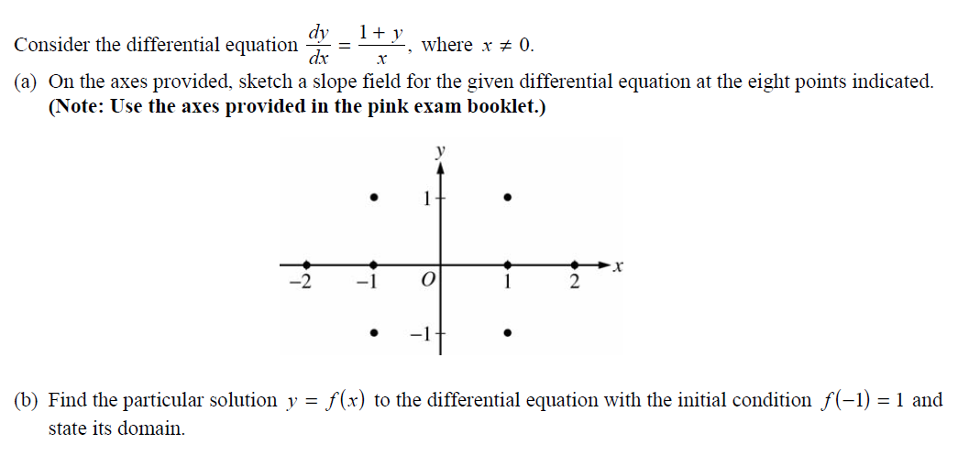
- (2005 No Calculator) 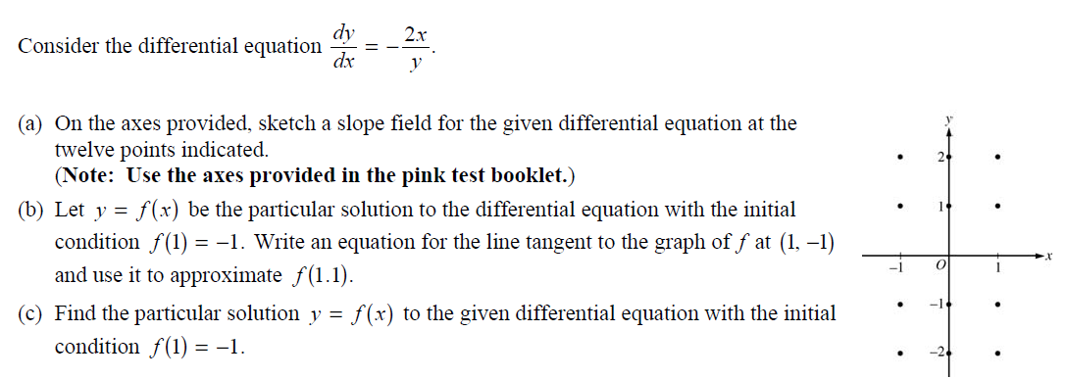
- (2004 No Calculator) 