Formula Sheet

FUNCTIONS
- Equations of a line: $y=mx+b$ $Ax+By+C=0$ $y-y_{p}=m(x-x_{p})$
- Slope: $m=\frac{∆y}{∆x}=\frac{y_{2}-y_{1}}{x_{2}-x_{1}}$

ARITHMETIC SEQUENCES

$$t_{n}=t_{1}+\left(n-1\right)d$$
$S_{n}=\frac{n}{2}(t_{1}+t_{n})$ or ${S }_{n}=\frac{n}{2}[2t_{1}+\left(n-1\right)d]$
TRIGONOMETRY
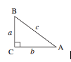
$\sin{A= \frac{opp}{hyp}}$ $\cos{A= \frac{adj}{hyp}}$ $\tan{A= \frac{opp}{adj}}$

FINANCE
- Determine the Annual Gross Income
- Determine EI and CPP
don’t forget the exemption for CPP
don’t forget to look at the max values
- Determine the other deductions before taxes
(union fees, addition pension plans...)
make sure everything is annual.
- Determine the taxable income without exemptions
Gross – EI – CPP – other deduction
- Determine the federal taxable income (with exemption)
Calculate the corresponding taxes using the tax brackets
- Determine the territorial taxable income (with exemption)
Calculate the corresponding taxes using the tax brackets

Net = Gross – EI – CPP – deductions before taxes – Territorial and Federal Taxes
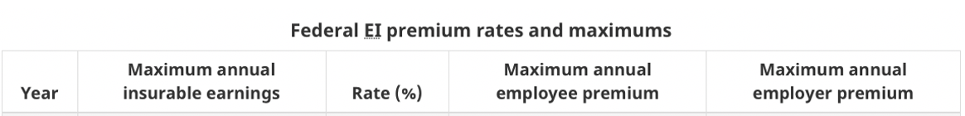

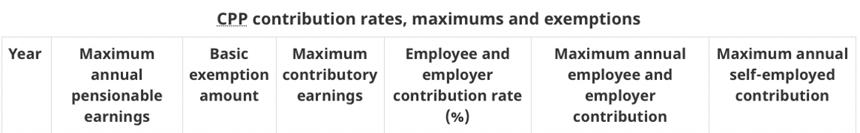
TAXES
The federal personal exemption: $11 635
Territorial/provincial personal exemptions: $10 207

