ARITHMETIC SEQUENCES

A sequence is an ordered list of elements called terms. These terms follow a pattern or rule to determine the next term in the sequence.
Each term is labeled according to its position by a subscript.

Example 1: 6, 8, 10, 12, 14, 16, 18, 20 is a sequence.

The pattern could be explained by: “To go from one term to the next, add 2” or “It’s the sequence of even numbers starting at 6 and ending at 20”.

First term: t₁= 6
2nd term : t₂ = 8 … t₇ = 18

We call general term of the sequence, the formula determining the n^{th} term of the sequence.
General term of this sequence: t_{n} = 2_{n} + 4
(If you replace n by and rank in the sequence, you can get the value of the term… t₃ = 2 × 3 + 4 = 10)

A sequence can be finite or infinite.

6, 8, 10, …, 20 6, 8, 10, 12, …

An arithmetic sequence is a particular type of sequence. The pattern is that to get the next term, you always add the same number (positive or negative). In other words, the difference between 2 consecutive terms is constant. We call it d: the common difference.

Examples: • The sequence from Example 1 is arithmetic.
d = 2
• The sequence: 9, 4, -1, -6, -11… is arithmetic.
d = -5

• 1, 2, 4, 8, 16, 32, … is not arithmetic.
The pattern is to double each term to get the next one.

t₂ - t₁ = 1 The difference between
t₃ – t₂ = 2 … 2 consecutive terms
is not constant!
Rank of the term
Common difference
t_{n} = t₁ + (n-1) d
General term for an arithmetic sequence

Value of the n^{th} term
Value of the 1st term

We can also use a similar formula for any 2 terms:
$$t_{p}= t_{q}+\left(p-q\right)d$$
Applications:
- Determining a particular term:
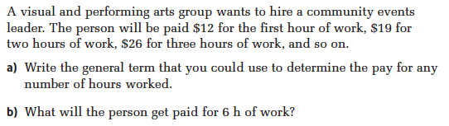
Your turn
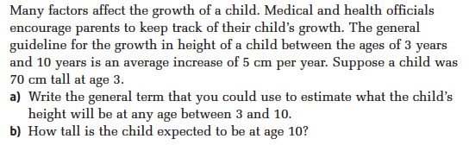
- Determining the number of terms:
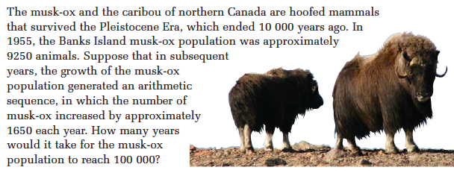
Your turn
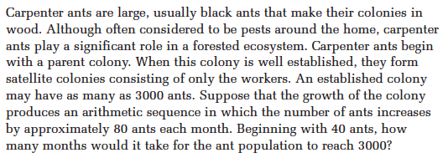
- Determining t₁, t_{n}, and n:
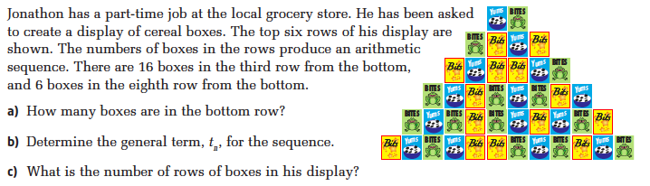
Your turn
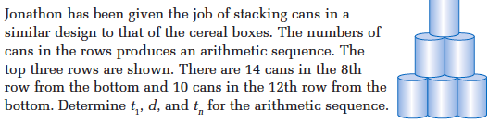
- Generate a sequence:
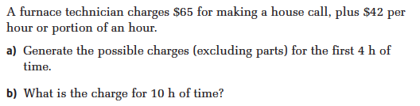
Your turn
Hwk: worksheet # 1c, 3 – 5, 8 – 11, 13, 16, 17, 22, 24, 26.

