ARITHMETIC SERIES

An arithmetic series is a sum of consecutive terms from an arithmetic sequence.

Example: 2 + 4 + 6 + 8 + 10 is an arithmetic series. We write S₄ = 2 + 4 + 6 + 8

To calculate a sum, we can use the following formula when we know the value of the last term:

S_{n} =

If you don’t know the value of the last term, you’ll use the equivalent formula:
S_{n} =

In both cases, you need to know the number of terms…
Example 1 p 25: a) What is the 30th term of the arithmetic sequence: 2, 4, 6, …
b) Determine the sum of its 30 first terms.
Example 2: Determine the sum of the 25 first terms of the arithmetic sequence: -10, -3, 4, 11, …
Example 3: Determine the following sum: 7 + 14 + 21 + … + 98
Be careful, there is no formula to link 2 different sums…
When you solve a problem, you usually try to find a formula that links what you know with what you want, but sometimes, it’s not possible…
Example 4:
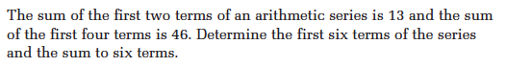
your turn
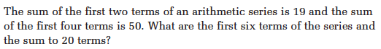

Example 5: Determine the 1st term and the common difference of the arithmetic sequence if its 5th term is 18 and the sum of its 10 first terms is 215.
Hwk: worksheet # 1ac, 2ac, 3ac, 4ac, 5, 7, 9-11, 13, 16, 17, 21, 23

