**PRACTICE Midterm – Chapter 5**

**MULTIPLE CHOICE**

____ 1. What is the Range of this Relation ?



____ 2. Let ,   
a) determine .   
  
  
  
b) Determine *x* such that $f(x)=6$

____ 3. a) On which portion(s) of the trip did the bus stop?

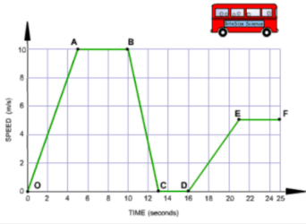

|  |  |  |  |  |  |  |  |
| --- | --- | --- | --- | --- | --- | --- | --- |
| a. | AB | b. | CD | c. | EF | d. | AB, CD and EF |

b) On which portion(s) of the trip did the bus drive accelerate the most?

|  |  |  |  |  |  |  |  |
| --- | --- | --- | --- | --- | --- | --- | --- |
| a. | OA | b. | AB | c. | BC | d. | DE |

____ 4. Which graph represents the cost of kayak rentals as a function of time?

|  |  |  |  |
| --- | --- | --- | --- |
| a. |  | c. |  |
| b. |  | d. |  |

____ 5. Determine the Domain and the Range of these graphs.

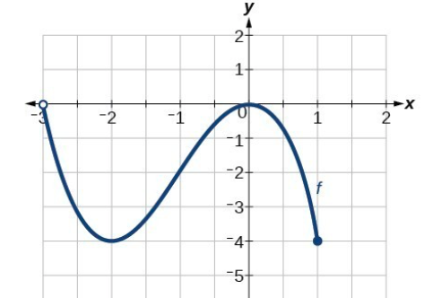 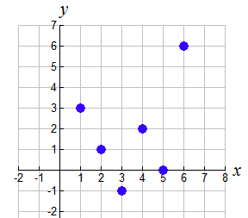

____ 6. Someone graphed some data about a school dance.  
Could the dots be connected? What is the restriction on the domain?



|  |  |
| --- | --- |
| a. | The Domain can only be positive numbers. |
| b. | The domain can only have 5 values between 50 and 350. |
| c. | The domain must be only whole numbers. |
| d. | The domain can only contain multiples of 50. |

____ 7. The graph represents the height of a plane during its descent. What is the rate of change?



**Short Responses**

8. Why aren’t the points connected?

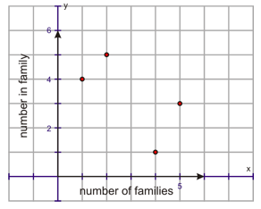

9. Determine the domain and the range.

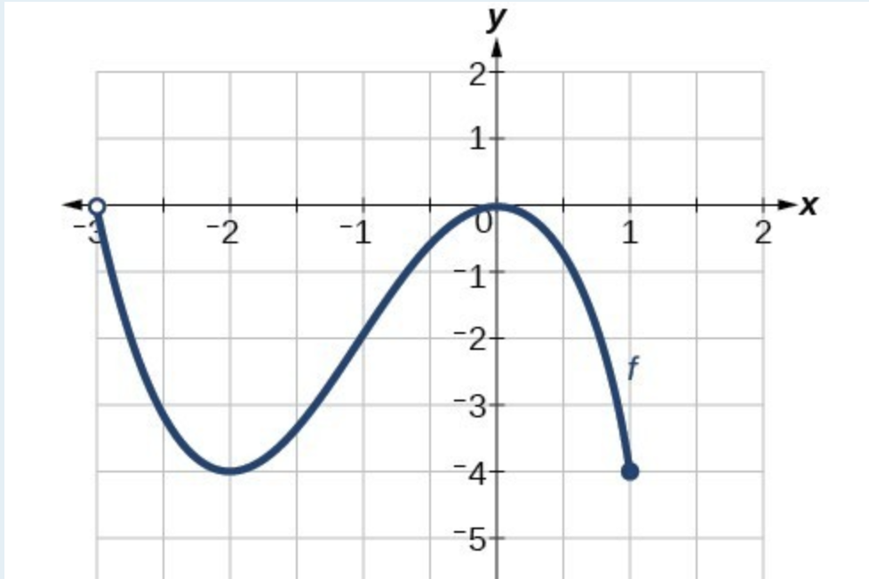

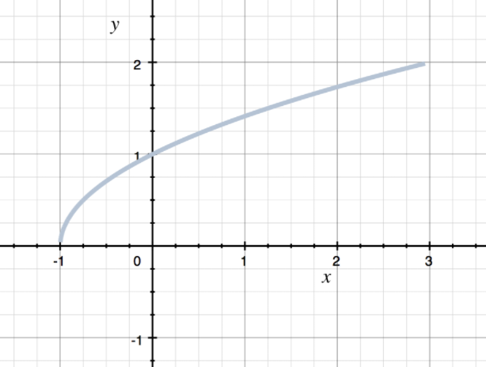

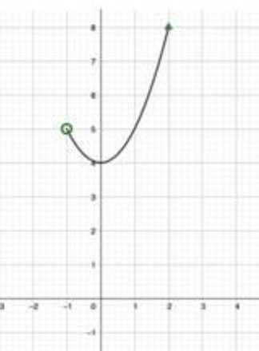

Determine the following values:

1. c)  
   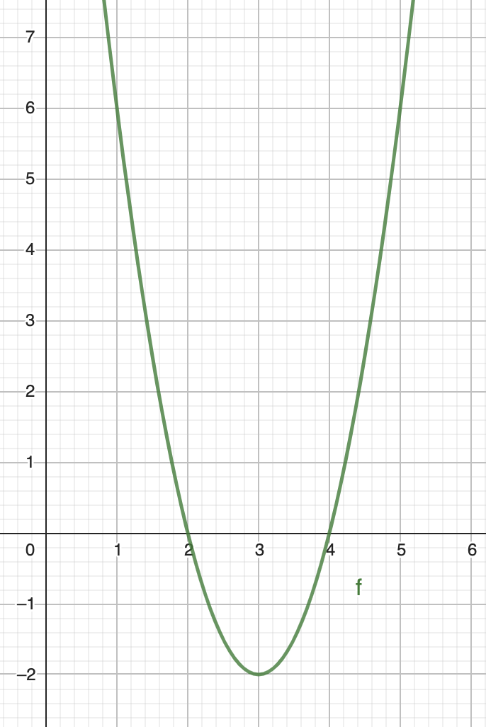 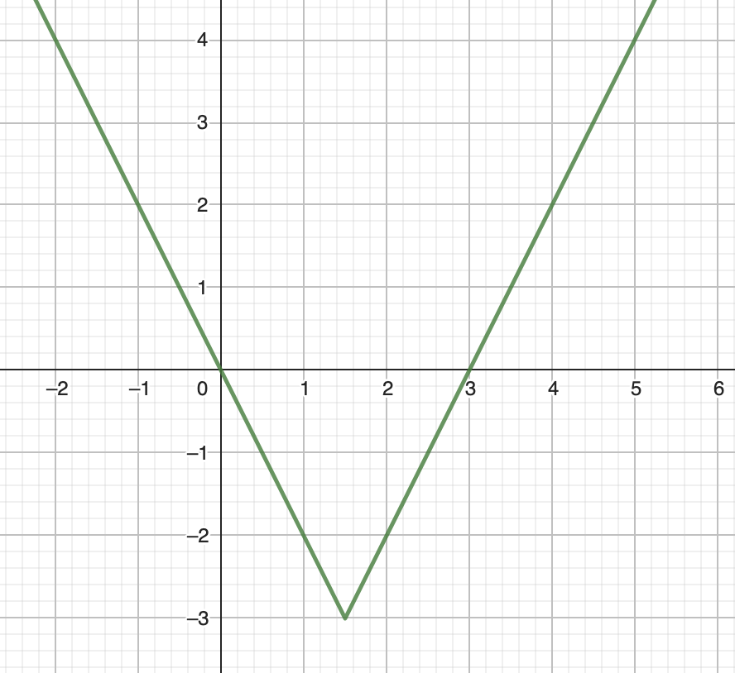

$f\left(1\right)=$ $f\left(3\right)=$ $f\left(2\right)=$ $f(4)$*x* when $f\left(x\right)=0$*x* when

1. 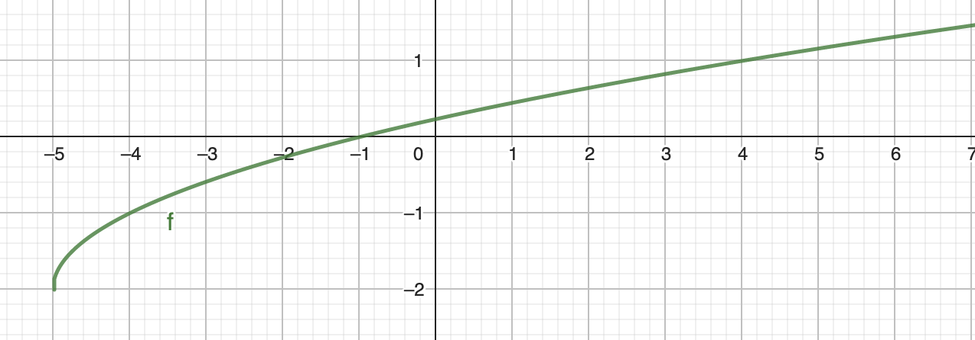

*x* when

10. This graph represents the cost, *C* in dollars, to print flyers for the school play, as a function of the number of flyers printed, *n*. What is the cost for 1000 flyers?



11. Sketch the graph of a function with domain  and range .



12.



a) What are the dependent and independent variables?

b) Sohan,, who has access to the coordinates of the 3 points, calculates the rate of change as follow:

Variation of the cost: 

Variation of the number of pamphlets: 2000 – 500 = 1500

Rate of change: 

Is it correct?

c) What does the rate of change represent?

13. A specific paint can be bought in 4L buckets for $52. One bucket can cover 37 m2 .  
There are 8 buckets in stock in the store.

a) Fill the table:

|  |  |  |  |  |  |
| --- | --- | --- | --- | --- | --- |
| **Volume of paint, V(L)** | 0 | 4 |  |  |  |
| **Cost, *c* ($)** |  |  |  |  |  |
| **Area covered *A* (m2)** |  |  |  |  |  |

b) Graph the area as a function of the volume.



c) Graph the area as a function of the cost.



d) What are the domains and ranges for the 2 previous questions ?