Mini QUIZ – Domain, Range and Values

- Consider the following graph of $y=f(x)$ :
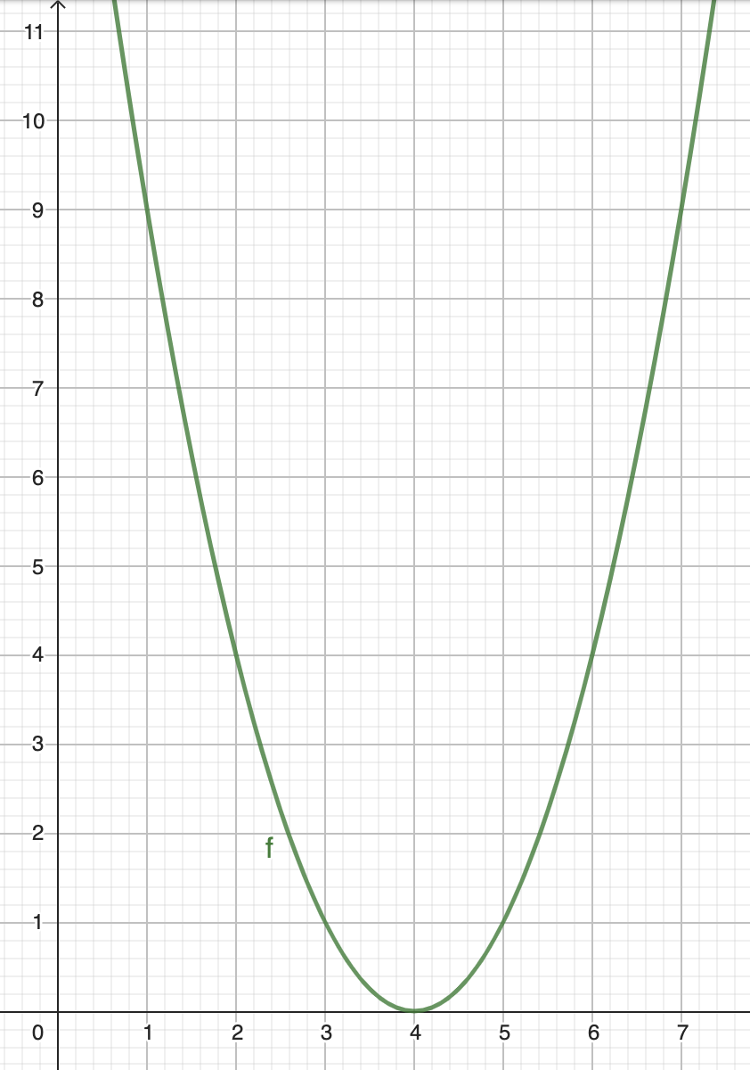
a) Domain : Range : [2]
b) Determine the following values : [1]
$f\left(3\right)=$ $f\left(4\right)=$
c) Determine x such that $f\left(x\right)=4$ [1]
- Consider the function $f\left(x\right)=-x+3$
a) Determine $f(-5)$ [1]
b) Determine $f(3)$ [1]
c) Determine the exact value of x such that $f\left(x\right)=-8$ [2]

