Chapter 5 Part I – Worksheet

Dependent and independent variables
Determine which variable is dependent and which is independent in the following relations:
- $P=20n+8$
- $C=\frac{5}{9}(F-32)$
- The relation between the time t of driving and the number of kilometres driven D.
- The relation between the height (h) of a child and the age (a) of the child.
- The following relation presented that way:
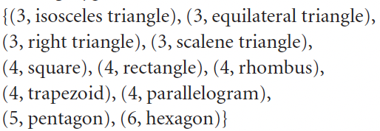
- f)
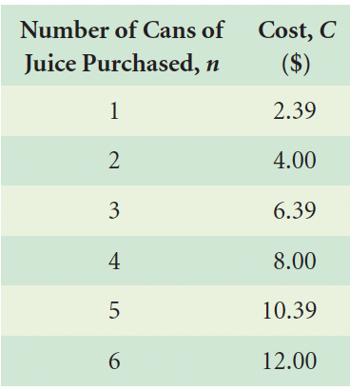 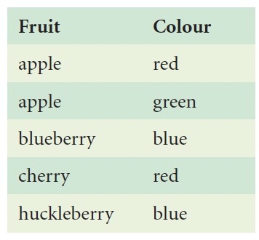

Domain and Range
Determine the domain and range of the following relations:
- 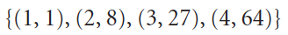
- 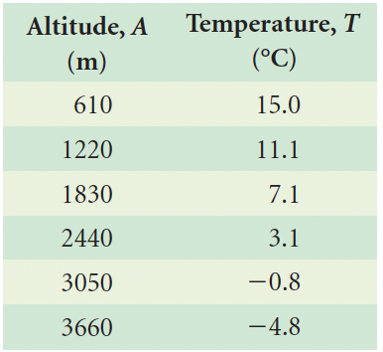
- 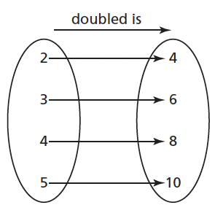
- 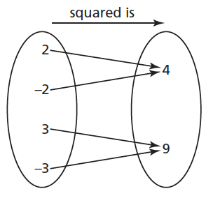
- 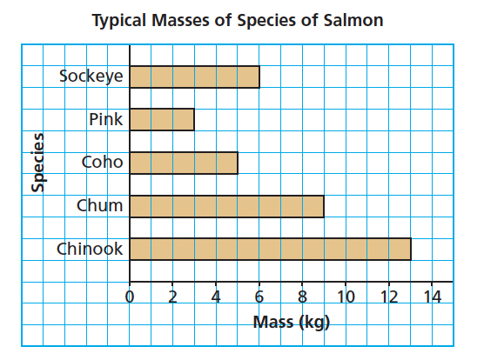
- 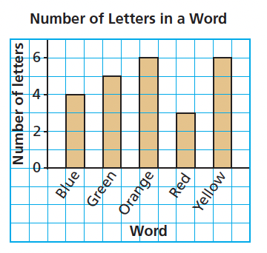
- $P=5n+5$, where P is the price paid at the cinema and n is the number of friends who came among the 5 friends you invited.
- The number of pieces of pizza left depending of the number of friends that came to your house (you’ve only invited 4 friends and you have 4 pizzas cut into 6 pieces each at the start)

