Chapter 5 Practice TEST
- For the following relations, determine if they are functions. Determine their domain and range and which variable is the independent/dependent one.
a) $A=πr^{2}$
b) $C=5n+30$
c) The salary, S, when you work t hours in a week, knowing that you are paid $10/hour.
d) The price paid for ice creams if you invite up to 10 friends and each ice cream costs $3.
e)
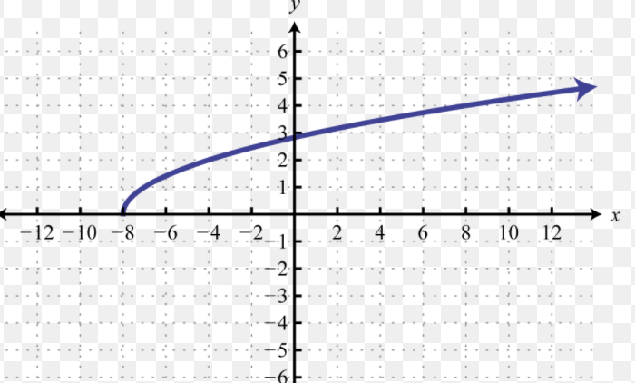
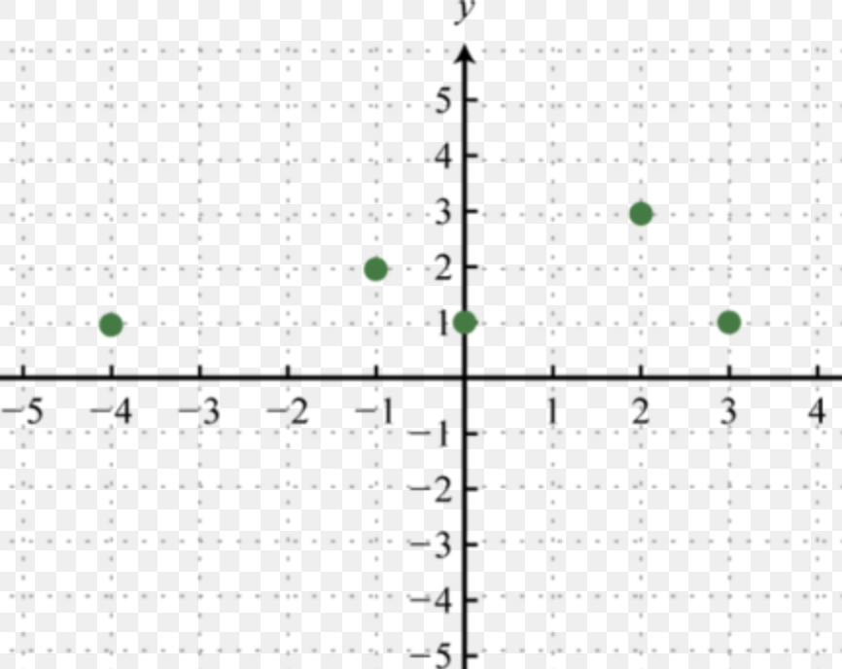
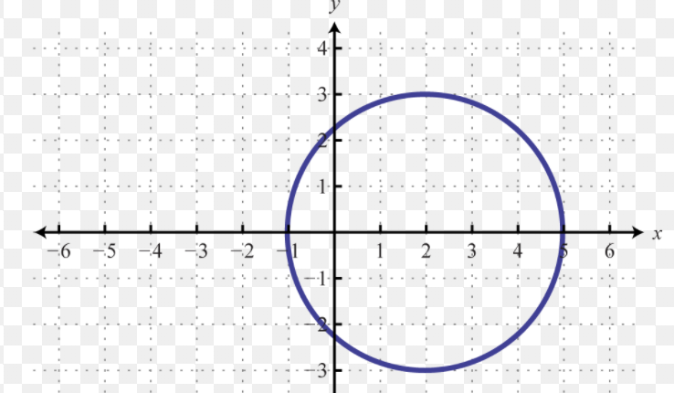
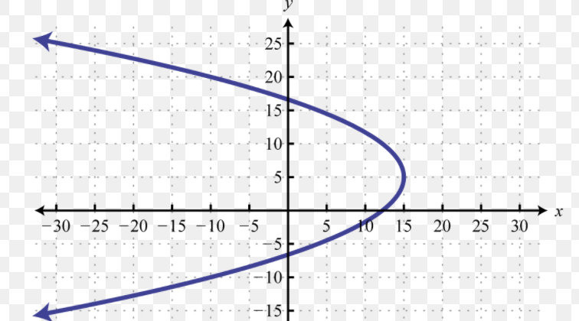
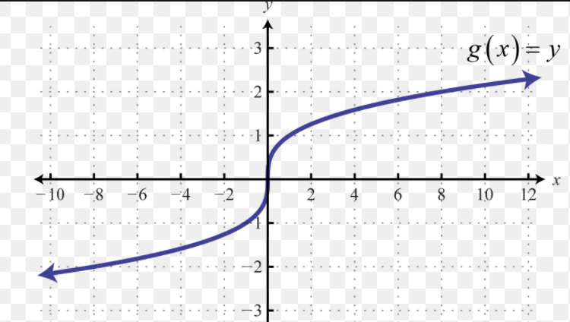
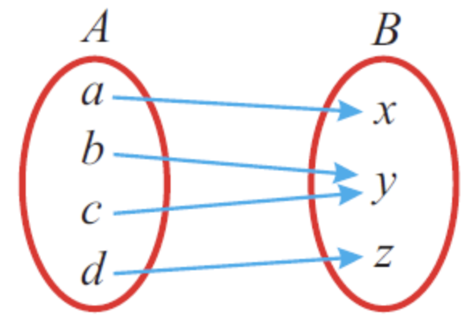
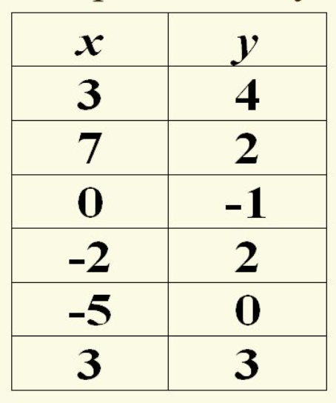
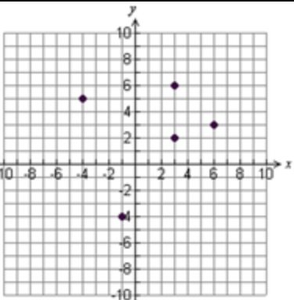
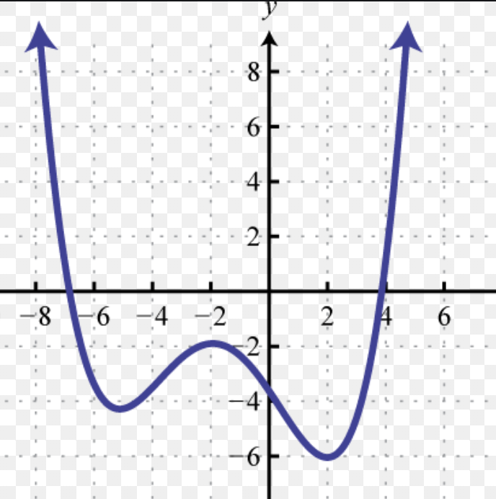
- Let $f\left(x\right)=3x-5.$
a) Determine $f(-4) .$
b) Determine $f\left(5\right).$
c) Determine x such that f(x) = 20
d) What are the x and y intercepts ?
- Let $f\left(x\right)=-x+1.$
a) Determine $f\left(-3\right).$ Determine $f\left(5\right).$
b) Determine x such that $f\left(x\right)=-15$ ?
c) What are the x and y intercepts ?

- Let’s consider the following relation for the interests received in January this year:
Time (days) | Interest ($)
0 | 2
5 | 3
12 | 4
21 | 5
a) Graph it, and explain why you are or aren’t connecting the dots.
c) Could you extend the graph ? Could you interpolate ?
d) Determine the domain and range.

- Determine the following values from the graph of $y=f(x)$ :
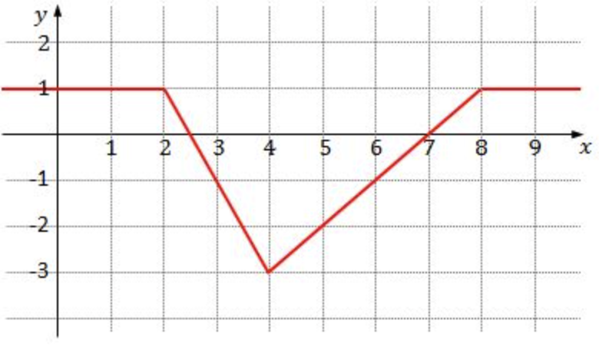
a) $f\left(-1\right)=$

b) $f\left(4\right)=$
c) $f\left(1\right)=$
d) the value(s) of x such that $f\left(x\right)=-1$

- Determine the following values from the graph of $y=f(x)$ :
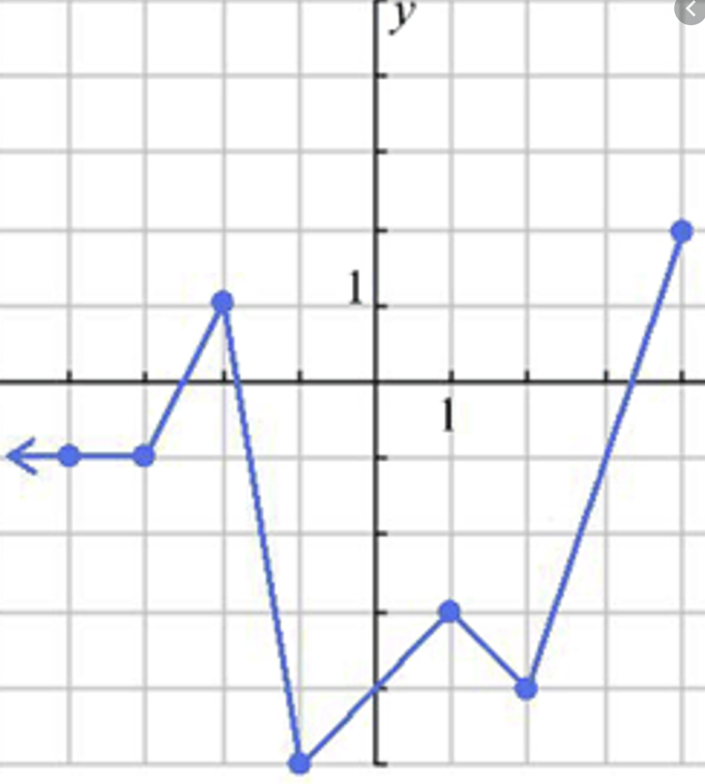
a) $f\left(2\right)=$

b) $f\left(0\right)=$
c) $f\left(-1\right)=$
d) the value(s) of x such that $f\left(x\right)=2$

a) $f\left(2\right)=$

b) $f\left(0\right)=$
c) $f\left(-1\right)=$
d) the value(s) of x such that $f\left(x\right)=1$

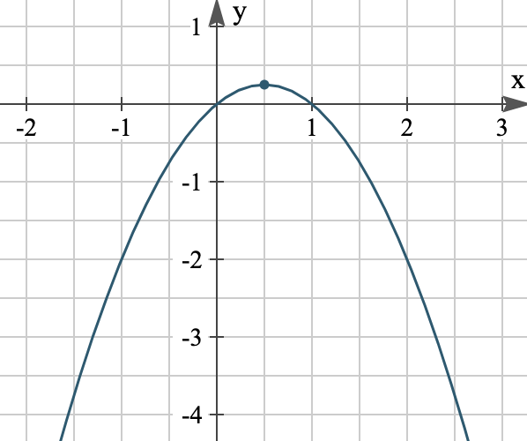

- Alex sells organized day trips. She charges $125 a day, plus $55 more for each participant. Let n be the number of participants on a given day and P her benefit for that day.
a) Determine an equation for P as a function of n.
b) Write that equation in function notation.
c) Determine P(6). What does it represent in this situation ?
d) Determine n such that $P(n)=730$. What does it represent in this situation ?
- Complete the following table of values for: $f\left(x\right)={3x}^{2}-12x+1$ and then graph it.
x | $$0$$ | 1 | 2 | 3 | 4 | 5
y

- Complete the following table of values for: $f\left(x\right)={-x}^{2}+2x+3$ and then graph it.
x | $$-2$$ | $$-1$$ | 0 | 1 | 2 | 3
y

- Describe a possible scenario:
a)
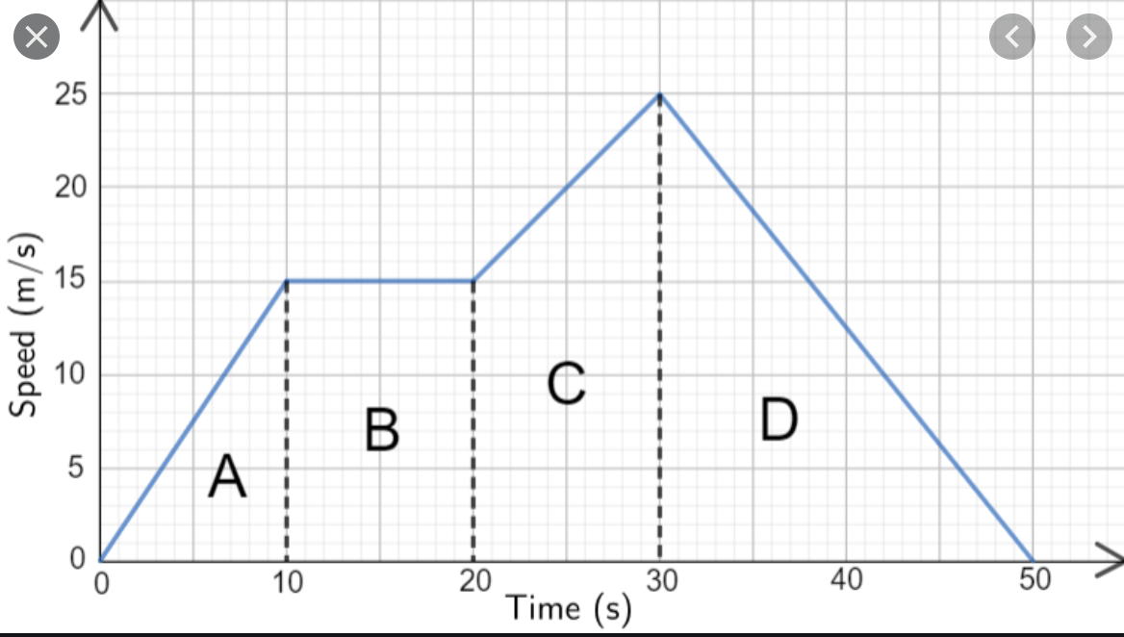
b)
