Chapter 5 TEST

- Jose leaves his home and walks to the store. It takes him 10 minutes to reach the store. After buying a drink (which took 5 minutes), he slowly jogs to his friend’s house. It takes him 20 minutes. He visits with his friend for 1 hour and then runs directly home at the same speed as previously.
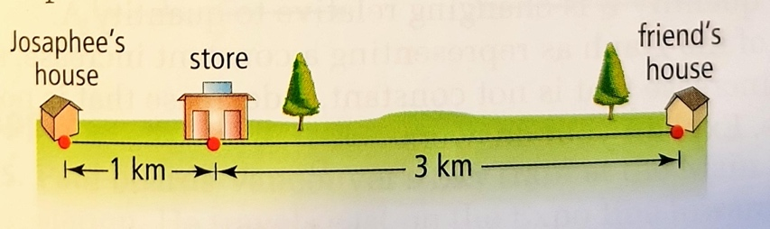
a) Using the distances shown above, draw a distance-time graph that shows Jose’s distance from his house as a function of time. [2]
b) Draw a speed-time graph of the same situation. [2]
- For the following graphs, determine the domain and Range and say if it represents a function of not. [12]
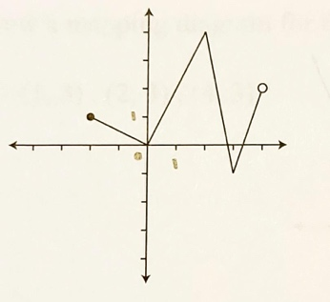
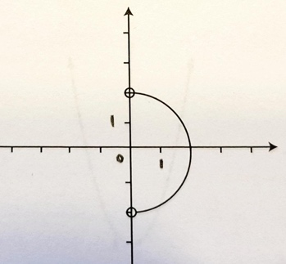
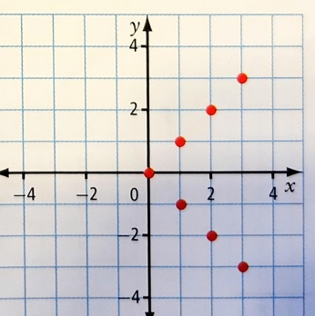
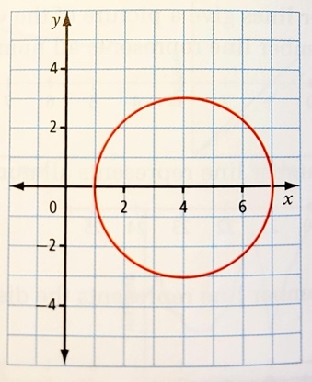
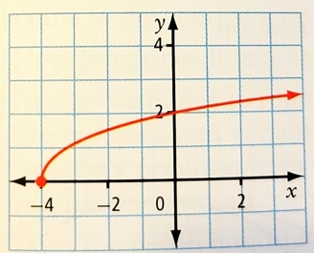
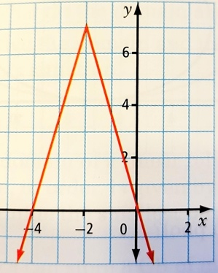
- Are these following relations functions? No justification required. [2]
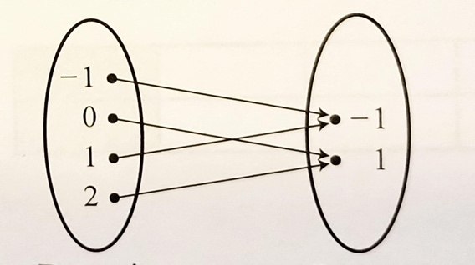 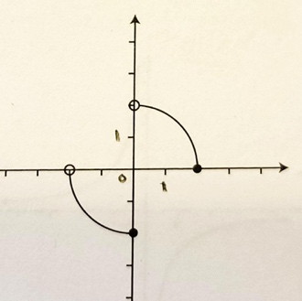
- Consider the following graph of a function f. Determine the following values: [4]
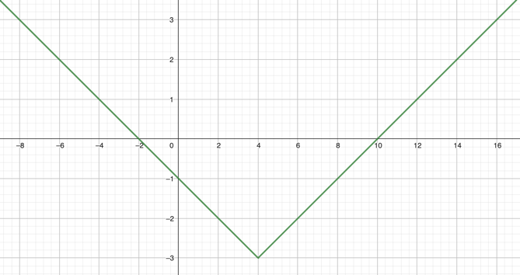
$f\left(-2\right)=$
$f\left(0\right)=$

$f\left(2\right)=$
$x$ such that $f\left(x\right)=0$
$x$ such that $f\left(x\right)=2$

- a) If you want to graph a relation, which variable (dependent or independent) do you put on the y-axis? [2]
b) If you create a vertical table of values on which column do you put the values of the independent variable?
c) If there is a relation between a price paid and the number of guests invited, which one is the dependent variable?
d) In the formula $p=2πr$, which variable is the independent one?
- Fill the table of values for the following equation and graph your data. $y=-x^{2}+4$ [2]
$$x$$ | $$-3$$ | $$-1$$ | $$0$$ | $$2$$ | $$4$$
$$y$$

- a) Graph 2 relations with domains $[0,5]$ and Ranges $[-2,3]$. [2]
The first one should be a function, and the 2nd one should not be a function.
b) Same question with domains $\left\{-4, 0, 6\right\}$ and Ranges $\left\{-3, 5\right\}$ [2]
- Consider the following function: $f\left(x\right)=-2x+5$ [4]
Determine the following values (make sure you present your work properly):
a) $f\left(3\right)=$
b) $f\left(-3\right)=$
c) $x$ such that $f\left(x\right)=-3$
d) $x$ such that $f\left(x\right)=10$

