QUIZ – Chapter 5 Part III & 6.1 – 6.3

- Below is a table which represents the value of an antique dresser as a function of the number of years since purchase.
Number of years since purchase t | Value V ($)
0 | 350
1 | 400
2 | 450
5 | 600
10 | 850
a) Is the relation linear? Explain. [1]
b) Which variable will you put on the x-axis if you represent this function graphically?
[1]
c) What is the rate of change? And what does it represent? [2]
- Determine if the following relations are linear. You do not need to justify your answer.
[2]
a) The volume of a sphere as a function of its radius: $V=\frac{4}{3}πr^{3}$.
b) $y=-3x+1.2$
c) The relation between the value of an investment as a function of the number of years, knowing that it increases by 8% each year.
d) The amount of fuel left as a function of the number of kilometres driven at a constant speed.
e) ) $y=2x^{2}-3$
- Answer the following questions about the graph below:
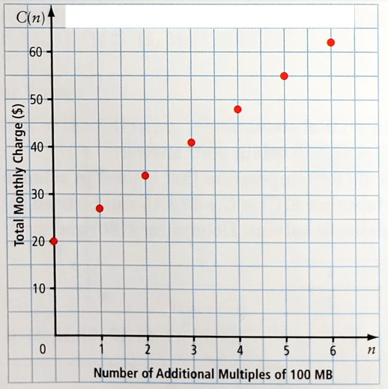
a) What is the independent variable? [1]
b) Is this relation linear? Justify [1]
c) What is the rate of change? What does it represent? [2]
- What is the slope and the y-intercept of the following lines: [3]
- $y=\frac{2}{3}x-4$
slope: _______
y-intercept : _______
- $y=x-2$
slope: _______
y-intercept : _______
- Draw a line corresponding to each situation: [2]
a) positive slope b) undefined slope
c) negative slope d) slope 0
- Fill the table with the words: parallel, perpendicular, neither. [3]
 | $$y=\frac{1}{3}x-5$$ | $$y=3x-5$$ | $$y=-3x-5$$
$$y=-\frac{1}{3}x+5$$
$$y=\frac{1}{3}x+5$$
$$y=3x+5$$

- Determine the slope of a line that passes through the points A(205 ; -140) and B(-20 ; 10).
[2]

- Determine the slope of the segments AB and CD. [2]
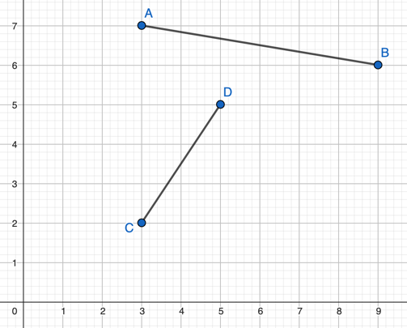
- Consider the points A, B, C et D on the figure below. Is ABCD a rectangle? Justify. [2]
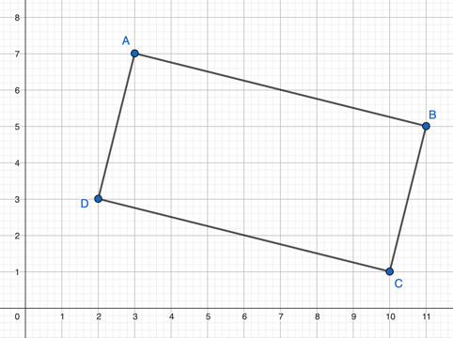
- Consider the equation $y=-2x+5$ [2]
Find the x and y-intercepts and use them to graph it.

