QUIZ 5 Part IV & 6.1 – 6.3

- Below is a table which represents the cost of a rental as a function of the number of km travelled.
Distance d (km) | Cost C ($)
0 | 50
100 | 80
200 | 110
300 | 140
400 | 170
a) Is the relation linear? Explain. [1]
b) Which variable will you put on the y-axis if you represent this function graphically? [1]
c) What is the rate of change? And what does it represent? [2]
- Determine if the following relations are linear. You do not need to justify your answer. [3]
a) The volume of a sphere: $V=\frac{4}{3}πr^{3}$
b) perimeter of a circle as a function of its radius: $p=2πr$.
c) The relation between the value of a car and the number of year that have passes, if the car loses
10% of its value each year.
d) The number of legs as function of the number of chickens considered.
e) $y=-\frac{2}{3}x+3$
f) $y=5x^{2}+3$
- Answer the following questions about the graph below:
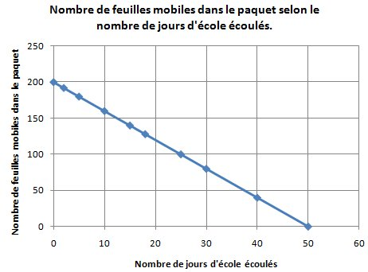
Number of days at school

Number of loose leaf paper
Number of loose leaf paper in relation to the number of days at school
a) What is the independent variable? [1]
b) Is this relation linear? Justify [1]
c) What is the rate of change? What does it represent? [2]
- What is the slope and the y-intercept of the following lines: [3]
- $y=\frac{2}{5}x-3$
slope: _______
y-intercept : _______
- $y=x+5$
slope: _______
y-intercept : _______
- Sketch an example of a line with respect to the following restrictions. [2]

#4 – slope = 0
#1 – positive slope

#2 – negative slope
#3 – undefined slope

- Fill the table with the words: parallel, perpendicular, neither. [3]
 | $$y=\frac{1}{5}x-1$$ | $$y=-\frac{1}{5}x-1$$ | $$y=5x-1$$
$$y=-\frac{1}{5}x+1$$
$$y=\frac{1}{5}x-1$$
$$y=-5x-1$$

- Determine the slope of a line that passes through the points A(145 ; -3) and B(-15 ; 231). [2]

- Determine the slope of the segments AB and CD. [2]
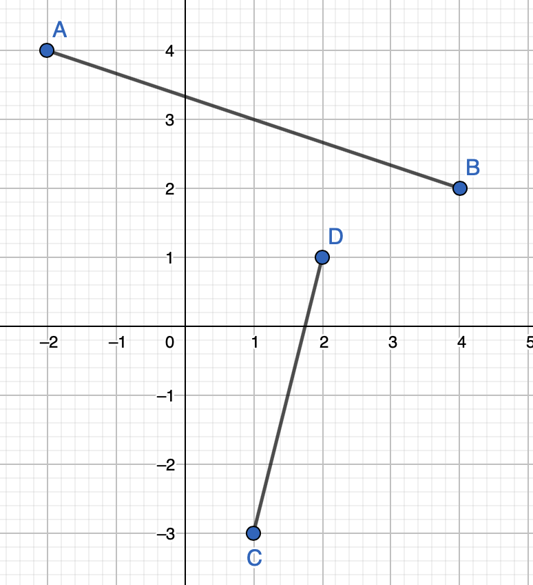

- Consider the points A, B, C et D on the figure below. Is ABCD a parallelogram? Justify. [2]
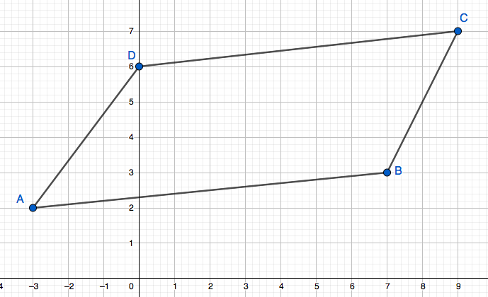
- a) On the graph below, place the points A(1 ; -3) and B(-2 ; 4) [1]
b) Determine the coordinates of a possible point C if ABC is a right triangle (right angled at A). [1]

- Consider the equation $y=\frac{2}{5}x-4$
- What is its y-intercept? [1]

- What is its x-intercept? [1]

- Using the information from a) and b), sketch a graph of the equation. [1]

