QUIZ 6.3 – 6.5

- Graph the following lines: [2]
a) $y=-\frac{3}{4}x+5$ b) $y-1=\frac{1}{7}(x-3)$
- Determine an equation for each of the following lines: [2]
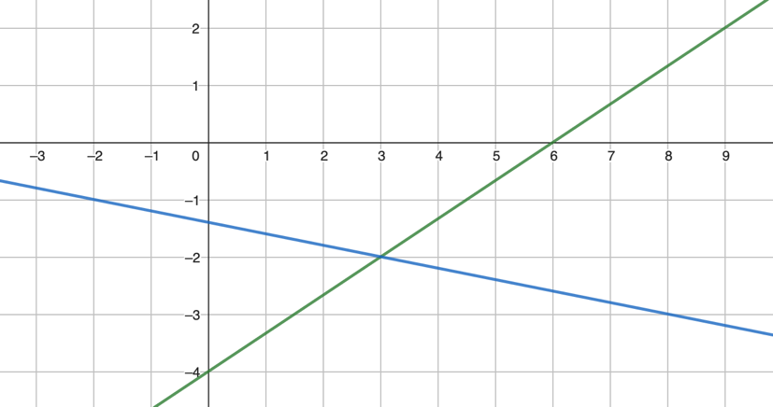
- If a line has equation $y-3=\frac{5}{3}(x+2)$, its slope is ______ [2]
and it passes through ( _____ ; _____ ).
- Change this equation into slope-intercept form: $y+3=-\frac{1}{6}(x-3)$ [2]
- Determine the y-intercept of the following lines: [2]
a) $y=3x-5$ b) $y+1=-\frac{5}{6}(x-2)$
- Determine the equation in slope-intercept form of the line with slope $\frac{1}{2}$ and passing through $\left(-2 , 3\right)$, [2]
- Determine an equation of the line passing through $A(1,5)$ and $B(-2,-3)$. [2]
- Determine algebraically the x and the y-intercepts of the line with equation $y=-\frac{3}{5}x+6$
[2]
- The student council sponsored a dance. A ticket cost $5 and the cost for the DJ was $300.
a) Write an equation for the profit P dollars, on the sale of t tickets. [4]
b) Suppose 123 people bought tickets. What was the profit?
c) Suppose the profit was $350. How many people bought tickets?

