Chapter 6 TEST
- Are the following relations linear functions? Justify. [3]
a)
$$x$$ | $$y$$
2 | 5
4 | 8
6 | 11
10 | 17
b) $y=-3x+5$
c) $y=5$
d) $x=2$
e) $y=2x^{2}-3$
f)
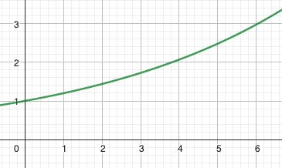
- Match each graph with its slope: [2]
a) ___ b) ___ c) ___
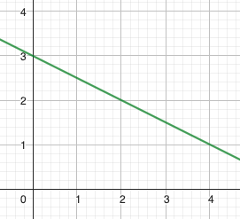 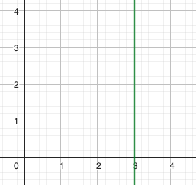 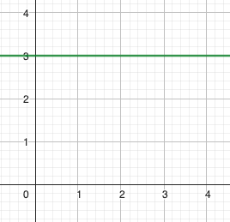
d) ___ e) ___ f) ___
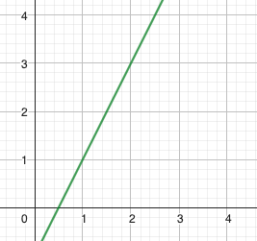 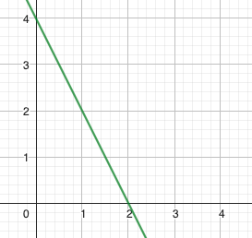 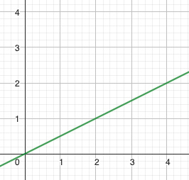
A: $-2$ B: $\frac{1}{2}$ C: $2$ D: $-\frac{1}{2}$ E: $0$ F: undefined
- Determine if the following lines are parallel, perpendicular or neither. [2]
Equations | $$y=-2x+3$$ | $$y=2x-3$$ | $$y=\frac{1}{2}x+3$$
$$y=-\frac{1}{2}x+3$$
$$y=\frac{1}{2}x-3$$
$$y=-2x-3$$

- Let $A(4,3)$, $B(10,2)$, $C(11,7)$ and $D(5,8)$. [2]
- Is ABCD a parallelogram?
- Is it a rectangle?

- Rewrite the following equations in slope-intercept forms: [2]
a) $2x-3y+5=0$ b) $y+2=-\frac{1}{3}(x-4)$
- Rewrite the following equations in general forms: [2]
a) $y-2=\frac{2}{7}(x+14)$ b) $y=-\frac{1}{3}x-4$
- Determine an equation for each line graphed below: [2]
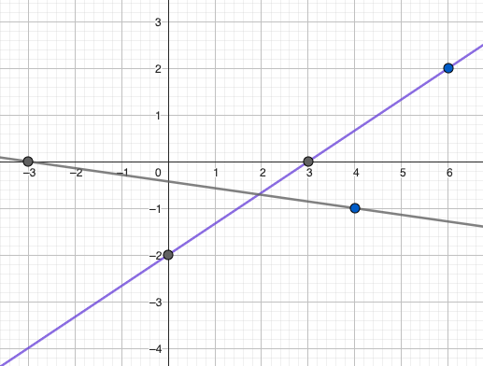
- Determine the y-intercepts of the following functions: [2]
a) $y=-3x+5$ b) $y+1=\frac{1}{5}(x-3)$ c) $2x-3y+5=0$
- Graph the following functions (show at least 2 exact points): [3]
a) $y=-\frac{4}{5}x+3$ b) $y+4=\frac{2}{7}(x-3)$ c) $3x-4y=-12$
- a) Determine an equation of a line going through the origin and perpendicular to the line with equation $y=\frac{1}{3}x+4$. [1]
b) Determine an equation in slope-intercept form of a line through $A(5,-4)$ and parallel to the line with equation $y=\frac{1}{4}x-1$. [2]
- Julian wants to order t-shirts online. The shipping fee is $25 per order and each t-shirt costs $31.50. Present your work clearly for each question. [3]
- Determine an equation to represent the price paid, P, as a function of the number of t-shirts ordered, n.
- How much will Julian pay if he orders 5 t-shirts?
- Julian received a bill for $277. How many t-shirts did he order?

