Chapter 5 – Extra Practice

- Consider the following graph of $y=f(x)$ :
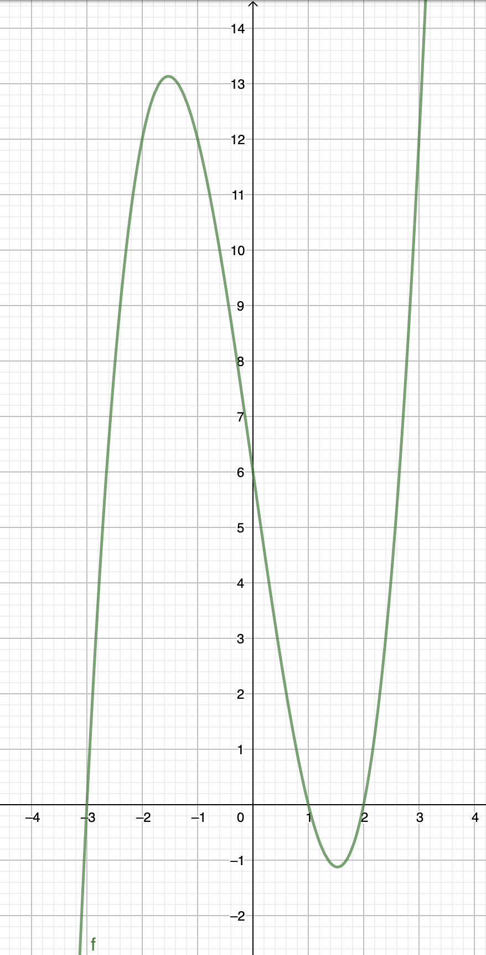
a) Explain why it is a function
b) Domain : Range :
c) Determine the following values :
$f\left(0\right)=$ $f\left(1\right)=$
$f\left(2\right)=$ $f\left(-2\right)=$
d) Determine x such that $f\left(x\right)=0$
e) Determine x such that $f\left(x\right)=12$
- Consider the following graph of $y=f(x)$ :
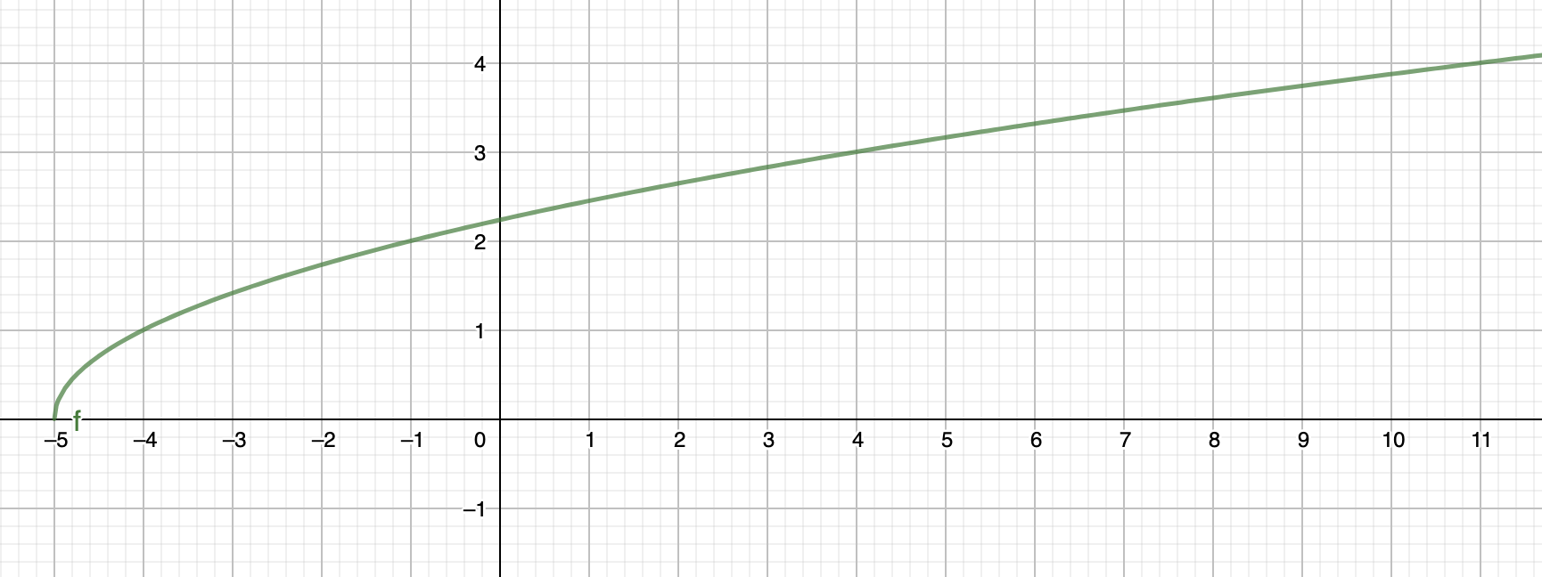
b) Domain : Range :
c) Determine the following values :
$f\left(-5\right)=$ $f\left(-1\right)=$
$f\left(4\right)=$ $f\left(0\right)=$
d) Determine x such that $f\left(x\right)=1$
e) Determine x such that $f\left(x\right)=4$
- Consider the function $f\left(x\right)=3x+5$
a) Determine $f(-2)$
b) Determine $f(3)$
c) Determine the exact value of x such that $f\left(x\right)=25$
- Consider the following graph of $y=f(x)$ :
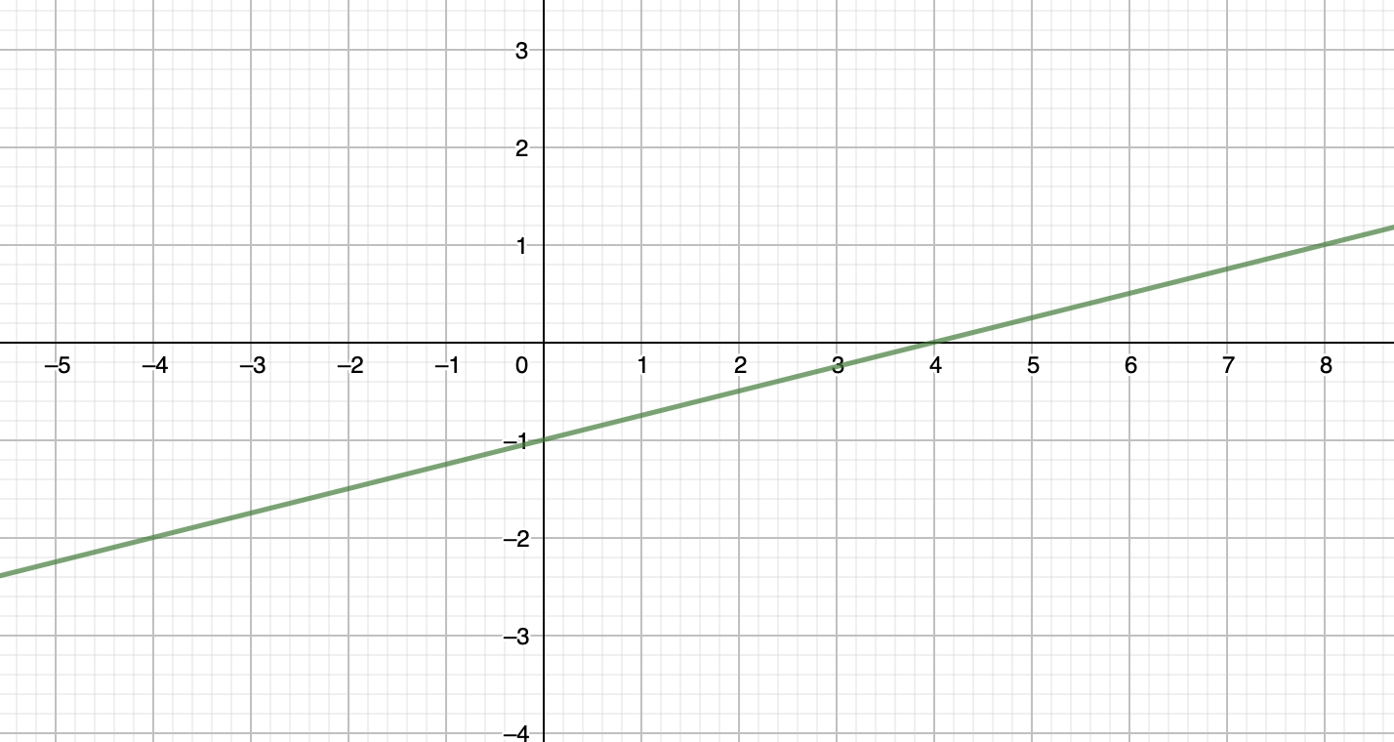
b) Domain : Range :
c) Determine the following values :
$f\left(0\right)=$ $f\left(-4\right)=$
d) Determine x such that $f\left(x\right)=0$
e) Determine x such that $f\left(x\right)=1$
- Consider the function $f\left(x\right)=-2x^{2}+3$
a) Determine $f(-2)$
b) Determine $f(3)$
c) Determine the exact value(s) of x such that $f\left(x\right)=-15$
- Consider the following graph of $y=f(x)$ :
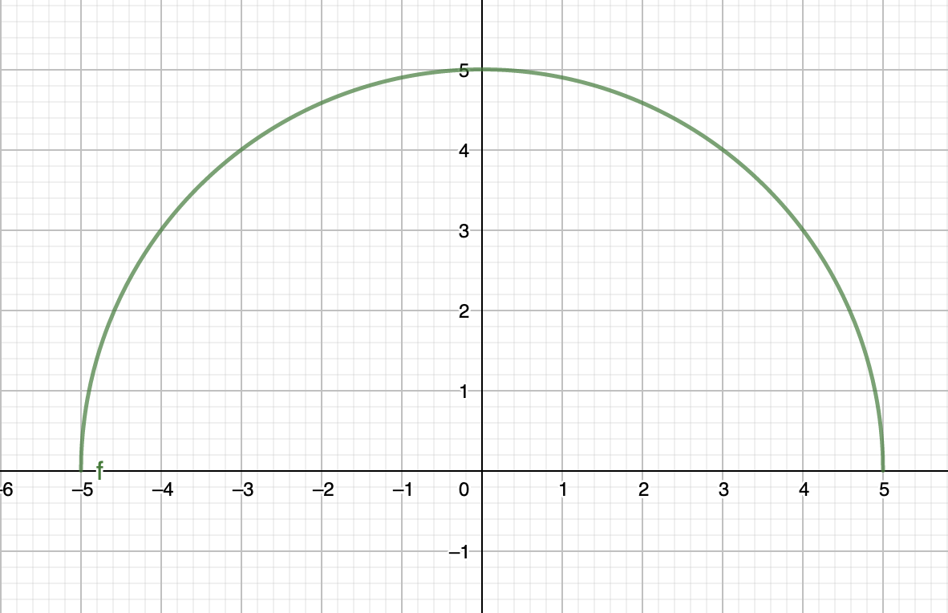
b) Domain : Range :
c) Determine the following values :
$f\left(-5\right)=$ $f\left(-4\right)=$
$f\left(0\right)=$ $f\left(3\right)=$
d) Determine x such that $f\left(x\right)=0$
e) Determine x such that $f\left(x\right)=3$
- Consider the function $f\left(x\right)=(x-3)(x+1)$
a) Determine $f(-2)$
b) Determine $f(3)$
- Consider the function $f\left(x\right)=-x^{2}+4x-2$
a) Determine $f(-2)$
b) Determine $f(3)$
- Consider the following graph of $y=f(x)$ :
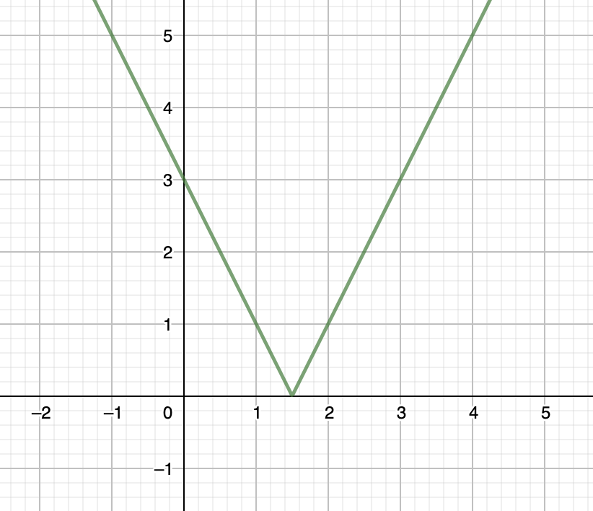
b) Domain : Range :
c) Determine the following values :
$f\left(0\right)=$ $f\left(1\right)=$
$f\left(2\right)=$ $f\left(3\right)=$
d) Determine x such that $f\left(x\right)=0$
e) Determine x such that $f\left(x\right)=5$

- Consider the function $f\left(x\right)=-x+5$
a) Determine $f(-2)$
b) Determine $f(3)$
c) Determine the exact value(s) of x such that $f\left(x\right)=-15$
d) Determine the exact value(s) of x such that $f\left(x\right)=72$

