- Graph the following lines and show at least 2 exact points :
a) $y=-\frac{1}{3}x+2$
a) $y=\frac{3}{4}x-2$
b) $y-2=-\frac{2}{3}(x+5)$
b) $y+3=\frac{1}{7}(x-1)$
c) $3x+4y=24$
c)$3x-5y=15$
- For each triangle, determine the value of the variable (to the nearest tenth when relevant) :
a)
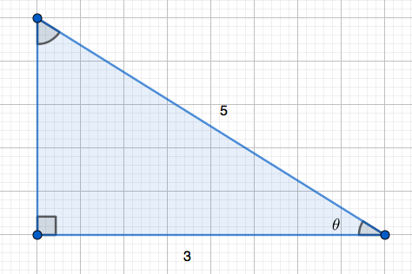
b)
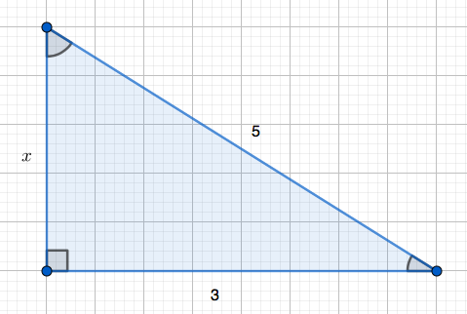
c)
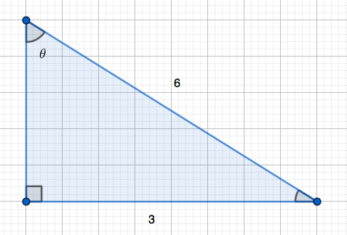
d)
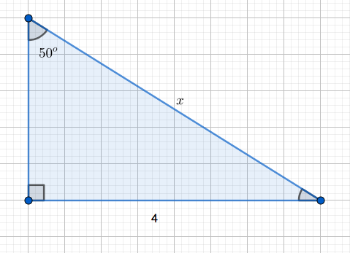
e)
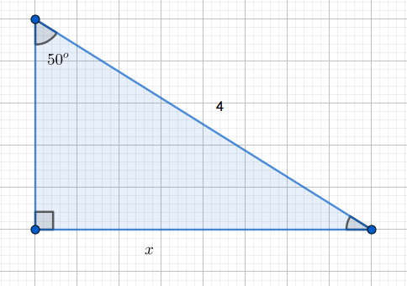
f)
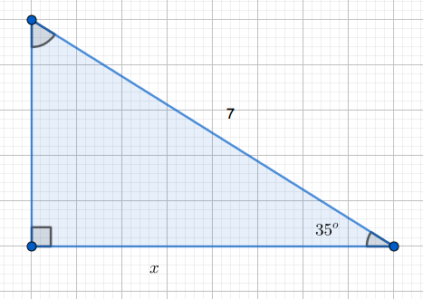
g)
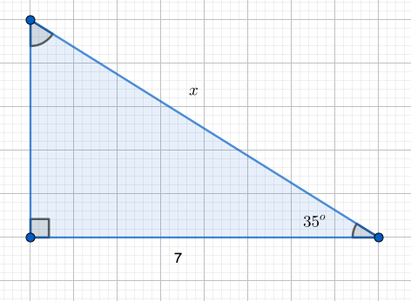
h)
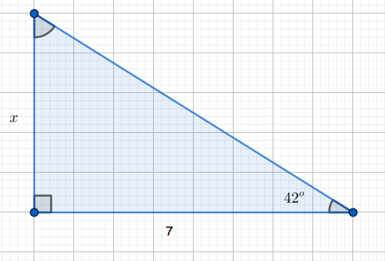
i)
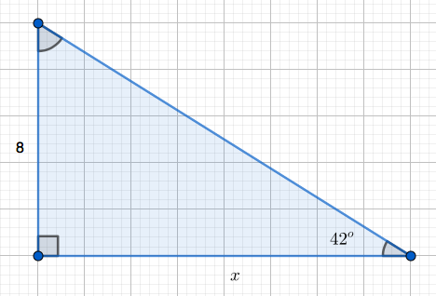
- Solve the following systems :
a)$\left\{\begin{aligned}2x-y=7 \\ 4x+y=5\end{aligned}\right.$a)$\left\{\begin{aligned}3x+2y=8 \\ 5x-3y=-12\end{aligned}\right.$
- Solve
a) $3-2\left(x-3\right)=5x-6$
b) $-3\left(x-5\right)=2x+7$
- Expand the following expressions and simplify :
$$A=\left(3x+4\right)\left(5x-6\right)-\left(2x+1\right)\left(3x-1\right) \\ B={\left(5x-2\right)}^{2}-5(3x-1) \\ C=\left(2x-1\right)\left(2x+1\right)-{\left(x-3\right)}^{2} \\ D=\left(2x-3\right)\left(x+2\right)-5x(x+5)$$
- Factor the following expressions as much as possible :
$$A=4x^{2}-16x \\ B=x^{2}-x-2 \\ C=25x^{2}-4 \\ D=25x^{2}-30x+9 \\ E=81x^{2}+18x \\ F=x^{2}+x-12 \\ G=49x^{2}-1 \\ H=36x^{2}+60x+25$$
- Express the following equations in slope-intercept form :
a) $y-3=-\frac{2}{5}(x+3)$
b) $2x-4y=7$
a) $y+2=-\frac{3}{4}(x-5)$
b) $5x-2y=8$
- Use the following graph to answer the questions (you can use approximations when needed):
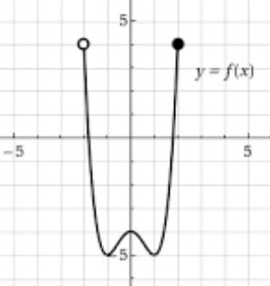
a) Domain : b) Range :
c) $f\left(-1\right)=$
d) solve $f\left(x\right)=-1$
- Use the following graph to answer the questions (you can use approximations when needed):
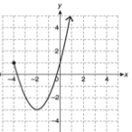
a) Domain : b) Range :
c) $f\left(-2\right)=$
d) solve $f\left(x\right)=-2$

