**Practice Final  
Chapter 3 – Polynomials**

**NO Calculator**

1. Factor these expressions as much as possible.  
  
 a) $x^{2}+4x-12$

b) $x^{2}-3x-4$

c) $50x^{3}y-15xy^{2}$  
  
  
  
  
 d) $9x^{2}-24x+16$

e)   
  
  
  
 f)   
  
  
  
 e)   
  
  
 e)   
  
  
  
 e)   
  
  
  
 e)

2. Expand and simplify :

a)

b)

c)

d)

e)

f)

3. Determine the value of *k* such that the expression factors into a perfect square :   
 a) $x^{2}+10x+k$ b) $4x^{2}-20x+k$

**Practice Final**

**Chapter 5 – Relations and Functions**

1. Let $g\left(x\right)=-\frac{2}{3}x+5.$ Determine $x$ such that $g\left(x\right)=25$.
2. Does the following graph represent a function ? Explain.



1. What is the max height of the tide that day?



1. Do the following graphs represent functions ? Explain. Determine their Domain and Range.

 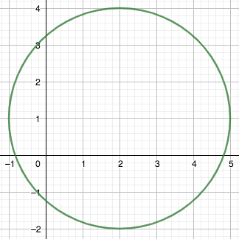

Function : __________________ Function : ___________________

Domain : ___________________ Domain : ____________________

Range : ______________________ Range : ______________________

1. The following graph represents the relation between the distance travelled by a vehicle and the number of tire revolutions. This relation can be modelled by the equation: $d=2.07r,$ where *d* is the distance travelled in metres and *r* the number of tire rvolutions. What is the distance travelled after 300 tire revolutions? Is the phenomenon discreet or continuous? Explain.



1. Create a story to describe Gail’s trip, according to the following graph representing its speed in km/h as a function of time t, in min.

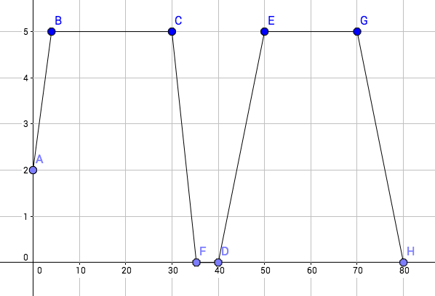

1. Let $f\left(x\right)=-2x^{2}+x-5$. Determine $f(-3)$.
2. A hélicoptère flies towards its destination.

|  |  |
| --- | --- |
| **Time (min)** | **Distance to Destination (mi.)** |
| 0 | 285 |
| 20 | 244 |
| 40 | 203 |
| 60 | 162 |
| 80 | 121 |

a. Identify the dependent and independent variables.

b. Is it a linear situation?

c. If it is linear, determine its rate of change.

d. If we assume that the helicopter continues with the same velocity, in how long will it reach its destination to the nearest minute?

**Practice Final  
Chapter 6 – Linear Functions**

1. Determine the equations of the following lines.

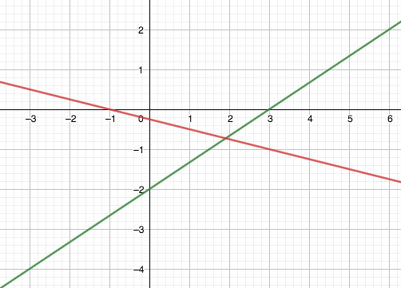

1. Rewrite in general form: $y-5=\frac{3}{5}(x+5)$.

1. A line goes through points $(a, 3)$ and $(2, 9)$. Its slope is $\frac{3}{5}$. Determine the value of *a* .

1. A line has *x*-intercept -8 and *y*-intercept 5.   
   Determine an equation of a line that is perpendicular to it and passes through point (-3 ;2).
2. Determine algebraically the *x*- and *y*-inrecepts of the line with equation : $5x+8y=40$ and graph it.



1. Francine owns a T-shirts business.   
    She charges $50 for each order, plus $8.95 per t-shirt ordered.
2. Write an equation of the total cost, *C* , in dollars, as a function of the number of T-shirts ordered *n*.
3. Marnell ordered 62 T-shirts. How much is she going to pay ?
4. Jacob paid $971.85. How many T-shirts did he order?
5. Determine the slope of the line with equation : $7x+3y+5=0$.

**Practice Final  
Chapter 7 – Systems of Linear Equations**

1. Create a system of linear equations to model the following situation:

Tickets for a play are sold $8 for adults and $4.75 for kids.

10 more tickets have been sold for kids than for adult. $1399 total has been collected with the sale.

1. Use the following graph to solve the system of linear equations : $y=-5x-2$



$y=5x-4$

1. Solve graphically the following system, then solve it algebraically.



$$y-8=5x$$

$$2x+y=1$$

1. A submarine moves at a speed of 20 km/h under water and 30 km/h on the surface.   
   The submarine travelled 650km in 25h. This situation can be modelled by the system :

$$u+s=25$$

$$20u+30s=650$$

where *u* represents the time travelled under water and *s* represents the time travelled on the surface.

1. Graph both equations.
2. Solve the system graphically :



1. a) Create a system of linear equations to model the following situation: A coach bought 25 pucks for its team for $70. Puck for practice cost $2.50 each and pucks for games cost $3.25 each.

b) Solve the system graphically and write a conclusion.



1. Create a system of equestions to model the following situation: For a school show, adult tickets cost $6 and students tickets cost $4. There were twice more students than adults. $2016 was made.

Solve the problem by substitution. Write a conclusion sentence.

1. Determine the number of solutions of the following system :

$$6s+6c=50$$

$$6s-6c=30$$