7.5 – Solve a System of Linear Equations by Elimination

Another algebraic strategy to solve a system of linear equations is called the elimination method. This method is usually faster than substitution when all the variables have coefficients.
Example 1: $\left\{\begin{aligned}4x-2y=10 \\ 5x+2y=26\end{aligned}\right.$
- If one variable has opposite coefficients in a group of two linear equations, that variable will disappear when we add the equations together.

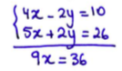
- We can then solve the equation for the remaining variable.
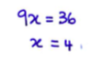
- To find the value of the other variable, we can substitute the value obtained into either of the two starting equations.
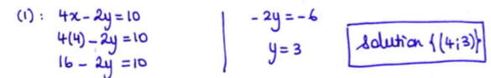
Example 2: $\left\{\begin{aligned}3x-4y=7 \\ 5x-6y=8\end{aligned}\right.$
- If neither of the variable are opposites, we can multiple each equation by well-chosen numbers that will make one of the variables opposites.
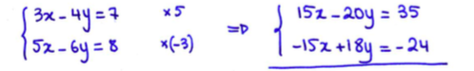

- We find one of the unknown variables.
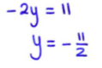

- To obtain the second variable, we can either do the elimination method again for the other variable or substitute the known variable into one of the starting equations (like we did in example 1)

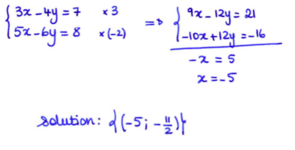
Your turn: $\left\{\begin{aligned}2x+7y=24 \\ 3x-2y=-4\end{aligned}\right.$

If the coefficients are fractions, it is often a good idea to make them whole numbers first…
Example: $\left\{\begin{aligned}\frac{2}{3}x-\frac{1}{2}y=4 ×3×2 \\ \frac{1}{2}x+\frac{1}{4}y=\frac{5}{2} ×2×2\end{aligned}\right. → \left\{\begin{aligned}4x-3y=24 \\ 2x+y=10\end{aligned}\right.$

Hwk: p.437 #3, 6, 12, 14-17, 22

