7.6 – Properties of the systems of linear equations
A system of two linear equations with two variables can have 0, 1 or an infinite amount of solutions.
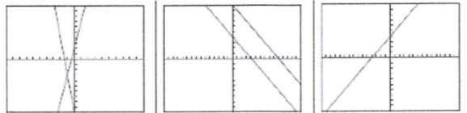
The slopes are different same slope but different same slope and same y-intercepts y-intercepts
$→1 solution$ $→no solution →an infinity of solutions$
Consequences: If we only want to know the number of solutions of a system, we need to write the two equations in their slope-intercept forms.
Examples:
- $\left\{\begin{aligned}2x+y=8 \\ 4x+2y=16\end{aligned}\right.$ b) $\left\{\begin{aligned}3x+y=9 \\ 6x+2y=12\end{aligned}\right.$ c) $\left\{\begin{aligned}x+y=8 \\ -5x+y=1\end{aligned}\right.$
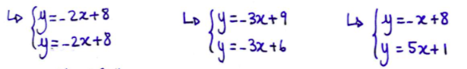$→an infinity of solutions →no solutions →1 solution$
Remark: What happens if we try to solve without finding the number of solutions?
- $\left\{\begin{aligned}2x+y=8 \\ 4x+2y=16\end{aligned}\right.$ b) $\left\{\begin{aligned}3x+y=9 \\ 6x+2y=12\end{aligned}\right.$ c) $\left\{\begin{aligned}x+y=8 \\ -5x+y=1\end{aligned}\right.$
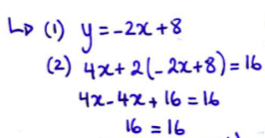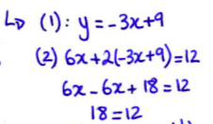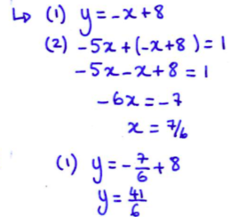
(always true) (never true )
$→$infinity of solutions $→$ no solution $→$ 1 solution
Hwk: p.448 # 4 – 8, 12 – 17, 22, 24

