Determining the values of a function from a graph - Worksheet

- Complete the following tables:
a) b)
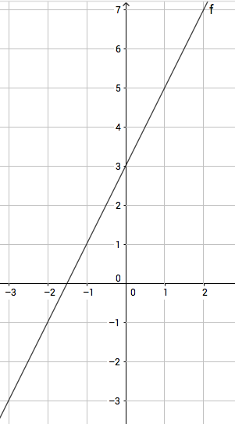 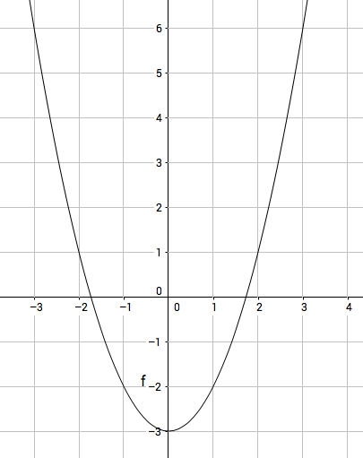

a)
x | -3 | 0 | 1
y |  |  |  | -1

b)
x | -1 | 0
y |  |  | 1 | 6

- Determine the following values for the function f:
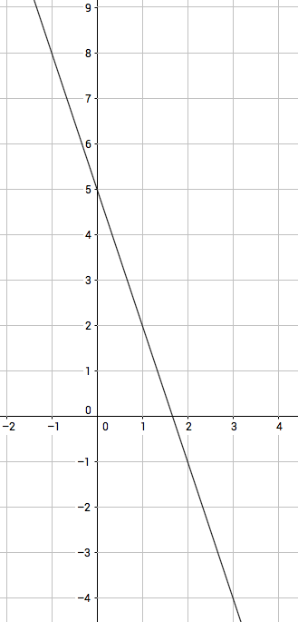
$f\left(0\right)=$ x when $f\left(x\right)=-2$

$f\left(1\right)=$ x when $f\left(x\right)=8$
- Determine the following values for the function g:
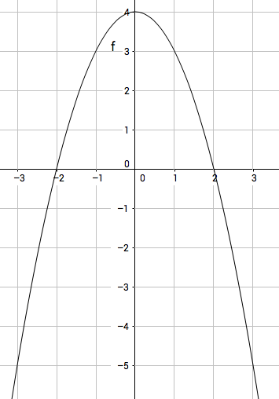

$f\left(0\right)=$ x when $f\left(x\right)=0$

$f\left(-1\right)=$ x when $f\left(x\right)=-5$

