Chapter 5 – Part II – Relations and Graphs
Reminder on coordinates on a Cartesian Plain
- Graphing relations
When we represent a relation graphically, we must place the independent variable on the x-axis and the dependent variable on the y-axis.
Examples :
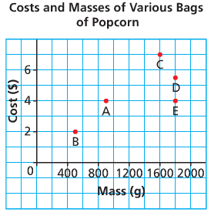or 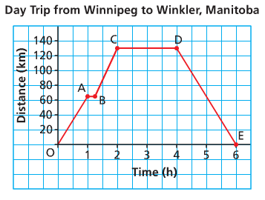
We must choose a good scale in order to see the important values of the domain.
The scale of the x-axis and y-axis do not have to be the same.
The values we represent are not necessarily exhaustive. We can sometimes extend the graph (to the right, to the left or both).
It is also necessary to question if the intermediate values make sense, in order to know if we connect the points or not.
We connect the points if it is a continuous phenomenon.
We do not connect them if the phenomenon is discrete. Se the previous example…
Hwk : p 286 # 1, 2

To interpret a graph correctly, pay attention to what the variables represent as well as their units
Examples :

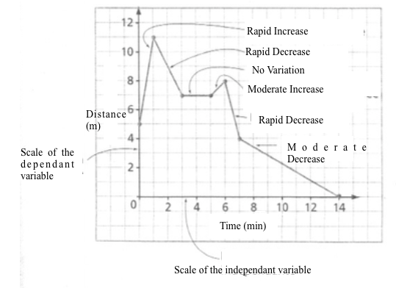
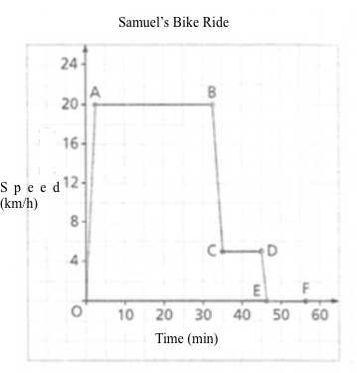
Hwk : p 281 # 3 – 12
p 296 #14, 22 – 24

- Graphic representation of functions
In order to determine if a graph represents a function, we can virtually slide a vertical line over the graph and see if it passes by two points at the same time …
Examples :
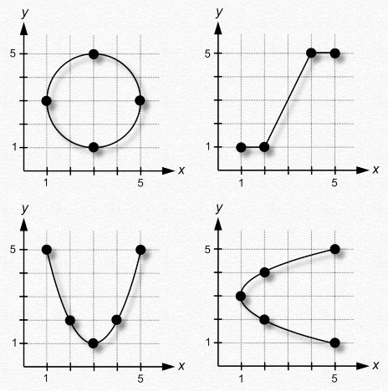
Hwk : p 294 Are the relations in the following exercises functions?# 4 - 9
- Values of a function on a graph
In general, the independent variable is x and the dependent variable is y.
Frequently, we graph multiple functions on the same graph. To differentiate them, we will name them f, g, h, …
We can note the values a function in two different ways…
- With functional notation:
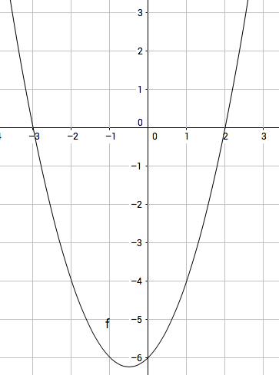

$$f\left(0\right)=$$

$$f\left(-1\right)=$$

Determine x if $f\left(x\right)=0$
Determine x if $f\left(x\right)=-4$

- With a table of values:
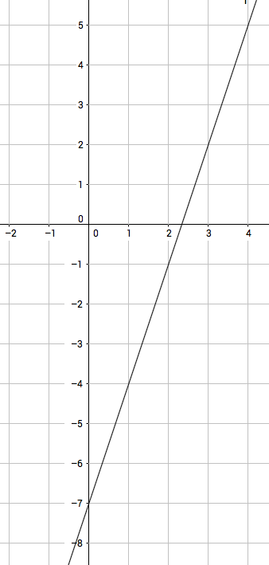

x | 0 | 1
y |  |  | -1 | 5

Hwk : worksheet + p 296 Determine f(1), f(2), f(-1) and x if f(x)=5, f(x)=-2 # 16, 17
- Determining Domain and Range from a graph
The independent variable is on the x-axis.
To determine the Domain, we must look at all the possible x-values of the graph.
Similarly, to determine the Range, we must look at all of the possible values of the y-values of the graph.

The difficulty is to determine how to express all the possible values for the domain and range in a clear and concise manner. ex:
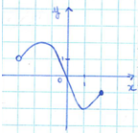

*How to express an infinity of values?
Graduated line Interval Set of values
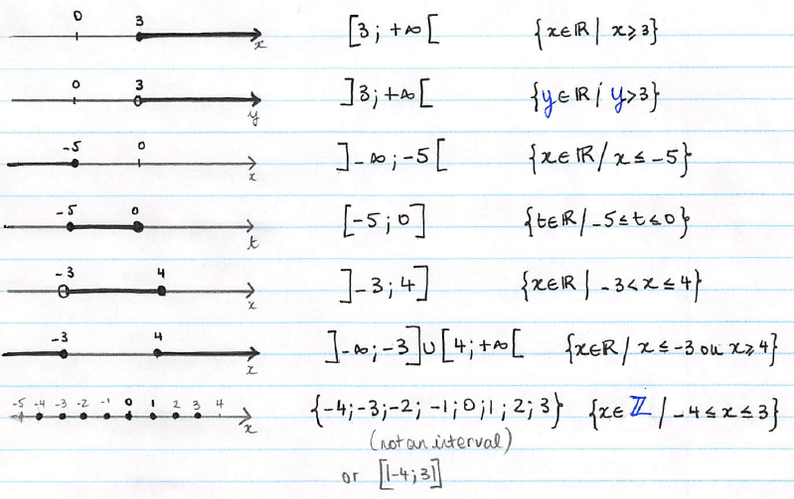
Your Turn :
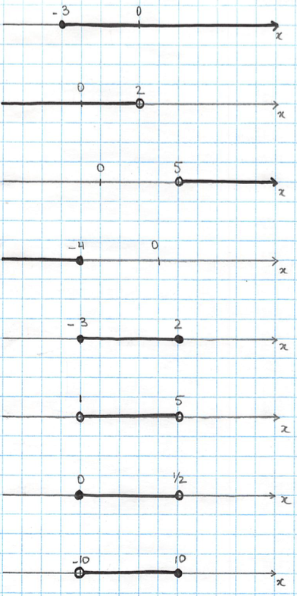
Hwk : worksheet
Examples of Domain and Range from a graph:
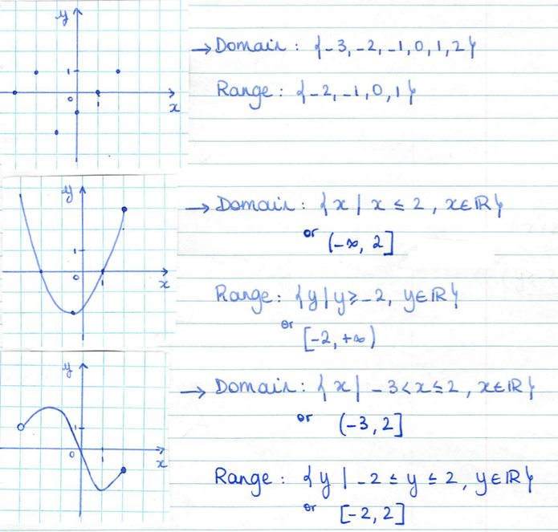
Note :
- When the points are not connected, the domain and range will be a list of values.
- When the points are connected, the domain and range can we written in the form of an interval or a set of values.
Hwk : p 294 # 4 – 13, 19, 21.
- How to represent a function graphically from its equation?
A common method to represent an unknown function graphically is to collect enough values to give you an idea of its shape.
In this courses and the next ones, you will learn how to recognize certain types of functions in order to find more efficient methods…
Examples :
a) $y=2x-1$
x
y

b) $f\left(x\right)=-4x+5$
x
Note : We can also obtain a table of values and the graph with a graphic calculator…
The “top” buttons of your graphing calculator are the ones we’ll use to graph functions and solve equations…
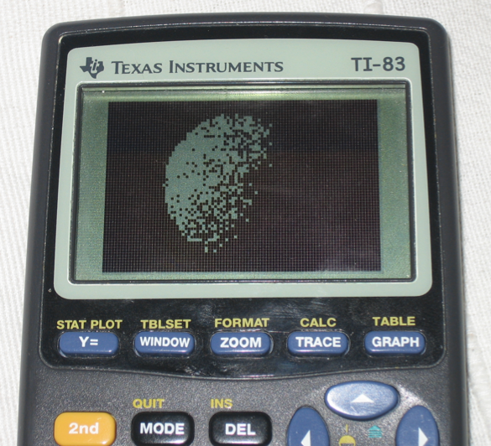

Y= is where you’re going to enter the equation of your function(s)
GRAPH is the button you’ll push after having entered your function in Y= to look at the graph.
TABLE is where you’re going to be able to read a table of values.
TBLSET is where you decide at what value of x you want to start for your table of values and how often you want another value. It can be reached by pushing 2nd and then WINDOW
WINDOW is where you’re going to decide which values of x and y you’re interested in seeing on your graph.
CALC is a button that can help you find different characteristics on your graph… It can be reached by pushing 2nd and then TRACE .
c) $y=\sqrt{x}$
d) $h\left(t\right)=t^{2}+4t+3$
e) $y=2\sqrt{x^{2}-9}$

Hwk : p 296 # 15 + worksheet

