**Chapter 5 – PART IV – Linear Relations**

**I – Properties of Linear Relations:**

A linear relation is a relation where the graph is a straight line.  
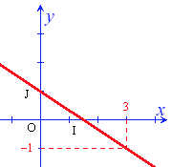  
  
***Recognizing a linear relation:***

1. On a table of values:  
   There is proportionality between the values of the 1st column and the ones of the 2nd column.  
   ex :  
     
     
   See example 1 p 303
2. With an equation:  
   There are 1 or 2 variables that do not have any visible exponents. The variables are not on a denominator and they do not multiply each other.

ex : linear $y=-3x+25$ non-linear : $y=3x^{2}+5$ $y=5$ $y=\frac{3}{x}$

$x=2$ $xy=4$ $$y=\frac{2}{3}x+2$$

See example 2 p 304

1. In a situation:  
   We must identify when the two variables vary at the same rate…  
     
   See example 3 p 305

In a linear relation, the proportional change of the two variables, is define as the **rate of change**:

$$τ=\frac{change in the dependant variable}{change in the independant variable} \\ we write : τ=\frac{Δy}{Δx}$$

Examples: Determine the rate of change of the following linear relations:  
1)   
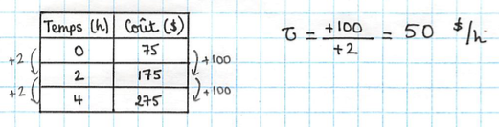

2)

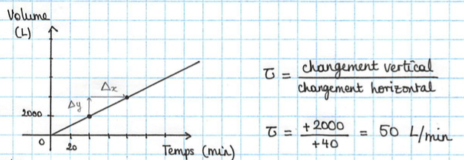

Note: It does not matter what points you chose to calculate the rate, you should always get the same answer…

3)

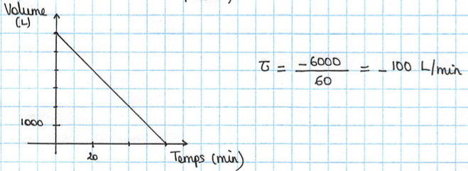

Hwk : p 308 # 3 – 8, 10 – 18, 20, 21

**II – Interpreting the graphs of linear relations:**

Straight lines that are not vertical represent linear functions.

We can describe a linear function with only 2 points. The most ‘practical’ points are the ***x* and *y*-intercepts:**  
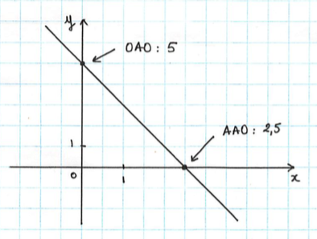

x-intercept : 2

y-intercept : 5

* The *x*-intercept is the point where the line crosses the x-axis   
  It is the value of *x* when *y* = 0.
* The *y*-intercept is the point when the line crosses the y-axis  
  It is the value of *y* when *x* = 0.

Example : Represent the function graphically : $y=2x-3$.  
You can do this by using a table of values (2 values are sufficient because the function is linear…)  
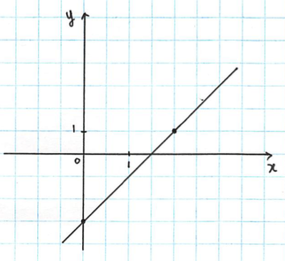

|  |  |
| --- | --- |
| *x* | *y* |
| 0 | -3 |
| 2 | 1 |

or

You can determine the intercepts:

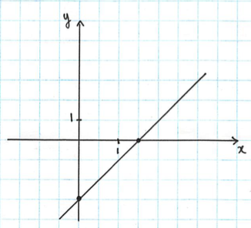

*y*-intercept: when *x* = 0, $y=2\left(0\right)-3=-3$

*x*-intercept: when *y* = 0, $0=2x-3$ $3=2x$

$x=\frac{3}{2}$ or 1,5

Example 3 p 316

***Determining the equation of a linear function from the graph :***

Example: Cost of an electrician troubleshooting :  
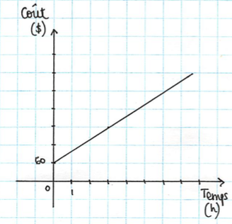

If you pay $190, how much time did the electrician charge you for?

🡪 It is not precise to try and look for the answer to the question on the graph…  
To obtain the exact value, you must solve the equation algebraically.   
For this, you must determine the equation of the graph :

In order to find the equation, we need to calculate the rate of change as well as the *y*-intercept.

$τ=\frac{120}{3}=40 \$/h$

* *y*-intercept: $60 (it is the fixed rate for his displacement)

We obtain: $C=40t+60$

Now we can solve the problem:

$$190=40t+60$$

$$130=40t$$

$$t=\frac{130}{40}, i.e. t=3,25h$$ Therefore ,the electrician worked for 3 house and a quarter.

Hwk : p 319 # 4 – 17, 19