2.1 – Tangent
Vocabulary :
A A
Hypotenuse
Hypotenuse
Adjacent to angle $∠A$
Opposite to angle $∠C$

C C
Opposite to angle $∠A$
B
Adjacent to angle $∠C$
B

- Angle of Inclination: formed by the object and the ground
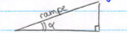

- Angle of Elevation: formed by the line of sight and the horizontal (when the object is above)
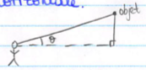

- Angle of Depression: formed by the line of sight and the horizontal (when the object is lower)
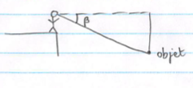
We have noticed that if we divide the opposite side of an angle by its adjacent side of a triangle, we will always get the same result for a given angle (no matter the size of the triangle) because it defines the slope.
This ratio is called the tangent of an angle.
$$\tan{A}=\frac{opposite side to ∠A}{adjacent side to ∠A}$$
Scientific calculators have all the values of tangent for every angle. This will allow us to determine the angles or the lengths of the triangles.
NOTE : This only works for right triangles!
Applications : Determining an angle
a)
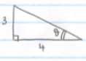
$\tan{θ}=\frac{3}{4}$
$θ=\tan^{-1}\left(\frac{3}{4}\right)$
$θ≈37°$
b)
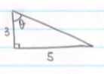
$\tan{θ}=\frac{5}{3}$
$θ=\tan^{-1}\left(\frac{5}{3}\right)$
$θ≈59°$

Reminders:
- In any triangle the measures of all the angles add up to 180º
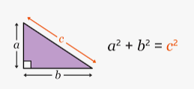
- Pythagorean Theorem:
Examples:
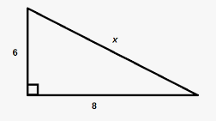 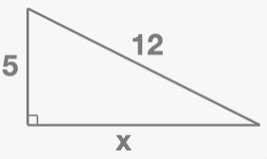

Hwk : p.75 # 5, 8, 10, 11, 13, 17, 19, 21
2.2 – Determining a side length using the tangent ratio

Examples :

a)
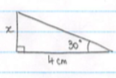
$\frac{\tan{30}}{1}=\frac{x}{4}$
$x=4×\tan{30}$
$x≈2.3$

b)
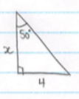
$\frac{\tan{50}}{1}=\frac{4}{x}$
$x=\frac{4}{\tan{50}}$
$x≈3,4$

c)
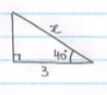
x is not the opposite or the adjacent side to the angle.
Therefore, we cannot directly calculate the length of the side using tangent…
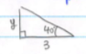
$\frac{\tan{40}}{1}=\frac{y}{3}$
$y=3\tan{40}$
Pythagorean Theorem: $x^{2}=y^{2}+3^{2}$
$x=\sqrt{{\left(3\tan{40}\right)}^{2}+9}$
$x≈3,9$

Hwk : p.82 # 3, 4, 6 – 10, 12, 16
2.4 – Sine and Cosine

Two other trigonometric ratios are defined in right triangles :
$\sin{A}=\frac{opposite to ∠A}{hypotenuse}$ and $\cos{A}=\frac{adjacent to ∠A}{hypotenuse}$
Applications : Determine the angles
a)
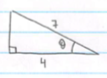
We know the length of the adjacent side and the hypotenuse. We must use cosine.
$\cos{θ}=\frac{4}{7}$ so $θ=\cos^{-1}\left(\frac{4}{7}\right)$
$θ≈55°$

b)
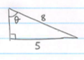
We know the opposite side and the hypotenuse. Therefore, we must use sine.
$\sin{θ}=\frac{5}{8}$ so $θ=\sin^{-1}\left(\frac{5}{8}\right)$
$θ≈39°$

Hwk : p.95 #7, 8, 12, 14, 16, 17, 18

2.5 – Determining a length using sine and cosine

Examples:
a)
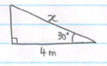
We are looking for the hypotenuse. We know the adjacent side to the angle$30°$.
Therefore, we will use cosine
$\frac{\cos{30}}{1}=\frac{4}{x}$ donc $x=\frac{4}{\cos{30}}=4,6m$
b)
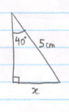
We are looking for the opposite side to the angle $40°$. We know the hypotenuse.
Therefore, we will use sine
$\frac{\sin{40}}{1}=\frac{x}{5}$ so $x=5\sin{40}=3,2 cm$

Hwk : p.101 #3 – 6, 9, 10, 12, 13, 14

2.6 – Using Trigonometric Ratios

SOH CAH TOA
$\sin{θ}=\frac{opp}{hyp}$ $\cos{θ}=\frac{adj}{hyp}$ $\tan{θ}=\frac{opp}{adj}$

Solving a triangle, means that you must find all the side lengths and angles.
Examples :
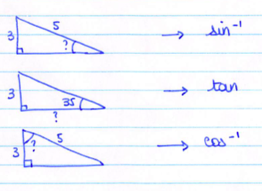
Hwk : p.111 #3, 4, 6, 9 – 11, 16 + p.102 # 13, 14

2.7 – Solving complicated equations using trigonometry

Reminder :
- Trigonometric ratios only apply to right triangles.
Applications:
1)
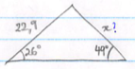
In this example, the triangle is not a right-angle triangle. ($180-26-49≠90)$ We cannot directly apply the trigonometry.
Therefore, we will apply the height in order to create two right angle triangles.

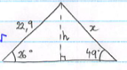

- $\sin{26}=\frac{h}{22,9}$ so $h=22,9×\sin{26}$ (we keep exact values until the end)

- $\sin{49}=\frac{h}{x}$ so $x=\frac{h}{\sin{49}}$

$x=\frac{22,9\sin{26}}{\sin{49}}=13,30 cm$
2) An airplane flies at an altitude of 1650m. On the left, the pilot sees a sailboat with a $21°$ angle of depression. On his right, he sees a ferry with a $52°$ angle of depression.
What is the distance, to the nearest meter, between the two boats?
We must make a drawing…

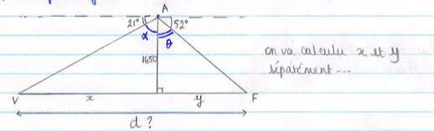
$∝=90-21$ $θ=90-52$
$∝=69°$ $θ=38°$
$\tan{69}=\frac{x}{1650}$ $\tan{38}=\frac{y}{1650}$
$x=1650×\tan{69}$ $y=1650×\tan{38}$
Therefore : $d=1650\tan{69}+1650\tan{38}≈5588m$
Hwk : p.118 # 3 – 7, 9, 11, 19

