6.1 – The slope of a line

The slope of a line is defined by:
$$m=\frac{vertical change}{horizontal change}$$

The slope is used to describe the “steepness” of the line.
Examples:
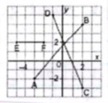
$m_{AB}=\frac{6}{5}{ m}_{CD}=\frac{8}{-3}=-\frac{8}{3}{ m}_{EF}=\frac{0}{3}=0 (horizontal line)$

When a line is vertical, the horizontal change will be 0. As a consequence, the slope will be undefined.
Note: If the line has an undefined slope, it is not representing a function.
Applications: Draw a line that passes through the point A(-2;1) and has a slope of:
a) $\frac{3}{4}$ b) $-\frac{2}{3}$ c) $2$
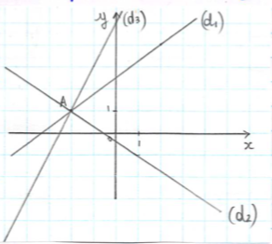

Notice: A slope of 3 can be seen as $\frac{3}{1}$ or $\frac{6}{2}$ or… When determining the slope of a graph, no matter what points you chose, the result will be the same. We will always use 2 points whose coordinates are exact.
If we do not have a graph, we can directly get the slope of the graph by using the coordinates of 2 points.
If $A\left(x_{A};y_{A}\right)$ and $B(x_{B};y_{B})$, then $m_{AB}=\frac{y_{A}-y_{B}}{x_{A}-x_{B}}$
Example: Determine the slope of the line that passes through:
- A(3;-3) and B(4;1)

$m_{AB}=\frac{1-\left(-3\right)}{4-3}=\frac{4}{1}=4$ or $m_{AB}=\frac{-3-1}{3-4}=-\frac{4}{-1}=4$

- C(45;-64) and D(495;236)

$$m_{CD}=\frac{-64-236}{45-495}=-\frac{300}{-450}=\frac{2}{3}$$

Note: The slope of a line is the same as the rate of change of the linear function that it represents.
Hwk: p.339 # 4-18, 20-27

6.2 – Slope of parallel and perpendicular lines

Property 1: Two parallel line have the same slope.
Therefore, to identify if two lines are parallel, you just need to compare their slopes.
Example: If A(-4;2) , B(2;-1) , C(-4;5) and D(5;1)
Is (AB) parallel to (CD)?
$m_{AB}=\frac{-1-2}{2-\left(-4\right)}=-\frac{3}{6}=\frac{1}{2} m_{CD}=\frac{1-5}{5-\left(-4\right)}=-\frac{4}{9}≠-\frac{1}{2}$
No!
Property 2: Two lines are perpendicular if their slopes are opposite and reciprocal.
Vocabulary: Opposite ex. 3 and -3
5 and -5
Reciprocal ex. 3 and $\frac{1}{3}$
$\frac{2}{5}$ and $\frac{5}{2}$
$-\frac{1}{4}$ and $-4$
Therefore, to know if a shape has a right angle. You must compare their slopes.

Example: If A(-2,7), B(2,-5) and C(-5,6)
Show that the triangle ABC is a right triangle.
$m_{AB}=\frac{-5-7}{2-\left(-2\right)}=-\frac{12}{4}=-3$
$m_{AC}=\frac{\left(6-7\right)}{-5-\left(-2\right)}=-\frac{1}{-3}=\frac{1}{3}$
Yes!

Reminder on geometric figures:

Parallelogram:

Trapezoid:

Rectangle:

Other applications: E(2,3) and F(-4,-1)
Determine the coordinates of a possible point G such that (EG) is perpendicular to (EF)
$m_{EF}=\frac{-1-3}{-4-2}=-\frac{4}{-6}=\frac{2}{3}$ so we must have $m_{EG}=-\frac{3}{2}$
$$\frac{y_{G}-3}{x_{G}-2}=-\frac{3}{2}$$
For example: G(4,0) or (6,-3) or…
Note: other method:
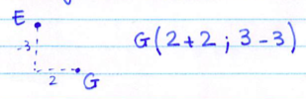
Hwk: p.348 #3-20

6.3 – Explore the graphs of linear equations

Develop your understanding p. 255
$$y=mx+b$$
Where m is the slope and b is the y-intercept.
Hwk: Evaluate your comprehension p.356 #1-7

6.4 – Linear equation in slope-intercept form

All linear functions can be written in the form: $y=mx+b$
When the equation is in this form, m is the slope of the line and b is the y-intercept.
This form is called the slope-intercept form.
Examples:
1)$y=-2x+3$
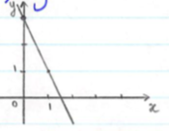
$m=-2 (-\frac{2}{1})$ and y-intercept = 3
2) $y=\frac{3}{4}x-5$
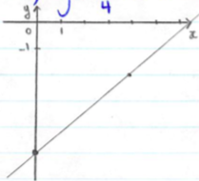
y-intercept = -5 and $m=\frac{3}{4}$
3)$y=5$
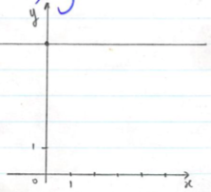
y-intercept = 5 and m = 0

Note: Vertical lines don’t represent functions. Their slopes are undefined. Their equation is in the form of x = k
ex: x = 3
Applications:
- Determine the equation of a line with a slope of $-\frac{7}{4}$ and a y-intercept of 5
$y=-\frac{7}{4}x+5$
- What is the equation of the following line?

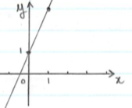
y-intercept : 1
$y=2x+1$
m = 2

- To get a gym membership, Kevin pays $99 to register and $29 for every month.
- What is the total cost, C, in function to the number of months, n.
- What is the cost of the gym membership for 23 months?
- Over how many months did Kevin stay if he paid $505 in total.
- Same question but $600.
  - $C=29n+99$
  - $C=29\left(23\right)+99=\$766$
  - $505=29n+99$
$$406=29n$$
$$n=14$$
  - $600=29n+99$
$$501=29n$$
$$n≈17.3$$
Hwk: p.362 # 4-9, 12-14, 16, 18, 19, 21, 22, 24
6.5 - Equation of a linear function in slope-point form

We use this form when we do not know the y-intercept….
Example 1:
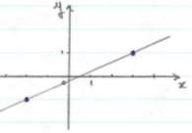
Example 2: Determine the equation of a line that passes through the points A(500,57) and B(780,71)
Slope-point form: $y-y_{p}=m\left(x-x_{p}\right)$
Where m is the slope and ($x_{p};y_{p})$ are the coordinates of a point on the line.
Example 1:
$m=\frac{1-\left(-1\right)}{3-\left(-2\right)}=\frac{2}{5}$
Lets use the point P(3,1)
$$y-1=\frac{2}{5}\left(x-3\right)$$
Note: We can change it from slope-point form to slope-intercept form.
$$y-1=\frac{2}{5}x-\frac{6}{5}$$
$$y=\frac{2}{5}x-\frac{6}{5}+1$$
$$y=\frac{2}{5}x-\frac{1}{5}$$

Example 2:
$$m=\frac{71-57}{780-500}=\frac{14}{280}=\frac{1}{20}$$
$$y-57=\frac{1}{20}\left(x-500\right)…. y=\frac{1}{20}x+32$$

Example 3: Graph the following function
- $y-3=2\left(x-1\right)$ slope: 2 passes through A(1,3)
- $y-5=\frac{2}{7}(x+2)$ slope: $\frac{2}{7}$ passes though B(-2,5)
- $y+3=-4\left(x-1\right)$ slope: -4 passes though C(1,-3)
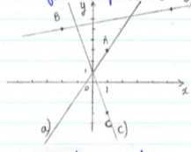
Example 4: The relationship between the temperature in degrees Celsius ($℃)$ and Fahrenheit ($℉)$ is linear. We know that $100℃$ is equivalent to $212℉$ and $0℃$ is equivalent to $32℉$.
- Express C in function to F.
- What is equivalent to $2795℉$?
- From the question, we can tell that C is the dependant variable and F is the independent variable.

Consider the points: (212,100) and (32,0)

$$m=\frac{100-0}{212-32}=\frac{100}{180}=\frac{5}{9}$$

$$C-0=\frac{5}{9}\left(F-32\right) or C=\frac{5}{9}F-\frac{160}{9}$$
- $C=\frac{5}{9}\left(2795\right)-\frac{160}{9}$
$$C=1535℃$$

Hwk: p.372 # 5-12, 16-19, 21-23, 25
6.6 – Equation of a linear function in general form

A linear equation is in general form if it is in the form:
$$ax+by+c=0$$
Where a, b and c are integers and a is positive or 0.
Examples:
$3x-5y+1=0$ $\frac{2}{3}x-\frac{1}{3}y+5=0$
$-3x+5y+1=0$ $3x-4y=2$
$0.2x+2y+3=0$

Transform the linear equation in general form:
- $y=-3x+5$ $3x+y-5=0$
- $y=\frac{1}{2}x+3$ $x-2y+6=0$
- $y-2=4\left(x+3\right)$ $4x-y+14=0$
The general form is ‘nice to look at’ and commonly given, but it is not very useful.
We can easily determine the x and y intercepts when the equation is in general form.
y-intercept: the value of y when x = 0
x-intercept: the value of x when y = 0
Example:
$$4x+y-8=0$$
If x = 0 : $y-8=0$ so $y=8$
If y = 0 : $4x-8=0$ so $x=2$
Note: To know the slope or when using a graphing calculator, you must transform the graph from general form to explicit form.

Transform an equation in general from to slope-intercept form:
Example:
$$4x-3y-12=0$$
$$-3y=-4x+12$$
$$y=\frac{4}{3}x-\frac{12}{3}$$
$$y=\frac{4}{3}x-4$$
Note: We will also use standard form:
$$ax+by=c$$
Where a, b and c are integers and a is positive or 0.
Example: $2x-3y=5$
Hwk: p.384 # 4-9, 11-14, 16, 18, 21-24

