7.1 – Developing systems of linear equations

Situation: Tickets for the end-of-the-year school play have started selling. Adult and student tickets have different prices. Felix bought 3 adult tickets and 2 student tickets. He paid 41$. Ellen bought 1 adult ticket and 1 student ticket. She paid 16$. What is the price of an adult ticket? What is the price of a student ticket?
$→$ With a being the price of an adult ticket and s being the price of a student ticket.
$\left\{\begin{aligned}3a+2s=41 \\ a+s=16\end{aligned}\right.$
All there is left to do is to solve the system for the two unknown variables. We will learn how to do this in the upcoming lessons. For this system, the solution is 9$ for an adult ticket and 7$ for a student ticket.
Verification:
Attention: When we want to test a solution, we are not solving the equation. We cannot work on both sides of the equation simultaneously. We must work on each side separately.
Example: Let’s consider the system: $\left\{\begin{aligned}c=2d+2 \\ c+2d=-6\end{aligned}\right.$.
We propose two potential solutions.
Solution A: $c=4 and d=1$ Solution B: $c=-2 and d=-2$
Which one works?
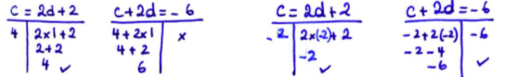
$→$ Solution A: no $→$ Solution B: yes!

Example:
- A logistic business has two types of vans. One holds 8 passengers and the other holds 6 passengers. In total, the business used 15 vans to transport 110 passengers. All the vans were full. How many 8 passenger vans did the enterprise use? How many 6 passengers
vans did the business use?
- The business says that they used ten 8 passenger vans and five 6 passenger vans. Verify this information.
$→$ with x being the number of 8 passenger vans and y being the number of 6 passenger vans
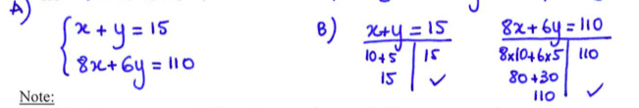

Note: To avoid errors, we always test the answer using the initial system.
Hwk: p. 401 # 4 – 8, 11, 12, 16

7.2 – Solve a system of linear equations graphically
If we have a linear system of two equations with two unknowns, we can visualise each equation as a line.
Solving the system means finding the values of x and y values which satisfy both of the equations. This means the coordinates of the points that are on both lines.
Therefore, we can find the solutions of the system by graphing both lines. If they intersect, then the coordinates of that point are the two values that are the solution of the linear system.
Example: Solve the following system graphically: $\left\{\begin{aligned}x-y=3 \\ 4x+5y=30\end{aligned}\right.$
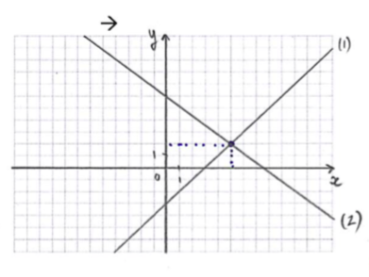
- $y=x-3 →slope:1$
$y-intercept:-3$

- $y=-\frac{4}{5}x+6 → slope:-\frac{4}{5}$
$$y-intercept:6$$

Solution: {(5, 2)}

Application:
Matt received money for mowing his neighbours’ lawns. He charged 12$ to mow a small lawn and 20$ for a large lawn. In total, he received 180$ for mowing 11 lawns.
- Represent this situation with a linear system.
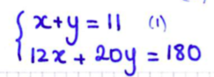
- Represent the system graphically.
several methods to graph. ($y=-\frac{3}{5}x+9$ and $y=-x+11$)
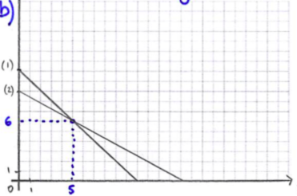
- Solve this problem: How many small and large lawns did Matt mow?
Matt mowed 5 small lawns and 6 large lawns.

Hwk: p.409 # 3 – 5, 8 – 14, 17

7.3 – Solving a system of linear equations graphically with the help of technology
To solve systems with a graphing calculation, we must solve each of the equations for y in order to use the button $Y=$ . Once you enter both equations into your calculator, we must use the find the intersection of both line equations. In the menu CALC find Intersect to find the coordinates of the point where both line equations cross.
Example:
- $\left\{\begin{aligned}-2x+y=10 \\ x+4y=4\end{aligned}\right.$
- $\left\{\begin{aligned}3x+y=6 \\ x+y=-\frac{4}{3}\end{aligned}\right.$

- $\left\{\begin{aligned}x+y=391 \\ x-y+141\end{aligned}\right.$
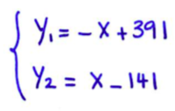
Because the values are so big, we need to look at the TABLE to find the approximate values of x where the graphs cross (between 250 and 300).
Then we must adjust the window of the graph:
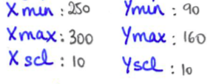
Solution: {(266, 125)}
Hwk: p. 412 # 3, 5 + Test your understanding p.415
7.4 – Solving a system of linear equations by substitution

Solving the system graphically is not always that precise and it is very time consuming. One algebraic strategy to solve the system is to solve by substitution. This method is recommended when the coefficient for one of the variables, in one of the equations, is 1…
Method: Solve the system $\left\{\begin{aligned}2x+y=3 \\ 4x+3y=5\end{aligned}\right.$
- Isolate one of the variables in one of the equations (choose the one that has no coefficient if possible).
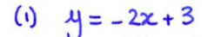
- Replace the expression of this variable into the other equation.
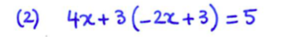
- Solve the equation.
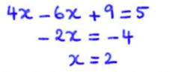
- Replace the solution that you found into the equation from step 1.
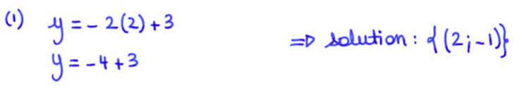
Your Turn: $\left\{\begin{aligned}2x+3y=3 \\ x-4=4\end{aligned}\right.$

Notice: If neither of the coefficients is 1, this method still works (but you’ll be dealing with fractions).
Example: $\left\{\begin{aligned}2x+3y=12 \\ 3x-2y=3\end{aligned}\right.$
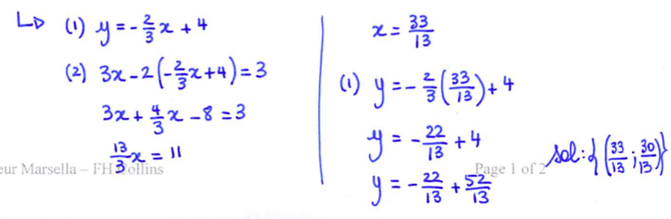
Notice: If the coefficients at the start are fractions, we can always multiple both sides of the equation with well-chosen numbers to simplify the equation and obtain whole numbers.
Example: $\left\{\begin{aligned}\frac{1}{2}x+\frac{2}{3}y=-1 \\ y=\frac{1}{4}x-5\end{aligned}\right.$ is equivalent to $\left\{\begin{aligned}3x+4y=-6 \\ 4y=x-20\end{aligned}\right.$

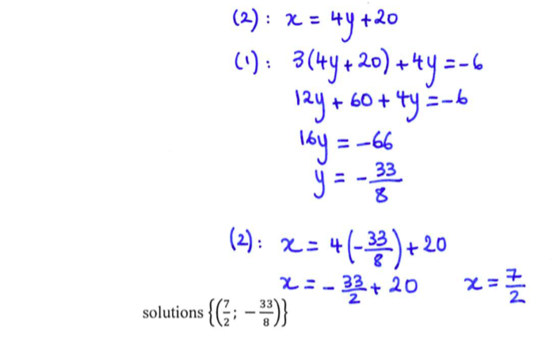
Hwk: p.425 #5, 10, 12, 15 – 19

