EXPOSANTS

REMINDER: An exponent is a shortened way to represent repeated multiplication.
Examples: ${3 }^{5}= 3×3×3×3×3$
$x^{2} = x×x$
In Grade 9, you manipulated natural exponents.

EXPLORATION: While analysing repeated multiplications, we could define other exponents to keep the regurity…
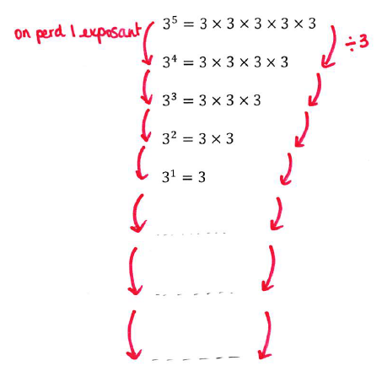

Note : Notice that 3⁰=1, this is true for any base that is not zero…

Definition : For all whole positive numbers n, we have$: 3^{-n}=\frac{1}{3^{n}}$

This rule is true for any other base (not zero).

Examples : a) $2^{-3}=\frac{1}{2^{3}}=\frac{1}{8}$ b) $5^{-2}=\frac{1}{5^{2}}=\frac{1}{25}$ c) $2x^{-5}=2×\frac{1}{x^{5}}=\frac{2}{x^{5}}$

This rule has many interesting consequences:
- ${\left(\frac{2}{3}\right)}^{-5}={\left(\frac{3}{2}\right)}^{5}$
(to change the sign of an exponent, take the reciprocal of the number!)
- 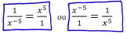
(if you want to switch the numerator and denominator, you need to change the sign of the exponent)

Examples: Simplify only using positive exponents and evaluate only if possible.

a) ${\left(\frac{3}{4}\right)}^{-2}$ b) $\frac{3}{5^{-4}}$

c) $\frac{2x^{-3}}{5}$ d) $\frac{3^{3}x^{-3}}{2^{-3}y^{2}z^{-4}}$
e) $\frac{2^{5}x^{3}}{2^{8}x^{-2}}$

Hwk : p 233 # 3 – 8 , 10, 16

LAW OF EXPONENTS (Reminders):

What simplifies well...

- Multiplying powers that have the same base: ${ 3}^{5}×3^{2}$
indeed: $3^{5}×3^{2}$
- Dividing powers that have the same base: $\frac{3^{5}}{3^{2}}$
indeed: $\frac{3^{5}}{3^{2}}$
- If a power has another exponent: ${\left(3^{4}\right)}^{2}$
indeed: ${\left(3^{4}\right)}^{2}$
- If a product has an exponent: ${\left(2x\right)}^{3}$
indeed: ${\left(2x\right)}^{3}$
All of these rules continue to work the same with negative or positive exponents...

What does not simplify… too bad...
Adding and subtracting powers that have the same base:
$$2^{3}+2^{5}=$$
Multiplying powers that don’t have the same base :
$$2^{3}×3^{2}=$$
If a sum has an exponent:
$${(x+3)}^{2}=$$

Examples:
a) $3^{-5}×3^{2}=$

b) $3^{-5}×9^{2}=$
c) ${\left({\left(-5\right)}^{2}\right)}^{-3}=$
d) $\frac{x^{-5}}{x^{-2}}=$

e) ${\left(3x\right)}^{-4}=$
f) ${\left(2x^{3}y^{-2}×\frac{1}{3}x^{5}y^{-3}\right)}^{-1}=$

g) ${\left(\frac{2x^{2}y^{-3}}{3x^{3}y}\right)}^{-3}$

h) ${\left(2xy^{-3}\right)}^{-2}{\left(3x^{2}y^{-3}\right)}^{2}$

i) ${\left(2x-3y\right)}^{2}$
Hwk : p 241 # 3 – 11, 14 – 17 , 19, 21, 22
Review : worksheet + p 247 # - 24, 28 – 30 , 32 + p 249 # 6, 7 + p 253 # 25, 26

