Finance

Reminder on Percentages:
A percentage represents a proportion of a quantity.
- Write the following percentages in decimal form:
12% 5% 3.2% 21.4%
- Calculate the percentage of each of the following quantities:
15% of $10000
3.5% of $15000
- Increase or decrease the quantities by the given percentages:
Increase 150 by 20%
Increase 200 by 3%
Decrease 150 by 10%
Decrease 200 by 5%

Gross and Net Income:

When we have an income, we must pay taxes or duties to contribute to government expenses for society. We differentiate between net and gross income.

- Gross Income: the income that someone receives before deductions (like taxes).
- This includes:
- Base salary: when an employee receives the same amount of money, each time they are paid
- Salary per hour: this includes supplementary hours.
- Commissions: when an employee receives a percentage of sales for example
- Bonus
- Reimbursements for travel, accommodation and meals
- Tips
The salary can be paid:
- Monthly = paid 1 time per month (12 times per year)
- Semi-monthly = paid 2 times per month (24 times per year)
- Every 2 weeks (26 times each year)
- Weekly = paid each week (52 times per year)
Examples:
- Bob gains $526 per week. If he works 50 weeks per year, what is his gross income?
- Morris earns $34.25 hour. What is his gross income if he works 40 hours per week for 50 weeks every year?
When Morris works extra time (after 40h per week), he is paid one and a half times for each hour. What is his gross income if he works 43 hours per week?
- Jill works at a store and gets 8% of sales. If the store sells $565000 this year, what is her gross income?
- Terry works at a restaurant for $10.45 per hour and receives 35$ in tips every day. If he works 8 hours per day, 3 days a week, what is his gross income each week?
- Troy has 2 work offers. Store A offers a salary of $10,45 per hour. Store B offers $1100 per month plus 4% of commissions on his sales. Both stores want Troy working 160 hours per month. How much money in sales does Troy need to make store B’s offer more advantageous?

Net Income: the income that remains after deductions.
The deductions include:
- Taxes
- Employment Insurance (EI)
- Canadian Pension plan (CPP)
- Union fees
- Medical insurance
- Other deductions.
Net Income = Gross Income – All Deductions .

Ex : Jasmine is a person that makes $60000 per year in BC. Her deductions are:
Provincial and federal taxes: $10 491, Pension: $2544, EI $955, Medical insurance $900.
What is her net income every 2 weeks?

Homework: worksheet

Deductions before taxes

We use the gross income to calculate EI (employment insurance) and CPP (Canadian pension plan) deductions.
In this lesson, unless otherwise mentioned, we will use the rates from 2019.
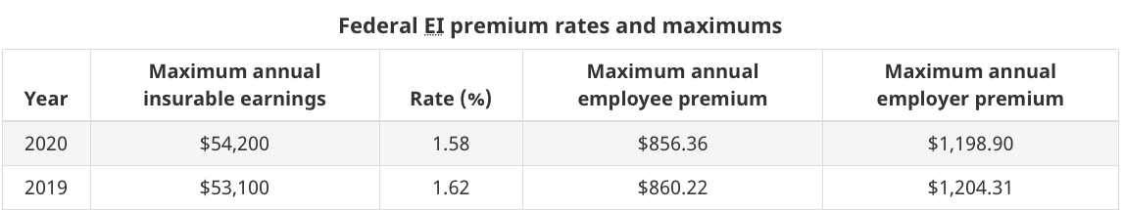
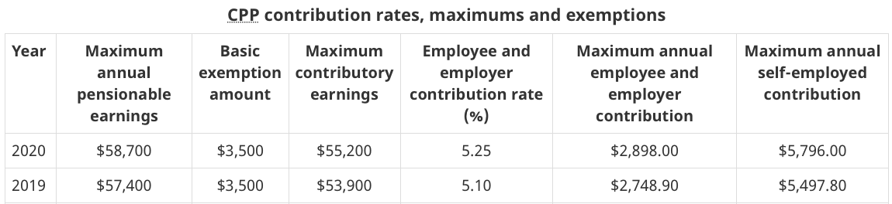
Examples :
- Angie’s gross revenue every two weeks is $1160. Calculate the deductions in EI and CPP.
- Lucie’s gross revenue every two weeks is $2500. Calculate the deductions in EI and CPP by the payment sheet in 2019.
Other deductions before taxes exist, like union fees or personal additional pension plans or other familial deductions.
Federal and Provincial/Territorial taxes
To calculate taxes on revenue, you must first calculate the taxable income.
This means to calculate the portion of revenue that we will have to pay taxes on.
To find this portion, we must subtract all the deductions before taxes from the gross revenue as well as the personal exemptions.
The federal and territorial/provincial exemptions change each year.
In this lesson, we will use the one from 2019, which is $11 635 for the federal and $10 207 for the territorial/provincial one.
Example: Alina gets $1020 gross per week, but she pays $6.50 in union fees and $85 towards her pension plan (RRSP). What are her provincial and territorial taxable income?
The Canadian tax system is a progressive system.
We divide taxable income into several different slices and the tax rate on each slice is different. However, everyone pays the same percentage of tax on each tax slice.
ex : Federal Taxes
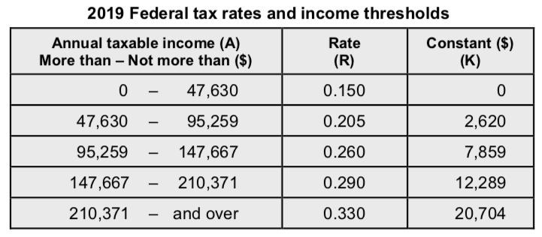
ex : Territorial or Provincial Taxes
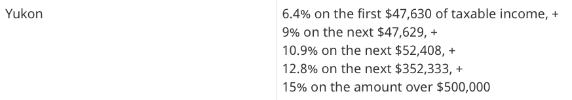
or
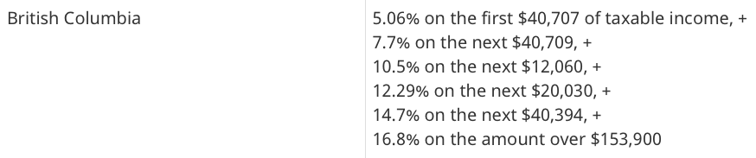
The more money we make, the more taxes we pay.

Examples :
a) Determine the provincial and federal taxes on an taxable revenue of $70 000 in BC.

b) Determine the territorial and federal taxes on a taxable revenue of $70 000 in Yukon.

Tax Credits :
There are situations where you can get some money back. We won’t cover it in this lesson.

Homework: worksheet

Calculating Net Income:

This is a simplified version because there are a multitude of exceptions and special cases that we will not take into consideration…
In order to calculate net income, we must calculate all of the deductions.

- Determine the Annual Gross Income
- Determine EI and CPP
don’t forget the exemption for CPP
don’t forget to look at the max values
- Determine the other deductions before taxes
(union fees, addition pension plans...)
make sure everything is annual
- Federal Taxes
Federal Taxable Income
= Gross – EI – CPP – other deduction – federal personal exemption
Then use the federal tax brackets
- Territorial or Provincial Income taxes
Territorial Taxable Income
= Gross – EI – CPP – other deduction – territorial personal exemption
Then use the territorial tax brackets

Net = Gross – EI – CPP – deductions before taxes – Territorial and Federal Taxes

Examples:
a) Matisse lives in BC. Elle gets $27.80 per hour and works 37.5 hours every week. She pays 5% of her earnings to her company’s pension plan and $960 each year in union fees. Determine her net revenue if she works 50 weeks a year.

b) Nellie lives in Yukon. She gets a gross monthly salary of $3425. Each month, in addition to mandatory payments to EI et CPP, she pays $45 in union fees and $225 towards an additional pension plan. Determine her monthly net revenu.

Note: Since taxes are taken before you receive your salary, it is not always possible to know the credits that you are intitled to. Therefore, at the end of each year, your tax return will ensure that you haven’t paid too much (or too little) and will allow you to be reimbursed the difference…

Homework : worksheet

